VOLT System Design Document

DRAFT

Document Number: | VOLT-DES-001
Document Version: | Revision 1.0
Document Issue Date | Feb 2, 2001

Document Summary
Document Title | VOLT Design Specification
Owner | Dharitri.misra@commerceone.com
Abstract
Status | Draft

Document Change History Log
Date of Change | Ver | Reason for  Change | Summary of Change | CCR #
 | 0a | Initial Draft | N/A | N/A

Approvals
Title | Name | Signature | Date

Table of Contents
VOLT System Design Document 1
DRAFT 1
Document Summary 2
Document Change History Log 2
Approvals 2
1 INTRODUCTION 5
1.1 General Information 5
1.1.1 Purpose 5
1.1.2 Audience 5
1.1.3 Document Organization 6
1.2 System Overview 7
1.2.1 System Description 7
1.2.2 External Interfaces 7
1.3 Design Summary 8
2 Design Strategies 8
2.1 Design Methodology 8
2.2 Design Drivers 9
2.3 Design Highlights 9
2.4 Technologies and Standards Used 9
3 Use-case Model 10
3.1 VOLT Use cases 10
3.1.1 Functional Use cases 10
3.1.1.1 Support planning of coordinated observations 10
3.1.1.2 Support planning of a single observation 11
3.1.1.3 Allow import of proposals in a mission’s native format 11
3.1.1.4 Allow seamless addition of new missions 11
3.1.1.5 Allow VOLT to be integrated with other Planning tools (e.g. SEA) 11
3.1.2 Non-Functional Use cases 12
3.1.2.1 Provide context sensitive help 12
3.1.2.2 Support user preferences 12
3.1.2.3 Provide templates for observation layout 12
3.1.2.4 Provide Scripting capability for repeatability of scenarios 12
3.1.2.5 Provide ability to Save and Restore Observation data 12
3.1.2.6 Support online and offline operations of the system 12
3.1.3 Future Use Cases 12
3.1.3.1 Support near-real-time collaboration of users for coordinated planning 12
3.1.3.2 Support import and display of Long-range schedules for the planning interval 12
3.1.3.3 Support role-based accessibility of the system by users 12
4 Analysis Model 13
4.1 High level Architecture 13
4.2 Architectural Components 14
4.3 Class Descriptions 15
4.3.1 Boundary Classes 15
4.3.2 Control Classes 16
4.3.3 Entity Classes 16
4.4 Class Diagrams 17
4.5 Collaboration Diagrams 17
5 DESIGN MODEL 18
5.1 Design Methodology 18
5.2 User Interface Methodology 18
5.2.1.1 Presentation Methodology 18
5.3 VOLT Application structure 20
5.3.1 VOLT Client Application 20
5.3.2 VOLT Server Application 21
5.3.3 Client and Server Communication Methodology 21
5.4 Design of High level VOLT Classes 21
5.4.1 Core Control Classes 22
5.4.1.1 VoltApp 22
5.4.1.2 Manager Classes 23
5.4.1.3 Volt Server Classes 24
5.4.1.4 Gateway Classes 25
5.4.2 Boundary and Entity Classes 26
5.4.2.1 Event Classes 26
5.4.2.2 Observation Related Classes 27
5.4.2.3 Observation Coordination Related Classes 27
5.4.2.4 Timeline related Classes 28
5.4.2.5 Schedulability related Classes 29
5.4.2.6 Observation Specification Classes 31
5.4.2.7 Schedulability Display related classes 33
5.4.2.8 Constraint Evaluation and Modification Suggestion Classes 34
5.4.2.9 Proposal related classes 35
5.4.2.10 Session Save/Restore related classes 36
5.4.2.11 Timeline Request Handling classes 37
5.4.2.12 Interfaces classes for running VOLT within other Planning Systems 37
5.5 Sequence Diagrams (Work Flow Diagram) 37
5.5.1 Observation Specification 38
5.5.2 Retrieval of data from remote facilities 38
5.5.3 Schedulability Determination and Display 39
5.5.4 Constraint Modification 39
6 VOLT System Implementation 40
6.1 VOLT Subsystems 40
6.2 VOLT Packages 40
6.3 Volt Configuration Files 42
6.4 VOLT System Deployment 42
Appendix A - Reuse of SEA Classes Within VOLT 43
A.1 SEA MessageLogger 43
A.2 HelpManager 43
A.3 SplashScreen 43
A.4 PreferenceManager 44

INTRODUCTION
This section provides an overview of the Visual Observation Layout Tool (VOLT) system, including its purpose, a high-level system description, external interfaces, and design summary.

General Information

Purpose
This document defines the VOLT software architecture and design via object oriented views and models. The architecture and design is based upon the VOLT system requirements and use cases derived from the VOLT System Requirements Specification.
The VOLT system is being developed following a “iterative and incremental development” methodology, in which modifications and new features are added to the system at each phase incrementally. Each VOLT phase will build on the previous phase’s functionality; it will undergo analysis through implementation activities, in an iterative manner, for the new requirements and will result in a release and a user demonstration. Modifications based on user feedback and predefined requirements will define subsequent design phases. The VOLT Project Management Plan defines the scope of the project and addresses other pertinent project life cycle information.
In compliance with the incremental development process, the system design document will be updated by the end of each phase to accurately reflect the latest design. Consequently, the VOLT design document is expected to be an evolving document. The current version of the VOLT System Design Specification focuses on the architecture and design of the latest system phase (Phase 4) and its associated release (Release 3.0). In addition, it discusses important classes and objects required for the implementation of the Phase 4 (Release 3.0) system. Other classes will be added in ensuing phases to reflect the addition or modification of system features.

Audience
This document is intended for:

- The Customer
- The Project Leader
- System Testers
- System Designers/Developers

Document Organization
This document is organized into the following sections
Section 1 – Introduction
Provides the introduction to the VOLT system.
Section 2 - Design Strategies
Discusses the methodology and strategies used to design the VOLT system
Section 3 – Use case Model
Presents the Use cases pertinent to the development of the VOLT system, addressing it from a lower level than that presented in the VOLT Requirements document.
Section 4 – Analysis Model
Discusses how the system functions, presented through the use cases, may be allocated to different high level functional classes. This model is developed using the pattern suggested in the book “The Unified Software Development Process.” The relationship between these functional classes and the work flow are also shown in this section as a set of Class Diagrams and Collaboration Diagrams.
Section 5 - Design Model
This section lays out the classes, their relationship and detailed functions so as to provide a blue print for implementation. These classes, therefore, constitute the high level VOLT implementation classes. Sequence diagrams, depicting a more detailed workflow using these classes, and satisfying the use cases presented in Section 2, are included in this section.
Section 6 – Implementation Model and Software Packaging
This section provides some implementation details for the VOLT system. It shows the conceptual subsystems into which the VOLT system may be broken down, as well the software (Java) packages that make up each of these subsystems. It also discusses the contents of the resource files that are used for initializing and running the system, and the actual deployment methods for the VOLT applications.
Appendix A – Reuse of SEA classes within VOLT
Appendix C – Package Level Class Listings

System Overview
The primary objective of VOLT is to develop prototype visual tools to assist observers and observatory staff for planning coordinated observations. In general, VOLT tools are intended to help these users in the planning of observations that need coordination between two or more observatories. However, the same tools should also be useful in allowing observers to plan non-coordinated, single-mission observations with higher scheduling probability.
The VOLT system currently focuses on providing planning support for astronomical missions. In the future, the VOLT system will aid in coordinated and individual observation planning for ground observatories and earth science domains.

System Description
VOLT is an interactive system, driven by the users through an easy-to-use graphical user interface. The planning tools incorporated into VOLT provide visibility into the schedulability of an observation for a specific mission, or that of related observations for collaborating missions. The VOLT tools interact directly with a mission’s planning scheduling facility or other external systems to retrieve the relevant data and present it to the user. In addition, actual schedules, constraint feedbacks, and other pertinent information are provided to the user to help in the modification to the original observation parameters - to increase the observation scheduling probability.
VOLT helps in the visualization of output data using various techniques, including zooming, panning and displaying information at different levels of detail. In addition, VOLT tools are configurable for use by different categories of users, namely the observers, the coordinators at local observatories, and the coordinators at collaborating observatories.

External Interfaces
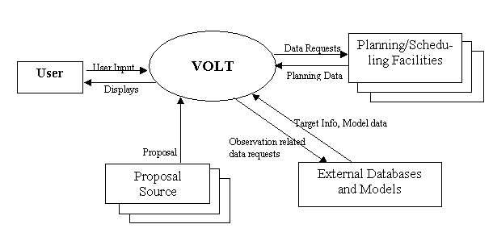
Figure 1-1 VOLT System External Interfaces

The VOLT system interfaces with the following external sources to carry out its objectives:
User – A user provides input data to the system, in the form of a planned observation, a target related to an observation, or a higher level plan (called a proposal) containing one or more observations, along with the Schedulability function(s) that need to be performed. VOLT receives the input interactively through a Graphical User Interface , processes the data internally, and ultimately provides user-feedback in the form of visual displays.
Proposal Source – A proposal specified by the user may have to be retrieved from the repository where it resides. Several such repositories may exist for a mission
Planning/Scheduling Facility – VOLT interfaces with the Planning/Scheduling facility of each observatory to retrieve schedulability, scheduling and other information related to observation specified by the user.
External Databases and Models - In certain cases, the system may interface with external databases and/or models in order to obtain data that may or may not be provided by other sources. VOLT queries these external facilities by providing for the relevant data through mechanisms supported by those facilities.

Design Summary
The VOLT system is designed using modern object oriented design techniques and implemented via the Java programming language. The chosen design technique and implementation language assures system portability, extensibility, and re-usability. In addition, COTS products are used where possible to save development time and costs.
The VOLT System consists of two executable processes: (a) the VOLT client application, and (b) the Gateway server. The client application manages interaction with the user, and visual display of requested scheduling information. The latter provides a convenient gateway to the external facilities that VOLT application need to interface with for retrieval of planning and scheduling information. For flexibility, the VOLT system may be configured such that both the client application and the gateway would run within the context of a single process.

Design Strategies

Design Methodology
VOLT design architecture is presented in this document following the methodology adopted by the “Unified Software Development Process” (See Reference 2), where a system’s design architecture is driven by its “Use-case Model.” Accordingly, The functional requirements of the VOLT system is defined here in the form of a set of high level use cases, each one specifying a function to be performed a user of the system (that is, an actor). From the Use-case model, we go to present an “Analysis Model” for the VOLT system, which shows the high level architecture of VOLT that is designed to satisfy the Use cases. Next, we present the “Design Model” of the system, which describes the system components (classes and interfaces) to a lower level and how they fit together in performing the desired functionality for each use case.

Design Drivers
The VOLT system design was further driven by a number of other non-functional key factors:
- Extensibility – Add different types of missions with minimal architectural changes
- Portability – Run on different platforms with minimal adaptation
- Role Differentiation – Different uses would have different privileges on system
- Reusability – Utilize COTS and GOTS where applicable to reduce schedule and save cost
- Flexibility - Run in a stand-alone mode or from inside other planning tools

Design Highlights
The salient features of the VOLT system design are mentioned below
- Separation of the User Interface from the back-end processing
- A “mediator” approach to customize the interface with each supported mission
- Easy extensibility to accommodate new missions

Technologies and Standards Used

Language: Java2, XML
Data Persistency: Object Serialization and File storage
Communications: RMI, Files, CGI
Processing Synchronization: Java Events and Thread Synchronization mechanism
Key Technologies: Visualization, XML, Swing, Java 2D/3D Graphics

Platform: Java 2 Platform (Windows-NT for development)
IDE: JBuilder-3.x
Design Tools: GDPro
Java Style Guide: NASA Java Style Guide

Use-case Model
The functional requirements of the VOLT system are specified in the VOLT Requirements Spec in the form of a set of high level use cases. These use cases represent the requirements from the perspective of VOLT system users, namely the scientists (principal investigators) and the planning staff (plan coordinators).
In this chapter, we present the VOLT Use-case model by adding these user level functional requirements with certain highly desirable, non-functional, system-level requirements such as providing help, allowing user preferences, improving performance. The term “non-functional”, in this context, implies that required functions of VOLT are not explicitly dependent upon these use cases. Each of these use cases is then described in further detail, indicating user interaction and system response at a more refined level. This would help the reader to understand and analyze the system architecture and design in a more meaningful way.

VOLT Use cases

Functional Use cases

Support planning of coordinated observations
This use case represents the over-all goal of the VOLT system. For simplicity, it is broken down into the following lower level use cases:

Support Specification of Coordinated Observations
The user interacts with the system through the GUI to create one or more observations. For each observation, the user specifies the mission name, planning cycle, target, observation duration and special requirements, if any (roll angle, continuous viewing zone, etc.) The user then coordinates between the observations by establishing temporal constraints between two or more observations.
VOLT system helps the user by providing lists of supported missions, known targets, in the placement of constraints on observations in a realistic way, and in visualizing the set of coordinated observation as a group.

Display Schedulability Information
After specifying the coordinated observation set, user requests for schedulability of the set.
VOLT system is then responsible for interfacing with each observation’s planning facility and retrieving different types of information that affects the schedulability of that mission’s observation. (These schedulability parameters are mission-specific, and usually static.) VOLT computes the mission schedulability for each observation, and presents this overall schedulability, as well as that of the contributing components, to the user.

Display Coordination Solutions
VOLT finds a solution to observation coordination by evaluating the temporal constraints against each observation's schedulability, and visually informs the user of a suitable solution (that is, determine the intervals where the coordination may occur satisfactorily). If no solution is feasible, VOLT indicates the reason for failure, and provides helpful suggestions regarding constraint relaxation and modification that might make the set schedulable.
VOLT further allows the user to explore for better solutions (where the schedulability would be higher) with the same set of coordination constraints, by supporting different temporal placements of the observations within the planning cycle and re-solving the problem.

Support planning of a single observation
This is a corollary to the previous requirement, which simply ensures that the VOLT system does not require two or more observations to be defined and coordinated for exploring the schedulability. A single observation, with no coordination requirement, is also fully acceptable to the system for such purpose.

Allow import of proposals in a mission’s native format
VOLT provides the ability to experiment with modifications by enabling the user to perform “what if” changes to the observation parameters within a proposal, without affecting the original proposal. The user provides a proposal file name and the mission name/format. VOLT retrieves the proposal from user’s local database, and displays it visually to the user, and allows the user to interact with it, similar to that with a manually created coordination set.
If the user desires to save certain modifications made to a proposal interactively, VOLT provides the ability to partially export the proposal in native observatory format

Allow seamless addition of new missions
As the VOLT system matures, it is expected to support new missions that participate in coordinated observations. VOLT system allows for the addition of a new mission as transparently as possible.

Allow VOLT to be integrated with other Planning tools (e.g. SEA)
Integrate with existing proposal tools, such as the SEA, wherever possible, yet retain the ability to run the new tools as a separate application

Non-Functional Use cases

Provide context sensitive help

Support user preferences

Provide templates for observation layout

Provide Scripting capability for repeatability of scenarios

Provide ability to Save and Restore Observation data

Support online and offline operations of the system

Future Use Cases
These are a set of use cases that are not available currently, but will be incorporated into the VOLT system in the future phases.

Support near-real-time collaboration of users for coordinated planning

Support import and display of Long-range schedules for the planning interval

Support role-based accessibility of the system by users
The primary users of the VOLT system are either scientists or program coordinators, who interact with the system to achieve similar, but not identical, goals. VOLT allows each user to access or modify observations and proposals in a manner consistent with the user’s role, so that no conflict would arise for overall scheduling of the proposals by the scheduling facility.

Analysis Model
In this chapter, the over-all architecture of the VOLT system is presented, without reference to the actual design. Such a description provides a high level view of the system in terms of interfaces with the external world, and the lower level components it is composed of. Each of these lower level components are further refined, in the form of a set of “conceptual” objects, and their collaboration is listed, so that one can walk through the sequence diagrams that depict the use cases presented in Chapter 3.
In the actual system design, where the architectural model is used to develop the design of the system in terms of “real” classes and objects, an “analysis model object” may translate to one or more high level classes of the system

High level Architecture
The highest level view of the VOLT system is represented, in terms of its external interfaces, in Figure 1.1. The external entities are:
- VOLT users,
- Planning/Scheduling facilities that provide requested schedulability data
- Proposal source, which is a repository for Observation Proposals in a format native to each mission.
- External database facilities such as the Target databases with list of targets known to astronomers.
In addition, VOLT uses Constraint Satisfaction Engine, which is an off-the-self software product that will accept the observation planning problem as a constraint satisfaction problem, and provide feasible solutions to VOLT. This CSP Engine is integrated into the VOLT system.
Operationally, VOLT software interfaces with the VOLT database, that contains mostly static and semi-static information referenced by the system.
The deployment architecture of the system, which influences the development of lower level models, in VOLT is presented in figure 4.1.
For efficiency and modularity, VOLT system adopts a Client Server Architecture, where the client-side is mainly responsible for interfacing with the user and providing visualization of schedulability information. The server side is responsible for interpreting client requests for specific schedulability parameters, communicating with the appropriate mission facilities to retrieve relevant data, formatting and/or caching the data if opted for, and sending the data to the client. The client, after the reception of the planning data, determines the overall schedulability of the coordinated observations (through interface with a Constraint Satisfaction Engine or CSP), and displays it to the user. It client also allows the user to explore “what-if” scenarios by invoking the CSP interface, but with no more round trips to the VOLT user.
The Gateway implementation provides the communication mechanism between the VOLT client and the server processes.
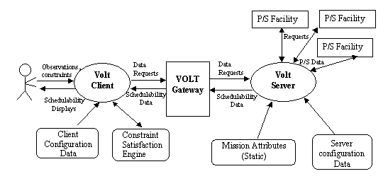
Figure 4.1 Client-Server architecture of VOLT

Architectural Components
From an architectural stand point, VOLT system is composed of a set of classes that are stereotyped into the following categories: (a) Boundary classes (b) Control classes, and (c) Entity Classes. Each of these categories are discussed below:
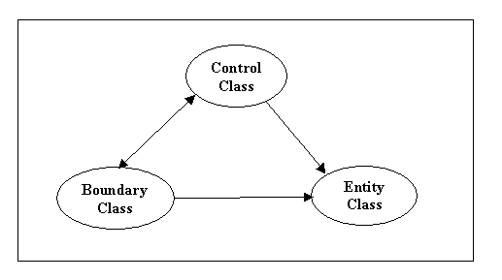
Figure 4.2 – Stereotyping of Analysis Model classes in VOLT
Boundary classes: These are the classes that model the interface between VOLT and its actors (the users and external systems, shown in Figure 1.1).
Control classes: These classes, together, encapsulate the control related to the system functions. Each VOLT use-case may be controlled by one or more of the control class members, and conversely, one control class may be used for more than one use case. The control classes depict the behavior of the system in terms of controlling the work flow, and determining the sequential steps in delivering a function.
Entity classes: These classes, in general, model the information used or manipulated by the VOLT system. Some of the information is transient, where as the rest is permanent or semi-permanent in nature.
While the Control classes and the Boundary classes interact with each other, and with the Entity classes, the Entity classes do not invoke upon the other two classes (except for a few service-oriented control classes such as a message logger).
The main classes belonging to each of these categories are discussed in sections 4.3 through 4.5.

Class Descriptions
The main classes in each of the three categories described in section 4.2, and their functions, are presented in the tables below:

Boundary Classes
Class | Description
ObservationSpecifi-cationPanel | Allows user to create an observation and specify all its attributes
CoordinationSpeci-ficationPanel | Allows user to represent the coordination of a set of observations by establishing the temporal constraints among them
Schedulability-DisplayPanel | Displays the schedulability of a set of coordinated or single observations. Allows the user to select schedulable intervals for one or more observations. Provides visualization aids such as zooming, panning, ranging.
VOLT Client-ServerGateway | Interface class between the VOLT client and server applications, allowing transfer of data from the server to the client side
PlanningFacility-Interface | Mediator class to establish interface and communicate with a planning facility for retrieval of schedulability related data
ConstraintEngine-Interface | Provides interface with the external Constraint Satisfaction Engine to obtain the solution(s) for the coordination problem
ProposalConverter | Interfaces with the ProposalParser to create a VOLT specific proposal from the parsed data held by the parser
VoltWrapper | Provides interface between the VOLT display and an external environment (SEA/APT) from which the VOLT application may be launched

Control Classes
Class | Description
VoltApplication | “Main” VOLT class, starts up and initializes the client application and presents the initial display screen to the user
DisplayManager | Creates and maintains all displays within a VOLT session
SessionManager | Manages a VOLT session, in terms of keeping track of the planned observations, and performs session save/restore operations
DataRequest-Handler | Responsible for starting up a chain of commands for the appropriate objects, for retrieval of schedulability data from a mission’s facility or related sources. Support both synchronous or asynchronous mode of data retrieval.
ProposalParser | Parses a proposal from a mission’s native format
MissionService-Manager | Performs mission related initialization functions, and manages retrieval of schedulability data from various facilities
Adapter | Perform data conversion from mission-specific format to VOLT format
VoltServer | VOLT Server application class, encapsulating the interface with various missions (back-end of VOLT) for schedulability data retrieval

Entity Classes
Class | Description
Mission | Encapsulates the characteristics and static attributes a mission from VOLT’s perspective.
Observation | Represents a single observation, with its unique ID, target, duration, etc.
Constraint | Represents a constraint (either a leaf or a node in a hierarchy) on an observation
ObservationGroup | A group of coordinated observations along with their temporal constraints
Proposal | A science proposal in VOLT-specific format, created from a native proposal
CoordinationModel | Encapsulates the “planning state” of the system, including all coordinated and non-coordinated observations and the defined constraints
Timeline | Represents a time variable parameter, related to the schedulability of an observation, as a function of time
Observation-Schedulability | The schedulability of an observation, based upon the mission and observation constraints, as a function of time (also referred to as Mission Timeline)
Schedulability-Model | Schedulability of an ObservationGroup, based upon each observation’s schedulability, temporal constraints among the observations, and selected start time of each observation
PresentationModel | One or more classes encapsulating information on zooming, panning, ranging visibility, and other display related features
SessionModel | Encapsulated the current state of the VOLT system; includes the Coordination Model and available schedulability information

Class Diagrams
<TBD>

Collaboration Diagrams
<TBD>

DESIGN MODEL
In this section, we describe the design of the VOLT System by defining the high level classes and interfaces, which demonstrate the three types of classes, namely, the control, boundary and entity classes discussed in the Analysis Model in Section 4. We also present diagrams depicting the “Flow of Events”, in further details than shown through Sequence Diagrams, by using these classes. This design model provides the “blue print” for VOLT system implementation - in accordance with the Unified Software development process methodology. (Ref 2).

Design Methodology
The language of implementation for the VOLT system being Java, the system design exploits the methodology adopted by Java packages such as Swing, and uses Java library classes as the base class for most of its user interface and visualization classes. Some of the Java-specific features reflected in the system design are:
- Generalization of classes through higher level abstract “interfaces”
- Use of Factory classes for transparent instantiation of a lower level class
- Separation of visual aspect from data aspect through related “View” and “Model” classes
- Propagation of changes to a model through Events and Event Listeners

User Interface Methodology
The VOLT system allows the user to interact with it in several different ways:
- To specify initial data such as creation of observations, specification of constraints, etc.
- To view the schedulability and related data that VOLT retrieves and presents to the user, and to manipulate certain presentation objects to explore various scenarios
- To request for services such as saving preferences, generating scenario templates, etc.
The last category of interactions are provided using standard GUI techniques such as Dialog Boxes, Wizards well as frames and windows for more complex input. The other two categories of user interaction are more complex and focus upon the VOLT Presentation Methodology, described below.

Presentation Methodology
VOLT system design uses Views and Models for presentation of information to the user. A high level description of some VOLT-specific base classes related to such presentation, along with their inter-relationships, is shown in Figure 5-1.

VoltView and CompositeView
A VoltView is an abstract class, derived from Swing JPanel, which is used as the base class that provides visual representation or “view” of data within VOLT. A CompositeView is a container view, comprised of a set of lower level views as its children. Example of its concrete derived classes are: SchedulabilityView showing schedulability information for an observation.

Embeddable
Embeddable objects represent GUI components which may be embedded in a parent component. Additionally, embeddable objects have controls, either menus or actions, and status display areas, called status bars, that they can pass up to their parent components.

Display
This is an abstract class, which extends the class CompositeView and implements the Embeddable interface. Therefore, it can provide a high level object which may be displayed on the screen as a unit for receiving user input and presenting visual information to implement a high level functionality of the system. (Such a unit is referred to as “display” within VOLT.)
Note that the actual menu items, action functions etc. associated with a Display are specific to each the concrete subclass of Display. Similarly, the actual set of models that contain the information being displayed belong to these concrete classes.

DisplayFrame
This class represents a top level window in VOLT with a title and a border, and may be manipulated by the user. It is derived from Java/Swing JFrame, and can be initialized from a resource file in the system. It contains a Display object, and incorporates the Display’s menu items, actions and status bar into self.

VoltModel
VoltModel provides an interface for encapsulating the information used by the system. There are two categories of interfaces that extend a VoltModel interface:
- Interfaces providing a “data model”; such as SchedulabilityModel. A SchedulabilityModel object represents schedulability information for a set of observations. A VoltModel object may contain lower level components to represent smaller units of data.
- Interfaces providing a “presentation model” for the view, such as the Range model. A Range model is a “Java Swing” type of model for visually representing certain information, such as Time Interval, as a range.
A VoltModel object may be shared by more than one VoltView, and a VoltView may use several VoltModel objects to provide visualization of complex information.
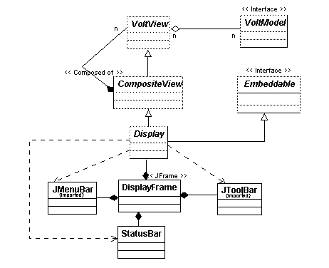
Figure 5.2-1 Structure of Generic Presentation Related Classes in VOLT

VOLT Application structure
Since the VOLT system is deployed as a Client-Server system (see Section 4.2), there are two application level classes in the system - the VOLT Client and the VOLT Server. The following subsections describe the design of these two applications as well as the interfaces between them.

VOLT Client Application
The Client application, called VoltApp, embodies most of the VOLT functionalities, except for the actual retrieval of the schedulability data from a mission’s planning scheduling facility through remote communication. It is also designed so as not to access any mission-specific information statically at its initialization time. This provides a flexible architecture to support new missions dynamically without changes to the client’s code and/or database.
Each user of VOLT system starts up and interacts with a single instance of VoltApp through action menus, action buttons, as well as through direct manipulation of visual objects. The application allows for functions such as saving/restoring of user preferences, saving/restoring of observation data, message logging, and context sensitive help, in addition to the basic planning of coordinated observations.
As mentioned in Section 3.1.1.5, VoltApp may be invoked from other planning environments, which allow such integration. Section 5.4.2.12 describes the VOLT classes needed to enable such integration with the SEA system. The interface with APT and other systems will be addressed in future.

VOLT Server Application
A VOLT Server application runs on a node which may be the same physical node or a different one from the client, but in the context of “remote” server. The server is designed to also run in a “local mode”, as explained in Section 5.4.1.3.
The server performs the following functions:
- Initializes of the VOLT system by accessing the VOLT-specific information for all supported missions, and providing it to the client. This helps the client and the server to be synchronized with respect to mission characteristics and interfaces during any session.
- Interprets the client request for required schedulability data, establishes communication with the each mission’s scheduling facility, and retrieves the data.
- Preprocesses the retrieved data as necessary, performing normalization of raw data, and caches the data. Then provides the data to the client over the designated interface.
- Downloads new mission specific classes (such as a “native proposal” parser for a newly supported mission) to the client side upon request from the client (To be implemented)

Client and Server Communication Methodology
VOLT Client and Server applications communicate with each other using the Java Remote Communication Methodology (RMI). The details of the communication are abstracted through a Gateway class, described in section 5.4.1.4.
For performance reason, the two processes may collapse together to a single application, without sacrificing the modularity of data retrieval from remote mission facilities. This is referred to as the “local” mode of operation. A GatewayFactory class is used within VOLT to create the Gateway object in accordance with the “remote” or “local” mode of operation.

Design of High level VOLT Classes
An overview of the structure and functions of high level VOLT classes, useful in understanding the overall system design and workflow, is presented in the rest of this section. For convenience and ease of understanding, the classes are grouped according to the functions they form, either individually or in collaboration. The sequence diagrams provided in section 5.5 show the actual end-to-end flow of control among these classes in achieving the use cases presented in Section 2.

Core Control Classes
There are a set of core classes within VOLT which are responsible for the flow of control in the system with respect to specific user actions. Included in this set are a set of “Manager” classes that instantiate, maintain and/or control lower level objects, including views, models and other entities during a session. There is a single instance of each of these managers in the system, instantiated statically at system initialization time. Some of the important Manager classes are described below.

VoltApp
This is the VOLT Client application main class, and responsible for VOLT system initialization. Its structure is shown in Figure 5-4-1.
VoltApp performs the following functions:
- Retrieves information from the VOLT server on supported missions in the form of a set of Mission objects, and initializes the singleton MissionManager with those objects.
- Instantiates the single instance of the DisplayManager object.
- Retrieves the single instance of VoltPanel (from the display manager), and in stand-alone mode, places it within a VoltFrame with VOLT-specific menus and action buttons to allow user interaction. VoltPanel and VoltFrame classes are described below.

VoltPanel and VoltFrame
A VoltPanel object is the main (or default) display panel of VOLT, which is displayed on the screen when the system in initialized. VoltPanel extends the Swing JPanel class and implements the Embeddable interface. In a stand-alone mode, it is embedded inside a VoltFrame object (an extension to the Swing JFrame), which acts as the main top level VOLT window. After a Display object is created, it is embedded inside the VoltPanel by default. Thus, if the system has a group Display objects, only one of which may be visible at any instance inside a VoltPanel. However, the caller has the option to place a Display inside a DisplayFame and make it independently visible.
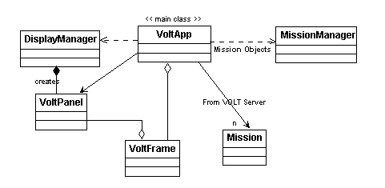
Figure 5.4-1 VoltApp Class Diagram

Manager Classes

DisplayManager
The singleton DisplayManager object creates and maintains the list of all Displays within the system at a given time. In creating a Display, the DisplayManager also creates the Models that are required by each Display and passes them to the new Display object. The DisplayManager maintains a reference to the currently active display on the screen. Thus, this object acts as the repository for all instantiated displays and models in the system.
In initialization time, the DisplayManager creates the single copy of the VoltPanel, which may be referenced by other objects (such as VoltApp) in creating high level display related objects.

SessionManager
The SessionManager is a singleton class instantiated at the start of the VOLT application. It is responsible for maintaining the information related to all observations known to the system and their current status in terms of coordination and schedulability assessment. To do so, SessionManager creates an instance of the ObservationModel (see Section 5.4.2.3) , which is used by all relevant VOLT objects to know the state of any observation and constraints known to the system.
SessionManager provides the additional ability to write the current system state (that is, the ObservationModel and the schedulability data) to a data file, and (re) initializing the system from a saved session file. When a session is thus restored, the SessionManager sends an appropriate event to all the listener objects interested in knowing this change.

Target Manager
The TargetManager is a singleton class that manages all of the known observation targets used in VOLT. The manager provides a single source that other classes can use to obtain all of VOLT’s target information. It also provides other classes with a capability that they can register as listeners with the TargetManager to be notified when any targeting information in VOLT changes. Finally, the TargetManager provides an automatic persistence capability so the targets list can be maintained between VOLT sessions.
Note that the target list may be modified by the user interactively, and new targets may be added to the system from a TargetEditorDialog box.

ProposalManager
ProposalManager is a singleton class which implements the import of native proposals into the system and maintains a list of the corresponding “Proposal” object in VOLT-specific form. It adds the observations in the proposal, along with their temporal constraints, into the system – for visualization and manipulation – similar to that performed on observations created by the user interactively.

Volt Server Classes
High level classes used by the VOLT server application are described below. Their association is shown in Figure 5.4-2. Note that all the server classes, except the MissionDataServer, may also be instantiated and run from the VOLT Client when the system runs in a single application, or local mode. Only in the remote mode, the objects run in the context of a remote server process. However, The mode of operation is mostly transparent to these objects.
MissionDataServer is the main class for the VOLT Server application, and thus executes only in the context of a remote server. In the remote context, it starts up as a separate process, registers as a Remote process, instantiates a RemoteGateway (an implementation of the Gateway interface), and a MissionServiceManager object, and communicates with the client through the these objects.
Class MissionServiceManager is responsible for retrieving information related to observations and their schedulability from individual observatories and other facilities. A MissionServiceManager object instantiates and maintains a list of MessionMediator objects based upon the information provided in the static VOLT database files. Each one of these objects interface with a unique mission supported by the VOLT system,
The MissionMediator class is responsible for knowing all of the services related to a specific mission and mapping those services to specific adapters. At initialization time, it instantiates the corresponding Mission object from externally defined data (resource files). When a MissionMediator receives service information requests (such as a Schedulability Timeline), it forwards those requests to the appropriate adapters.
An Adapter is an interface which provides the API for all classes that are responsible for retrieving a service’s schedulability information from a non-VOLT facility, or any other designated source. Classes of this type are expected to convert any retrieved schedulability (or other required) information to the VOLT specific format before passing that information further into the VOLT application.
There are several generic implementations of the Adapter interface in VOLT (not shown in the diagram), such as:
- CgiAdapter : can be used by any service that is interested in retrieving schedulability information from web tool through a CGI interface.
- FileAdapter: can be used by any service that is interested in retrieving schedulability information that has been saved to a file.
- JspikeAdapter : can be used to obtain schedulability information for any service that needs to obtain its information from a Spike server. It communicates through RMI to a remote JspikeServer whose task it is to do the actual communication to Spike.
- GenericSimulatorAdapter: can be used to generate simulated, semi-realistic schedulability data for a mission service.
Class Mission is used by both the server and the client side classes of VOLT. However, it is never instantiated from the client side. (The MissionMediator of each supported mission creates the corresponding Mission object and passes it up to other objects who require it.) A Mission object contains a collection of Service objects, each representing a single schedulability related service parameter of the observatory.
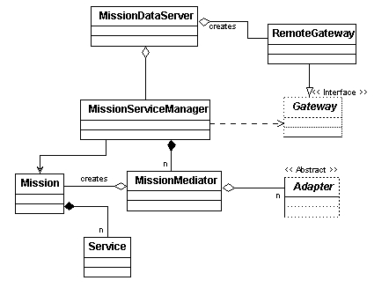
Figure 5.4-2 MissionDataServer Association Diagram

Gateway Classes
All communication and data/object transfer between the Volt client and server modules are carried out by an object implementing a “Gateway” interface. There are two implementations of this interface which are used by the MissionServiceManager for two different operational modes:
1) RemoteGateway: used when MissionServiceManager is running remotely from VoltApp (It implements a Java UnicastRemoteObject interface for RMI invocation.)
2) LocalGateway: used when MissionServiceManager is running locally within VoltApp.
The Gateway interface provides a method to query if the implementation is a remote or local.
The GatewayFactory class is used within the Volt client application to create either the remote or the local gateway object depending upon the mode of operation. (The Server application always uses the Remote gateway.) The functions performed by the Factory class in each mode is as follows:
In Remote mode
- Retrieve the name of the VOLT Server application and the corresponding RMI port number, using the following precedence hierarchy: (a) User preference at runtime (b) Command line option (c) Specification in the VOLT General Preference file
- Perform a naming lookup for the VOLT Server running remotely and retrieves the corresponding Remote object (the stub of RemoteGateway); return it to the caller as the Gateway interface.
In the local mode, the following sub-modes are possible
Online (Normal) Mode
- Creates and initializes the MissionServiceManager object to run locally in the client
- Create the LocalGateway object, with reference to the created MissionServiceManager Return the LocalGateway object to the caller as a Gateway interface
Offline mode
- Perform the same function as above, but set the MissionServiceManager to act in offline mode, which implies it should retrieve data from saved files rather than from the external facilities.
Other local mode operations (such as simulation mode) are also supported to handle testing.
Note that any non-remote object that is passed through the Gateway interface must be “Serializable.”

Boundary and Entity Classes
As mentioned in Section 4, the Boundary and Entity classes, along with the Control classes, provide the required functionalities of the VOLT system. The following subsections describe the design and function of these classes by grouping them according to their overall use in the system. A group may includes both boundary (e.g. user interface) as well as entity (e.g. Presentation, Model and Data) classes:

Event Classes
Changes to VOLT System state, either through user interaction, or due to change to relevant information, are propagated within the system using the standard Java Event passing mechanism.
Any class which is interested in receiving a particular event implements (or uses an implementation of) the corresponding Listener class and registers the listener object with the generator(s) of the event When the generator object fires the specific event, it delivers the event to each registered receiver through the listener’s interface method.
Each VOLT Event class extends the Java java.util.EventObject class. Important system events, their purpose and producers are shown in Table 5.1.

Table 5.1 Use of Events in the VOLT System

Event Type | Purpose | Event Generator
ObservationModelEvent | Notifies change of state of the ObservationModel due to addition, removal or modification to observations or associated constraints | Implementer of ObservationModel interface
ObservationViewEvent | Notifies selection/deselection of an observation or constraint that is visualized in the view by the VOLT user | Implementer of SelectedObservationModel interface
SchedulabilityModelEvent | TBD
SelectionEvent | An Event that is fired when an element of a view is selected/deselected | Implementer of SelectionModel interface
SchedulingSolutionEvent | Specifies that a task to calculate a schedulability solution has  finished | Implementer of SolutionModel  interface
SuggestionEvent | Indicates that the request for “next suggestion” for constraint relaxation for a coordination group was fulfilled. | SuggestorModel
ProgressEvent | Indicates the progress of some asynchronous task, such that the retrieval of schedulability data from a mission facility

Observation Related Classes
An observation, the basic “planning” unit in the Volt system, is represented by the class Observation, which, for generality, implements an interface called Activity. The basic attributes of an observation are its unique ID (within the VOLT system), its mission, target and duration and a scheduling interval. Constraints may be placed on an observation to restrict its schedulability.
The user may change the attributes of an observation, including its target. An Observation object maintains a PropertyChangeListener list to notify interested objects when any of its attribute objects are changed during a VOLT session.

Observation Coordination Related Classes
A group of coordinated observations, within VOLT, implies a set of observations (for the same or different missions) that are related to each other through a set of temporal constraints. This group is represented by an object of the class CoordinationGroup, which forms the basis of coordinated planning activities within VOLT. The components of this object are dynamic in nature - in the sense that observations may be added to or removed from the observation set, or their constraints may be modified by the user during a VOLT session
Constraints, within VOLT, are represented by the interface Constraint. Its two high level derivations are: LeafConstraint and NodeConstraint. A NodeConstraint represents a node in a binary tree, whose two branches may be either Leaf Constraints or other Node Constraints, which are linked by certain logical relationship. A logical relationship refers to boolean operations such as AND and OR.
LeafConstraint represents a leaf node in the constraint hierarchy.TemporalConstraints are implementations of the class LeafConstraint.
The structure of CoordinationGroup related classes are shown in Figure 5.4-3.

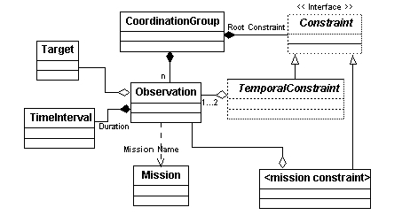
Figure 5.4-3 Observation and Coordination Related Classes
Class DefaultObservationModel implements the interface ObservationModel. It models the known observations, the constraints, and the state of coordination of all observations within a VOLT session. There is a single instance of this class used within the VOLT system. As the list of observations within the system and their relationships change dynamically, this object computes and returns a the list of CoordinationGroup objects at any instant, when invoked by the caller. Note that DefaultObservationModel can return the list of all stand-alone (non-coordinated) observations in the system as well.

Timeline related Classes
A Timeline is an interface, whose implementation is provided by the concrete class StateTimeline. A StateTimeline consists of a set of non-overlapping TimeIntervals, each one covering a time range along the time axis over which the value of a measured quantity, called the “quality-of-fit” is non-zero. A TimeInterval is a composite class, consisting of a set of contiguous subintervals of the same type, with their own quality of fit. A Timeline has an associated identifier to indicate its data type.
A higher level timeline may be computed from a set of lower level timelines (without retaining explicit knowledge of the lower level timelines) as follows:
Over an interval, where any of the lower level timelines has a value of zero, the higher level is assigned the value zero. At all other points, its value is the “average” of the value of the component timelines at those points.
A CompoundTimeline is an extension to the Timeline interface, which retains reference to the lower level timelines from which it is derived, but the algorithm for building the compound time intervals is external to this class. (Data related to certain schedulability parameters may be retrieved by the VOLT server as one or more non-normalized data timelines, which are then processes by the server to create an appropriate CompoundTimeline object.)
The details of Timeline and its associated classes presented in figure 5.4-4.
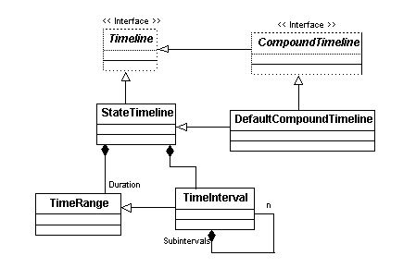
Figure 5.4-4 Timeline Class Structure
The schedulability of an observation is represented by a Timeline object, called the “mission timeline”, which shows the probability of scheduling of the entity against time, within the scheduling time period. The scheduling probability is a normalized quantity with a value between zero to one.
The mission timeline of an observation is computed by VOLT from a set of lower level timelines specific to operational constraints of each mission, termed as schedulability parameters. (Examples: Target Visibility, Roll Angle).

Schedulability related Classes
These classes work in concert to help user explore the possible solutions to a the scheduling of a set of coordinated observations, and to retain the selection of one or more solutions. The highest level class in this group is the SchedulabilityDisplayModel, which contains a number of lower level submodels, described below.
An ObservationSchedulabilityModel object computes the mission timeline of a set of observations (in a coordination Group) from the lower level timelines corresponding to the mission’s schedulability parameters (or services).VOLT also supports a “user defined timeline” concept, in which additional timelines, created from user provided data, may be added to schedulability service timelines in producing a mission. ObservationSchedulabilityModel creates and maintains a SchedulabilityHierarchyModel object representing a hierarchical tree, whose nodes correspond to individual timelines in the schedulability hierarchy of each observation. The mapping between each of these node and the corresponding Timeline is maintained through a Hashmap.
A SelectionModel object is responsible for managing information on the selected of time intervals for one or more observations in a set. It supports only single selection of time intervals for any observation. (Although a selected interval must be within an observation’s mission timeline, this fact is transpent to the SelectionModel.) When the selection interval for an observation is changed by the user, the event is notified to its listeners.
A SolutionModel object provides solutions on the placement of a set of observations on their mission timelines, based upon the temporal constraints binding the observations. It interfaces with a Constraint evaluation engine to determine the possible solutions. As the user changes selections on one or more timelines, the model re-initializes the ConstraintEvaluator for computation of new solutions.
In addition, an implementation of the SchedulabilityDisplayModel interface contains objects such as RangeModel and VisibilityModel to model the time period for display, and the visibility of various timelines respectively on the Schedulability display screen.
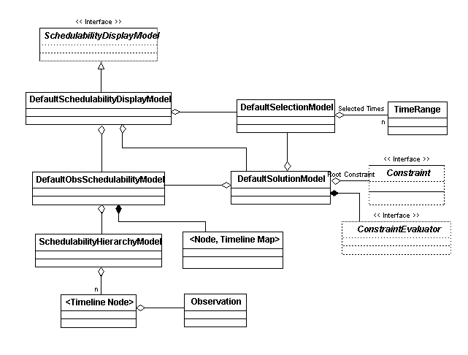
Figure 5.4-5 SchedulabilityModel and Related Classes

Observation Specification Classes
There are a number of Presentation type classes used by VOLT to help user in creating observations and specifying their constraints, for the purpose of exploring their Schedulability. The structure of and functions of the high level classes in this category are mentioned below. A schematic diagram of these classes is presented in figure 5.4-6.
ObservationSetupFrame is responsible for receiving all user input needed for coordination planning of a set of observations, including the creation of the objects, specification of targets, and placement of temporal constraints on observations. It interfaces with the Constraint Evaluator to help user place valid constraints between observations.
ObservationSetupFrame contains two modal dialog boxes, namely the ObservationDetailsDialog and the CoordinationDetailsDialog, which may be used by the user to specify attributes and coordination details of the observations respectively.
Another modal dialog, called the TagetEditorDialog, is used to provide detailed attributes (e.g. RA, Dec) of each target known to the VOLT system as obtained from the TargetManager. It may also be used by a user to edit the current target list by adding, deleting or modifying an existing target. New targets are searched for and retrieved from a list of known Target databases external to the Volt system, such as NED and SIMBAD. Any such change is then intimated to the TargetManager and propagated to other objects who must be interested in such changes.
(Note: The actual search for a new target from external target databases is performed by the clients of these databases, which are reuse classes from the SEA package. )
ObservationSetupFrame provides a visual representation of the observations and their coordination on the display through a component object called the ObservationVisualizationPanel, and maintains information on all displayed observations through an ObservationModel object, a single instant of which is maintained by the Volt System during any session.
ObservationVizualizationPanel is extended from Swing JPanel, and implements an Embeddable interface. It contains a number of lower level VoltView objects (such as ObservationView, RangeView, etc.) for visualization of different aspects of an observation coordination model. It also uses an object of class CoordinationTableModel for a tabular representation of coordination groups.
ObservationVizualizationPanel uses the VOLT Constraint Evaluator to provide a default layout of for placement of a group of observations within their scheduling interval period that does not violate the temporal constraint between these observations, and prevents the observations for the same facility to overlap on each other. The layouts are recalculated and redrawn on the display as the user modifies the coordination and temporal relations.

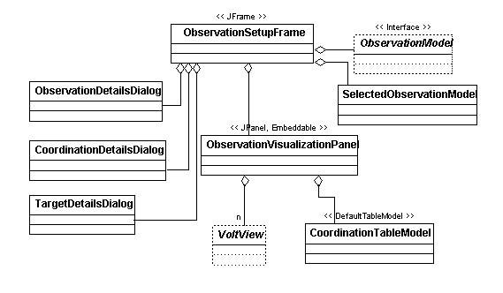
Figure 5.4-6 ObservationSetupFrame Class Structure

Schedulability Display related classes
SchedulabilityDisplay, an extension of the class Display, is used for the visual presentation of the schedulability of a set of coordinated (or a single non-coordinated) observations in VOLT. It also allows the user to explore and decide where they want to place the individual observations to maximize the schedulability in compliance with the associated constraints. At any instance in a VOLT session, there may be several SchedulabilityDisplay objects in the system, only one of which would be active and receiving user input.
SchedulabilityDisplay, as a CompositeView object, contains a number of subviews. The main ones, namely, SchedulabilityView, Overview and SchedulabilityTreeView are described below. In addition it contains other view objects such as ZoomView, ScrollView, AxisView etc. to help in the visualization of the presented information at user’s choice. A SchedulabilityDisplay object is associated with a SchedulabilityDisplayModel (see section 5.4.2.5) to obtain all the required information that needs to be presented ion the screen.
SchedulabilityView is the main component within the SchedulabilityDisplay presentation, and is a derived class of VoltView. It shows the schedulability of single observation or a single set of coordinated observations – by rendering a visual display of the timelines in the schedulability hierarchy of an observation in the corresponding ObservationSchedulabilityModel. If a node in the schedulability hierarchy is collapsed visually, the corresponding timelines are made invisible on the screen.
SchedulabilityView displays the timelines of an observation as objects of class DrawableTimeline, and the mission timeline as a SelectableTimeline such that the user may select any schedulable interval there as the intended start time of that observation. After the user makes such selections, and requests for a solution, SchedulabilityView retrieves the solution and displays it on the screen. SchedulabilityView implements a number of EventListener interfaces so as to be notified of any changes to the schedulability, schedule selection or solution for the set of observations.
A SchedulabilityTreeView object allows the user to expand or collapse the visibility of the schedulability tree nodes at any nodal point. This information is used by the SchedulabilityView object to display or hide the corresponding timelines.
An OverView object within SchedulabilityDisplay uses the associated SchedulabilityDisplayModel to provide an overview of the schedulability of the observation set in terms of the mission timelines, selected intervals and solution intervals.
A class named TabledDisplay, an extension of class Display, and uses a table to control the display of a list of Display objects. There is a single instance of the TabledDisplay object in the system. It is created and maintained by the DisplayManager and encloses the SchedulabilityDisplay corresponding to the user selected observation set. Its table is modeled by the class SchedulabilityDisplayTableModel for a tabular display of the coordination groups in the system, from which the user may select any entry to see its schedulability. (If the user makes a new selection, its schedulability information is fetched by the system and presented to the user through a new instance of the SchedulabilityDisplay class.)

The structure and association of the Schedulability related classes is shown in figure 5.2-7.
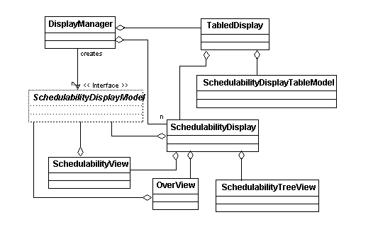
Figure 5.2-8 Schedulability Display related classes

Constraint Evaluation and Modification Suggestion Classes
Determining the basic schedulability of a set of coordinated observations is treated as a constraint satisfaction problem in VOLT, which is solved by a search engine in a non-deterministic manner. When no solution is feasible to the coordination problem with the original constraints, VOLT can explore the possibilities of obtaining a solution by modifying the constraints in a deterministic way. The classes participating in such operations are shown in figure 5.4-8, and are described below:
The ConstraintEvaluator interface allows the VOLT inner classes to interact with an external search engine (such as the Java-based JSolver, a COTS product) through a set of API calls. It is responsible for initializing the search engine with the observation mission timelines, and the root constraint for the set of observations. As selected time intervals on the mission timelines are changed by the user, the search engine adjusts the initial conditions for the problem and searches for a set of new solutions. VOLT may specify different heuristics to be used by the search engine to obtain a solution. A ConstraintEvaluator object caches the next and previous solutions for a problem, and returns it to a caller. It also supports search “time outs” if the underlying search engine handles such operations.
Note that if the mission timeline of any observation changes during exploration, the problem is regarded as a new one, and the search engine is re-initialized with the new timelines.
SuggestorModel is a high level class responsible for providing suggestions on how the constraints (that are allowed to be modified) might be modified, either singly or in combination, to yield a solution to the coordinated observation set.
The interface Modifier indicates how a LeafConstraint may be modified by the system, and its implementation classes provide the actual algorithm for receiving different types of constraints and returning a new constraint of the same type with the required modifications. The ModifierManager is a singleton VOLT manager object which instantiates various types of constraint modifiers supported by VOLT, from a resource file.
The SuggestorModel uses a lower level class object, named ModificationSuggestor perform the real action related to providing the next suggestion. This object maintains the list of Modifiers and iterates through them, in a specific order, to yield the modified constraints. It then applies these constraints to a cloned copy of the observation set (without modifying the original ones) , and uses a SolutionModel object to find a solution by interfacing with the ConstraintEvaluator, similar to that done for obtaining a normal solution (see section 5.4.2.5).
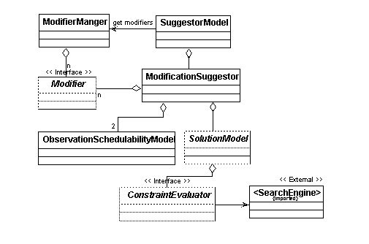
Figure 5.4-8 Constraint Modification Related classes
When the user wants to “apply” a suggested solution to the problem, SuggestorModel updates the ObservationModel by incorporating the suggested changes to the model. This results in a generation of ObservationModelEvent, which is notified to all listeners.

Proposal related classes
A Proposal object represents the attributes of a native proposal, which are of interest to the VOLT system. It maintains the header fields of the proposal, the target names, observation data, and the set of temporal constraints that bind the observations within the proposal. The Proposal class, because of its structural similarity to a set of coordinated observation, is designed as a derived class of CoordinationGroup, where the set of observations all are for the same mission.
The ProposalConvterter is an interface which allows the conversion of native text proposals, in various mission specific formats, to be converted into a Proposal object. A number of concrete classes implement this interface. Each of these concrete classes is responsible for performing conversion from a specific native proposal format (such as RPS2ProposalConverter for HST and FuseProposalConverter for FUSE)
A ProposalParser is responsible for the parsing of a proposal. This is an interface, whose implementations perform the actual parsing of the text file, based upon the mission-specific keywords. The ProposalParser interface provides methods such that the ProposalConverter may retrieve all pertinent information from the parser to build the Proposal object in memory.
The ProposalParser implementation class performs the actual parsing by defining the “definitive” grammar for the proposal, using the keywords. This grammar is dependent upon the parsing engine to be used by the VOLT system. Presently, the JavaCC compiler is used as the parse engine.
The structure and association of Proposal related VOLT classes are shown below. Note the class name <Native ProposalParser> indicates a generic name for each concrete implementation of the ProposalConverter.
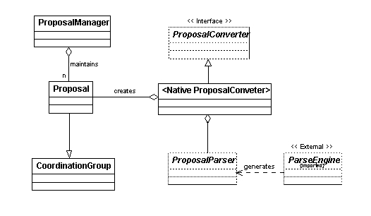
Figure 5.4-9 Classes associated with Proposal Import

Session Save/Restore related classes
The singleton SessionManager object is responsible for managing the save and restore operations of a VOLT session at any instant. It creates an object of class SessionModel which contains a reference to the system’s single instance of the ObservationModel, the Timeline objects associated with each observation, and the selected start time of each observation, if available. In saving the session, the SessionModel object is serialized and written to the disk. On restore, the reverse operation is performed, and the ObservationModel is recreated, overriding the current instant within the system.
The SessionManager then fires a “SessionChanged” event for the listener classes, and waits until all interested object complete their restore operation.

Timeline Request Handling classes
<TBD>

Interfaces classes for running VOLT within other Planning Systems
The design of VOLT system provides flexibility such that it can be run in a stand-alone mode, or may be launched from another planning tool in an integrated manner. This requires that VOLT display screens can displayed in a standalone mode or can be embedded within another framework in a configurable manner. The VOLT specific classes used for this purpose are described below:
- VoltWrapper - This is a simple interface for the implementation of all framework-specific wrapper classes for activating the VOLT application and/or displaying the VOLT screen. The known implementation classes of VoltWrapper, specific to each external framework, are:
SEAWrapper – For interfacing with SEA
APTWrapper - For interface with APT (for future)
VoltFrame - For stand-alone invocation
Each of these classes may use other classes or properties for their interfacing framework.
- SEAWrapper - This is a derived class of SEA’s Module class which implements the ModuleContext interface.
- APTWrapper – This class is a future implementation of the Wrapper class that would help interface VOLT with APT.
- VoltFrame - This class provides the connection to the VOLT framework, which is used when VOLT runs in a stand-alone mode. This is a derived class of SEA’s ResourcedFrame class, and implements JFrame.

Sequence Diagrams (Work Flow Diagram)

Observation Specification
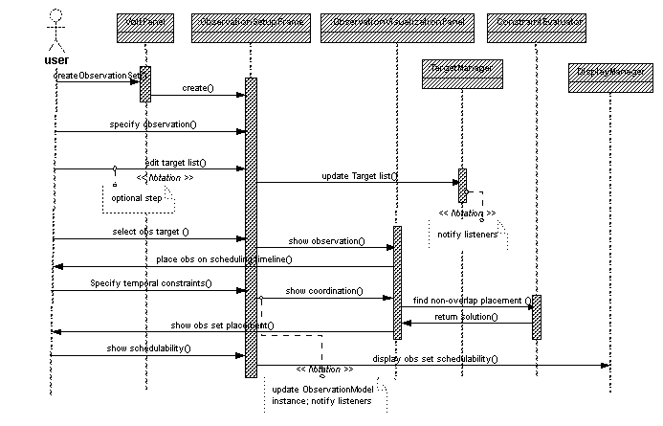

Retrieval of data from remote facilities

Schedulability Determination and Display
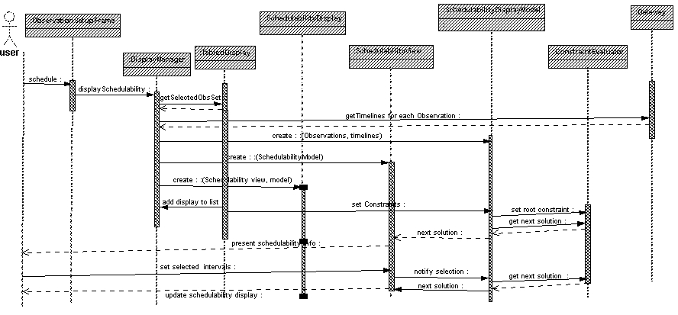

Constraint Modification

VOLT System Implementation
This chapter addresses the implementation of the VOLT system in terms of a set of “conceptual” subsystems, and the physical “packages.” Actual implementation classes, belonging to each package is provided n Appendix <TBD>.

VOLT Subsystems
A Subsystem is a “semantically useful grouping” of classes that provide closely related functionalities, and together perform services that can be identified through a set of interfaces. This allows the system to be viewed in terms of the functions it provides, and helps in the actual packaging of classes during implementation.
The VOLT system, is grouped into the following “conceptual” subsystems, and implementation packages.
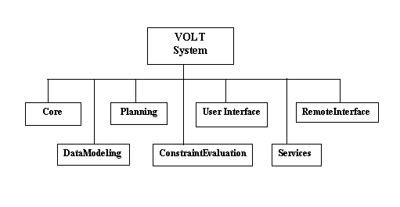
Figure 6.1-1 VOLT Subsystems

VOLT Packages
Subsystem | Package | Description
Core | volt | Highest level package containing top level classes, most of which are singleton classes with system-wide visibility. These classes provide managerial, and other application-level functions
 | event | Describes different types of events that depict the possible changes to the VOLT system through user interaction, I/O completion, or any other action that the system is aware of. Also defines the listener classes for these events.
Planning | mission | Consists of a set of classes defining the characteristics and attributes of missions supported by VOLT.
 | planning | Consists of classes that define Observations, Schedulability, Proposals, and other elements specific to VOLT supported observation planning.
 | constraint | Defines various types of constraints, and temporal relationships that may be associated with coordinated observations. Also define the interface classes that provide the bridge between the VOLT application and any constraint engine used by the system.  - Constraint modification suggestions, etc.
User Interface | gui | Consists of the user interface classes which provide the means by which a user may interact with the VOLT system. Also include higher level classes to provide VOLT-specific look and feel of each screen.
Remote Interface | gateway | Consists of all interfaces that the VOLT client and server use to communicate to each other with.
 | gwclient | Consists of all client side classes involved in communicating with the VOLT server.
 | gwserver | Consists of the set of classes and interfaces that define the communication between the VOLT system and the external observatories with which VOLT system interfaces to retrieve required observation schedulability information, as well as to convert the retrieved data to VOLT-specific internal formats
 | jspike | Provides the interfaces and classes specific to communication and schedulability data retrieval with a facility supporting the SPIKE scheduler.
Service | report | Contains classes that may generate reports on planned observations within the system. Also includes lower level formatting classes.
Data Modeling | Vis | Contains a large number of classes providing the visualization of various planning components, such as Coordinated observations, Schedulability timelines, and planned activities within time ranges. Also includes various models that feed required data to these visualization classes.

Volt Configuration Files
The VOLT system in initialialized from a number of XML formatted files, termed as Resource files, defining various system parameters, showing the characteristics and attributes of supported missions, general and specific user preferences, etc. Some of these files are used by the VOLT server application and the rest by the client. The name and function of the higher level files in this category (which may themselves reference lower level ones) are listed below:
<< TBD: Resource File names and contents >>

VOLT System Deployment
<< TBD: Running the server and the client in different modes, etc.>>

Appendix A - Reuse of SEA Classes Within VOLT
A number of Service type of classes from SEA are used within VOLT to facilitate software reuse. The name, description and usage of those classes are provided below:

A.1 SEA MessageLogger
VOLT system uses the GOV.nasa.gsfc.sea.MessageLogger class for logging. This class is a singleton object that can be used to manage logging. MessageLogger allows messages to be sent with a type tag indicating the severity of the message. Messages can be automatically logged to a file and/or sent to stdout. In addition, the types of messages generated can be filtered on a per-object basis by the implementation of the MessageSource interface, or globally via setGlobalMessageLogTypes(). There are five built in message types. These are ERROR, INFO, DEBUG, VERBOSE_INFO, and WARNING. You can also add your own types.
GOV.nasa.gsfc.sea.SeaLogConsole will also be used by VOLT. This class is a simple window that supports display and filtering of log messages. If the need arises, we may decide to extend the functionality of this class.

A.2 HelpManager
VOLT uses GOV.nasa.gsfc.sea.HelpManager to support help. This class is a singleton Object that is built on top of JavaHelp and provides easy access to JavaHelp features. Both regular help and context-sensitive help are supported. The HelpManager simplifies the process of adding help from a programmatic standpoint but doesn’t change the process of creating help. A helpset file and other associated files will still need to be created.
Here are the steps for enabling context-sensitive help:
- Use createCSHButton() and/or createCSHMenuItem() to create components that enable the context-sensitive help feature. Add these components to a window.
- Register help topics for all your components. Use registerHelpTopic() to do this.
- Write the help. Each help topic must exist in the map file of the specified help set. Each entry points to an HTML file or portion of an HTML file (remember, '#' anchors are supported).
- It's also a good idea to use enableWindowHelp() to assign a help topic to each window. This enables the Help key on the window, but also serves as a suitable default help topic should the user ask for context-sensitive help on a component that is not registered.

A.3 SplashScreen
VOLT uses GOV.nasa.gsfc.util.gui.SplashScreen as a splash screen during application start up. SplashScreen is a reusable GUI component that displays an image and a status message while the application is loading. It also has the ability to automatically display the MessageLogger messages.
Steps for using the SplashScreen:
- Create the SplashScreen as follows: SplashScreen splash = new SplashScreen(“myimage.gif”); This is normally done on the first line in your main routine.
- If you want the SplashScreen to display the log messages, call monitorMessageLog().
- Close the SplashScreen using the close() method. This is normally done on the last line in your main routine.

A.4 PreferenceManager
VOLT uses GOV.nasa.gsfc.sea.util.PreferenceManager to support user preferences. PreferenceManager is a singleton Object that manages all preferences and provides a framework that supports GUI editing capabilities. All the backend work is handled automatically. All that needs to be done is to extend BasePreferencesPanel which requires implementation one method, buildPanel(). Each Preference panel that is created should be specified in the top-level preferences file. Preferences are stored in XML files that have a specific structure but do not have a DTD associated with them. Basically, a top-level file is created which points to one or more specific files.
Preferences are built on top of Resources and the PreferenceManager uses the ResourceReader and ResourceWriter to do its work. These two classes will be used by VOLT for properties that are not user configurable at runtime. The standard Java properties mechanism was considered but resources proved to be more flexible.

