WFPC2 Acceptance Testing
Ron Downes
September 11, 2006

Summary
A detailed acceptance test for the WFPC2 has been performed. A regression test shows that BOT is giving the correct answers. The new features (exposure expansion, pointing adjustments, actual duration usage, and visualization) are all functioning properly, and for the most part, BOT can handle error conditions gracefully and provides meaningful feedback to the users.

There is one aperture (F160AN15) that should not be processed by BOT (it is unsupported) but are, and there is one configuration (use of polarizers) that, while supported, should be unsupported in BOT; both of these have PRs filed.

Three issues with the Aladin display have been found – a slight misalignment of the BOT overlay with the DSS image, a failure to display all sub-exposures, and a broken link in the Aladin spreadsheet; all of these are known issues with PRs previously filed.

The unsupported mode (use of polarizers) issue, as well as the failure to display all sub-exposures, should be corrected prior to the release of the tool for WFPC2 usage.

Introduction
For this test, the following target and exposure was used:

Target: FY Com – 12h 49m 4.6s, +27º 27’ 57.11”

Exposure: WFPC2, IMAGE, F555W, WF2, 700s, CR-SPLIT=NO, GAIN=7

When appropriate, modifications to the exposure (e.g. POS TARG) are detailed below.

This target/exposure was used to perform the following:

Test | Definition
Regression | Comparison with old VTT/BOT
New features | Exposure expansion, pointing adjustment, actual duration, visualization
Exception Handling | Unsupported exposure (network query and cancel operations were performed with the ACS/SBC, Bad Exposure with the ACS/HRC)

For certain tests, both the tabular and graphic output products are included for ease of comparison with future test results.

Regression Test

The test exposure was run through both the VTT/BOT and the new BOT/Aladin interface. The VTT/BOT used a search radius of 57.5”, while the BOT/Aladin used 159.7”. This resulted in 25 additional stars being found with the new BOT interface; the magnitudes and derived count rates were identical (after correcting the VTT/BOT for CR-SPLIT) for the objects detected by both methods. The 40 objects detected (6 science, 3 safe, and 31 unknown) were:
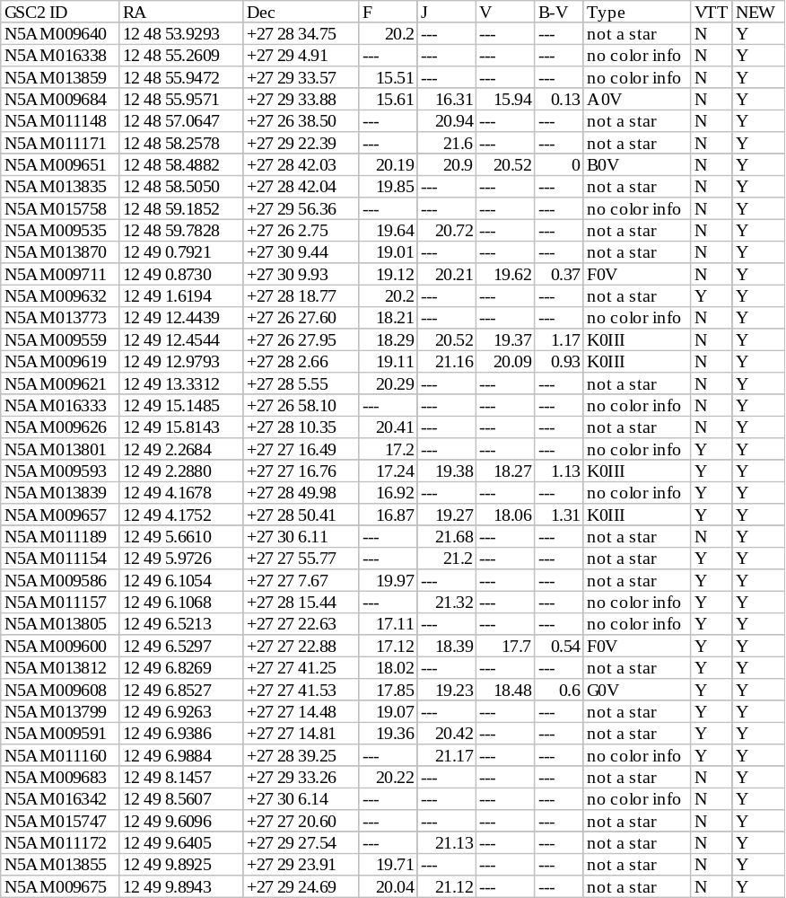

All the stars that were only found by the new BOT were located more than 57.6” from the center of the aperture, and is therefore due to the increase in the search radius.

The field map, showing the objects found, is given below.

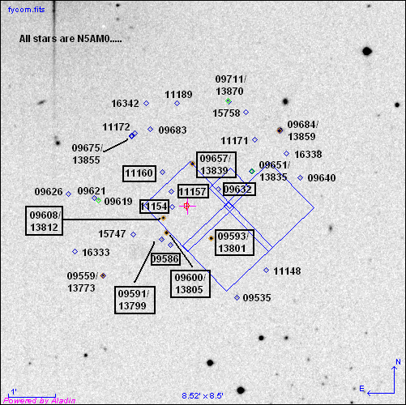

In the figure, all objects found by the VTT/BOT are in the boxes.

Issue
There appears to be a slight misalignment between the BOT overlay and the DSS image, which is 0.2” in both RA and Dec. The RA offset is consistent (the BOT overlay is always east of the star), while the Dec offset is sometimes north and sometimes south. This discrepancy is small enough (0.2 pixels) to be of no concern, but is covered under APT-VTT PR 56217.

New Features

Exposure Expansion
For the WFPC2, there are three ways for exposures to be expanded – use of the CR-SPLIT optional parameter, number of iterations greater than 1, and the use of a pattern; it is also possible to combine these methods (i.e. CR-SPLIT and pattern). The following cases were tested:
CR-SPLIT | Num. of Iter. | Pattern | Number of sub-exposures | Original Exposure Time (s) | Exposure Time Perdicted (s) | Exposure Time Used by BOT (s)
NO | 1 | no | 1 | 700 | 700 | 700
DEF (=0.5) | 1 | No | 2 | 700 | 350 | 350
0.25 | 1 | No | 2 | 700 | 175/525 | 175/525
NO | 3 | No | 3 | 700 | 700 | 700
DEF (-0.5) | 1 | Yes | 3x1 | 700 | 350 | 350

In each case, BOT created the correct number of sub-exposures, and modified the given exposure time correctly. As with the SBC, Aladin did display the BOT overlays, although there was only 1 image plane shown for the CR-SPLIT and number of iterations cases, unlike the Pattern case where each sub-exposure was its own plane. Since the CR-SPLIT and number of iterations planes would all be, by definition, identical, showing only 1 plane is acceptable (however, if the actual duration field was used, a problem could result).

Pointing Adjustment
There are 3 different types of pointing adjustments valid for the WFPC2 – POS TARG, PATTERN, and use as a PARALLEL instrument.

POS TARG

For this test, the standard exposure was modified by adding a POS TARG of X=-40” and Y=-40”. The direction of the POS TARG is important in this test, and in order to be able to simply predict the size of the POS TARG motion, the motion must be in the same direction as the "Search Radius Vector" which is defined as the point from the fiducial to the outermost corner of the Aperture. A selection in a different direction makes the calculation of the motion vector more complicated.

The test exposure was run through both the VTT/BOT and the new BOT/Aladin interface. The VTT/BOT used a search radius of 57.5”, and only did analysis at the exact pointing (i.e. it assumed ORIENT=0). The new BOT increased the standard search radius (159.7) by 10.5” to 170.2”, which resulted in a circle being analyzed to support any possible ORIENT value. Because the WFPC2 search radius is not just for the chip selected, but is for the entire detector, predicting the size of the search radius is not straightforward. Therefore, I ran a series of POS TARGs from 10”-70” in steps of 10”, and measured the separation between the (non POS TARGed) aperture fiducial and the furthest point on the (POS TARGed) aperture, and compared to the value determined by BOT. The following table shows the results:

POS TARG | BOT Radius | Measured Radius
-10”, -10” | 160.5” | 160.2”
-20”, -20” | 162.6” | 163.2”
-30”, -30” | 165.9” | 166.2”
-40”, -40” | 170.2” | 168.6”
-50”, -50” | 175.6” | 174.0”
-60”, -60” | 182.0” | 181.8”
-70”, -70’ | 189.2” | 188.4”

The measured values agree to within the measurement error with the BOT values, so it appears that POS TARGs are being properly handled.

With the increased search radius, the new BOT analyzed more objects than the VTT/BOT, but all objects in the VTT/BOT were detected, and for those objects, the magnitudes and derived count rates were identical.

The 43 objects detected (6 science, 3 safe, and 34 unknown) were:

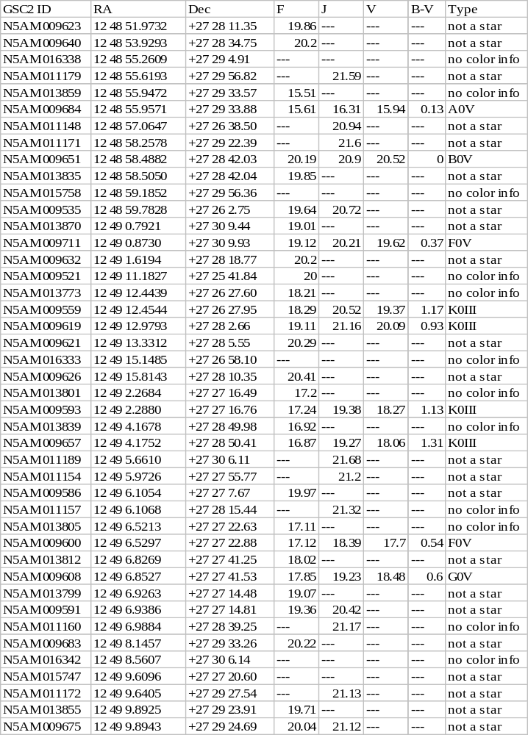

The field map, showing the objects found, is given below.
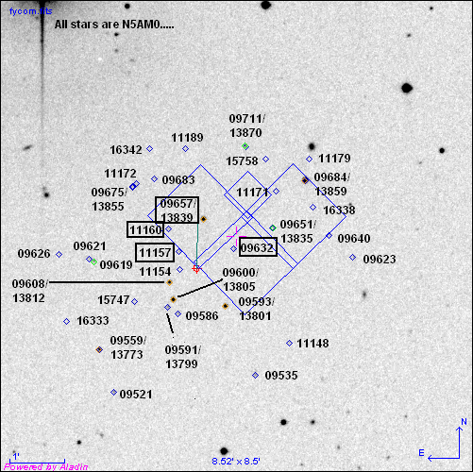
In the figure, the objects in boxes were found by the VTT/BOT. The new objects are all in the area that is expected.

Pattern

For this test, the standard exposure was modified by putting it in a PATTERN (a LINE with 3 points with a 40” spacing at an orientation of 225º). The orientation of the pattern is important in this test, since in order to be able to simply predict the size of the PATTERN motion, the motion must be in the same direction as the "Search Radius Vector" which is defined as the point from the fiducial to the outermost corner of the Aperture. A selection in a different orientation makes the calculation of the motion vector more complicated.

The test exposure was run through both the VTT/BOT and the new BOT/Aladin interface. The VTT/BOT used a search radius of 57.5”, and used the same radius for each pattern position. The new BOT also did 3 searches – one for the initial pointing (with the standard 159.7” search radius) and one for each of the two pattern points (with the search radius increased to 165.2” and 179.7”); all objects in the initial pointing were included in the larger pattern pointing report, as expected. The expanded search radius size was tested by measuring the separation between the aperture fiducial and the furthest point on the aperture in Aladin, and comparing to the BOT value (in a similar procedure used in testing POS TARG). The BOT search radii all agreed with the measured values to within the measurement error. With the increased search radius, the new BOT analyzed more objects than the VTT/BOT, but all objects in the VTT/BOT were detected, and for those objects, the magnitudes and derived count rates were identical.

The 50 objects detected (6 science, 4 safe, and 40 unknown) were:
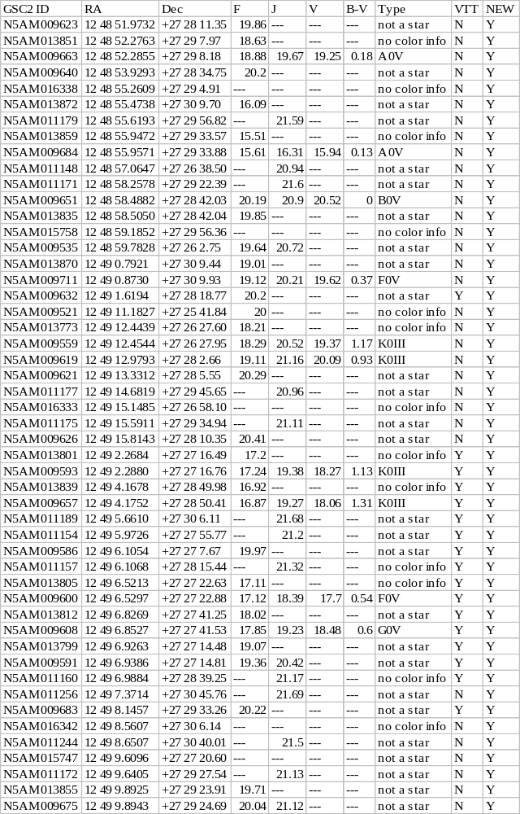
The field map, showing the objects found, is given below.
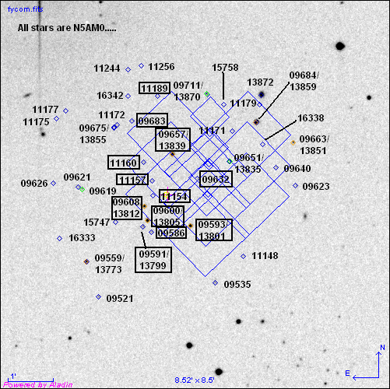

In the figure, the objects in boxes were found by the VTT/BOT. The new objects are all in the area that is expected.

Parallel

For this test, the standard exposure was modified making it be a coordinated parallel observation with a ACS/WFC prime exposure. The test exposure was run through the new BOT/Aladin interface only; the old VTT/BOT did not take the position of the parallel aperture into account when performing its checking. The search radius used by BOT was 7.34’, which is in agreement with that measured on the Aladin image.

A total of 572 stars were found in the new BOT, so the table below only lists the science concerns (40). The objects detected were:

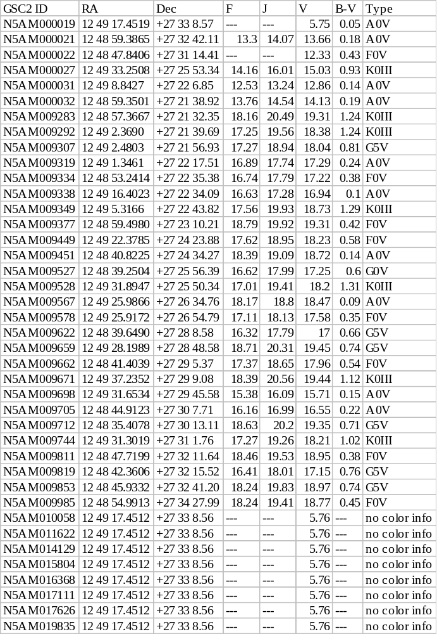
The field map, showing the objects found, is given below.

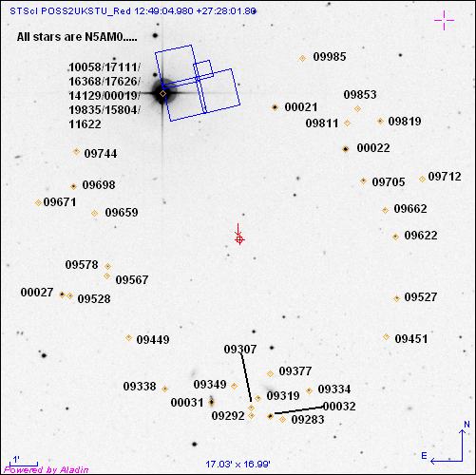

Actual Duration
There are three ways in which the WFPC2 can use actual durations – a CR-SPLIT exposure, a pattern exposure, and a number of iterations greater than 1 exposure. For this test, the second piece of a CR-SPLIT, the third piece of the pattern, and the third piece of a number of iterations=3 exposure will have the actual duration set to 100s.

CR-SPLIT
An examination of the BOT details shows that the revised exposure time for the second piece of the CR-SPLIT was detected by the tool, and that value was used in the determination of the total counts from the stars; for the other pieces of the CR-SPLIT, the correct exposure time was used.

Pattern
An examination of the BOT details shows that the revised exposure time for the third piece of the pattern was detected by the tool, and that value was used in the determination of the total counts for the stars; for the other pieces of the pattern, the correct exposure time was used.

Number of iterations
An examination of the BOT details shows that the revised exposure time for the third piece of the pattern was detected by the tool, and that value was used in the determination of the total counts for the stars; for the other pieces of the number of iterations, the correct exposure time was used.

Issue
For CR-SPLIT and number of iterations, only the first sub-exposure is shown in Aladin. If there were different actual durations, both sub-exposures would need to be display, as they could have different answers. This is a problem is covered in APT-BOT OPR 56136, and should be corrected prior to the release of the tool for WFPC2 usage.

Visualization
- There are many aspects to this test, all of which have already been verified by the previous SBC and HRC testing.

Issue
Aladin spreadsheet name link to an external html page with more details fails for the GSC2; this is covered with APT-VTT PR 56234.

Existing Proposals
I ran BOT on 9 cycle 15 operational proposals - 5 with prime WFPC2 observations, and 4 with parallel WFPC2 observations. The prime observations utilized POS TARGs (albiet very small), patterns, and ORIENTs, and all worked properly. The parallel observations also worked well, including exposures with 1500-2000 objects, which all ran and displayed (both in Aladin and in the details summary) quickly; there was also an exposure that used the actual duration field. There was one proposal with 144 exposures (prime and parallel), and after 20 minutes, only 100 exposures had processed. The memory monitor indicated that I was at my limit on memory, which explains that slow processing time. Note that my computer has the minimum memory necessary for APT (384 MB), so this is not a problem.

Exception Handling
There are four types of exception handling to be tested; Network Query Error and Cancel Ongoing Operations have been verified in the SBC testing, and Bad Exposures has been verified in the HRC testing.

Unsupported Exposures
There is 1 unsupported aperture (F160AN15) for the WFPC2.

Issue – Unsupported mode incorrectly supported in BOT
When this is used, the appropriate error message is not given, but instead you get the pop-up about no GSC2 stars found, and the status field says completed. This is covered in APT-BOT PR 56559, but does not need to be corrected prior to the release of the tool for WFPC2 usage.

Issue – Supported modes that should be unsupported in BOT
Use of polarizers are fully supported configurations. However, the polarizers impact the count rate (reduce it substantially). These spectral elements should be considered UNSUPPORTED in BOT; this is covered in APT-BOT PR 56559, and should be corrected prior to the release of the tool for WFPC2 usage.

