STIS/MAMA Acceptance Testing
Ron Downes
September 25, 2006

Summary
A detailed acceptance test for the STIS MAMA detectors has been performed. A regression test shows that BOT is giving the correct answers. The new features (exposure expansion, pointing adjustments, actual duration usage, and visualization) are all functioning properly, and BOT can handle error conditions gracefully and provides meaningful feedback to the users.

Three issues with the Aladin display have been found – a slight misalignment of the BOT overlay with the DSS image, a failure to display all sub-exposures, and a broken link in the Aladin spreadsheet; all of these are known issues with PRs previously filed. None of these issues is severe enough to warrant a delay in the release of the tool for SBC usage only.

On the details page, the central wavelength needs to be included in the exposure parameters section. In the save-to-file option from the details page, the global field check results need to be included. There are several supported apertures that need to be added, as well as the NUV PRISM spectral element. All of these are covered in existing PRs, and should be closed prior to the release of the tool for STIS/MAMA usage.

A highly desirable enhancement (which is not STIS specific) is to have a way for the tool to process ONLY prime exposures, without having to select each exposure individually from the Tree Editor; a APT-BOT PR has been filed. This work does not need to be complete prior to the release of the tool for STIS/MAMA usage.

Introduction

For this test, the following target and exposure was used:

Target: G191-B2B – 05h 05m 30.6119s, +52º 49’ 45.95”
(Note that this is slightly off from nominal position of the star)

Exposure: STIS/FUV-MAMA, ACCUM, MIRROR, F25SRF2, 1000s

For regression testing, I also used the following exposures:
STIS/FUV-MAMA, TIME-TAG, MIRROR, F25SRF2, 1000s
STIS/FUV-MAMA, ACCUM, 52X0.2, G140L/1425, 1000s
STIS/NUV-MAMA, ACCUM, MIRROR, F25SRF2, 1000s
STIS/NUV-MAMA, ACCUM, 52X0.2, G140M/1400, 1000s

When appropriate, modifications to the exposure (e.g. POS TARG) are detailed below.

This target/exposure was used to perform the following:

Test | Definition
Regression | Comparison with old VTT/BOT
New features | Exposure expansion, pointing adjustment, actual duration, visualization
Exception Handling | Bad exposure, unsupported exposure, network query, cancel operations

For each test, both the tabular and graphic output products are included for ease of comparison with future test results.

Regression Test

The test exposure was run through both the VTT/BOT and the new BOT/Aladin interface. For imaging, the VTT/BOT used a search radius of 35.6”, while the new BOT used 38.8”. All stars found by the old VTT/BOT were found by the new BOT, while 2 additional stars were found by the new BOT (both in the extended region of the new BOT search area); the magnitudes and derived count rates were identical. The 15 objects detected (1 Health-and-Safety, 11 Safe, and 3 Unknown) were:

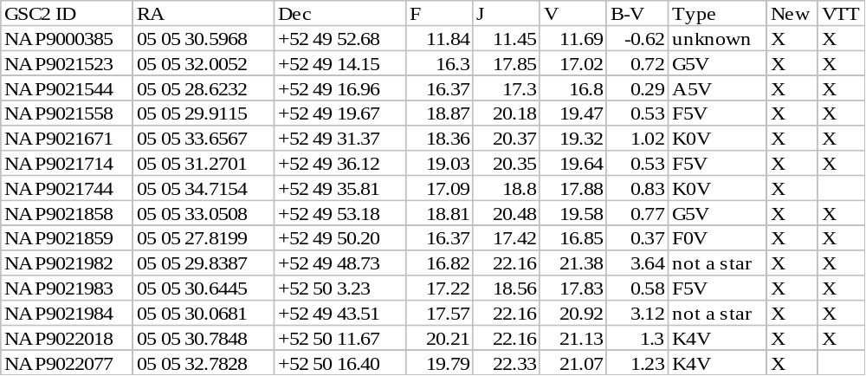

The field map, showing the objects found, is given below.

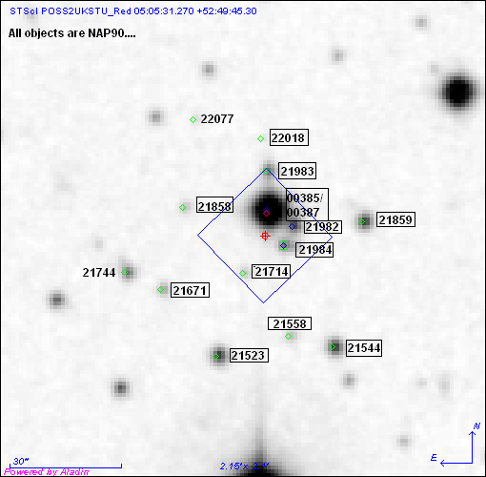

In the figure, the objects in boxes were found by the VTT/BOT. The NUV detector (using ACCUM mode), and the FUV detector with TIME-TAG mode, found the identical objects.

A spectroscopic observation was also processed, with the VTT/BOT using a search radius of 35.6” and the new BOT using 47.4”. All stars found by the old VTT/BOT were found by the new BOT, while 7 additional stars were found by the new BOT (both in the extended region of the new BOT search area); the magnitudes and derived count rates were identical. The 20 objects detected (1 Health-and-Safety, 16 Safe, and 3 Unknown) were:
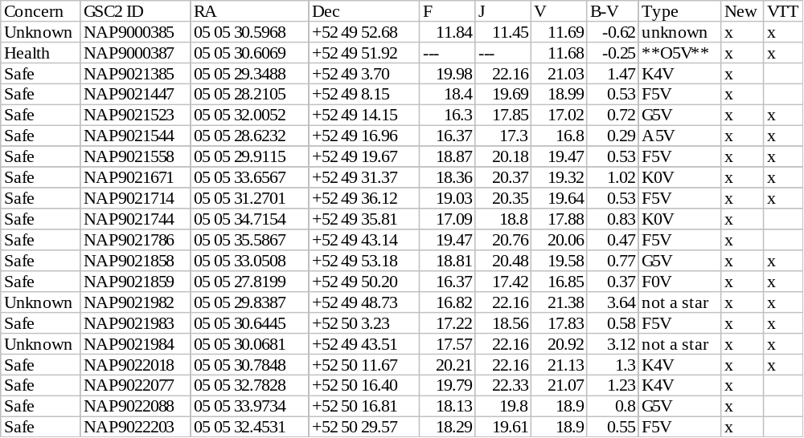
The field map, showing the objects found, is given below.
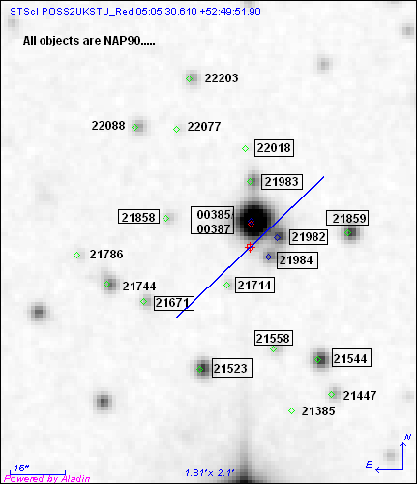

In the figure, the objects in boxes were found by the VTT/BOT; the NUV detector found identical objects.

Issues
There appears to be a slight misalignment between the BOT overlay and the DSS image, which is 0.2” in both RA and Dec. The RA offset is consistent (the BOT overlay is always east of the star), while the Dec offset is sometimes north and sometimes south. This discrepancy is small enough (0.2 pixels) to be of no concern, but is covered under APT-VTT PR 56217.

On the details page, the exposure summary (upper right corner) should include the central wavelength for spectroscopic observations, and the save-to-file option should also include this parameter; this is covered under BOT-OPR 56616, and should be corrected prior to the release of the tool for STIS/MAMA usage.

A global field check is performed for STIS MAMA observations, and the results are included in the details page. However, this information is missing from the save-to-file option; this is covered under BOT-OPR 56619, and should be corrected prior to the release of the tool for STIS/MAMA usage.

New Features

Exposure Expansion
For the STIS MAMAs, there are two ways for exposures to be expanded – number of iterations greater than 1 and the use of a pattern. The pattern case is detailed in the Pointing Adjustment section below. For the number of iterations test, a value of 3 was used. In this case, three identical sub-exposures were generated, and BOT processing was performed on all three sub-exposures with identical results. Aladin did display the BOT overlay, although there was only 1 image plane shown, unlike the Pattern case where each sub-exposure was its own plane. Since the number of iterations planes would all be, by definition, identical, showing only 1 plane is acceptable (however, if the actual duration field was used, a problem could result; see below).

Pointing Adjustment
There are 3 different types of pointing adjustments valid for the STIS MAMAs – POS TARG, PATTERN, and use as a PARALLEL instrument.

POS TARG

For this test, the standard exposure was modified by adding a POS TARG of X=-20” and Y=-20”. The direction of the POS TARG is important in this test, and in order to be able to simply predict the size of the POS TARG motion, the motion must be in the same direction as the "Search Radius Vector" which is defined as the point from the fiducial to the outermost corner of the Aperture; for the STIS MAMAs this is the lower left corner. A selection in a different direction makes the calculation of the motion vector more complicated.

The test exposure was run through both the VTT/BOT and the new BOT/Aladin interface. The VTT/BOT used a search radius of 35.6”, and only did analysis at the exact pointing (i.e. it assumed ORIENT=0). The new BOT increased the search radius by 28.0” to 66.8”, which resulted in a circle being analyzed to support any possible ORIENT value; based on the size of the POS TARG, this increase in search radius is exactly what was predicted (i.e. SQRT(20*20 + 20*20) = 28). With the increased search radius, the new BOT analyzed more objects than the VTT/BOT, but all objects in the VTT/BOT were detected, and for those objects, the magnitudes and derived count rates were identical.

The 37 objects (2 Health-and-Safety, 30 Safe, and 5 Unknown) detected were:

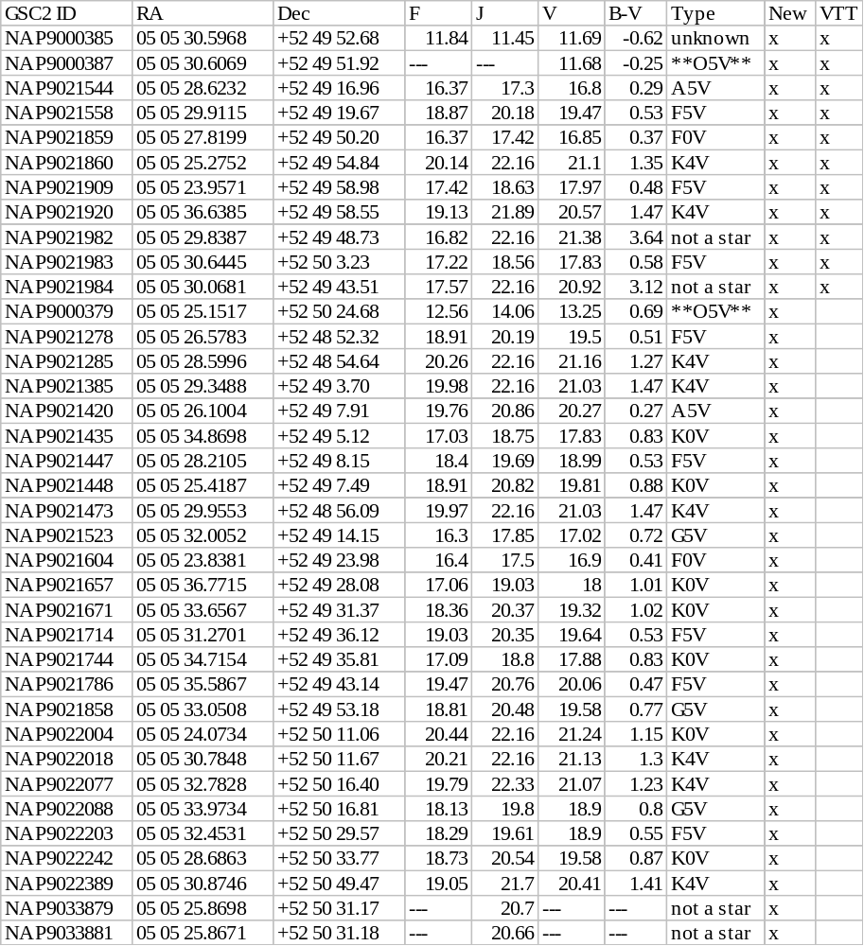
The field map, showing the objects found, is given below.

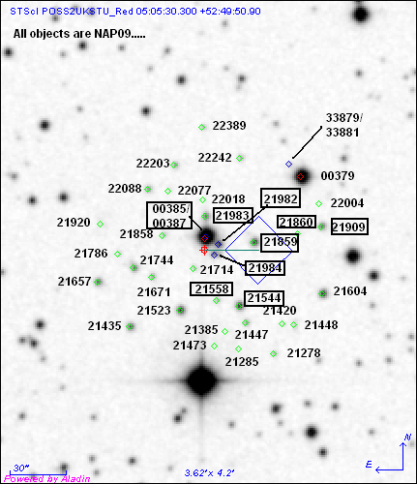

In the figure, the objects in boxes were found by the VTT/BOT. The new objects are all in the area that is expected.

Pattern

For this test, the standard exposure was modified by putting it in a PATTERN (an STIS-ALONG-SLIT with 3 points with a 10” spacing at an orientation of 90º). The orientation could not be set to be along the "Search Radius Vector", so determination of the accuracy of the search radii had to be performed be measurement in Aladin.

The test exposure was run through both the VTT/BOT and the new BOT/Aladin interface. The VTT/BOT used a search radius of 35.6” at all three pattern points. The new BOT used different radii for its searches – one for the initial pointing (with the standard 38.8” search radius), one for the second pattern exposure (with the search radius increased to 46.8”), and one for the final pattern exposure (with a search radius of 55.9. The expanded search radius was measured to be (approximately) 47.0” and 55.2” for the second and third pattern exposure, respectively, very close to the values used by BOT. With the increased search radius, the new BOT analyzed more objects than the VTT/BOT, but all objects in the VTT/BOT were detected, and for those objects, the magnitudes and derived count rates were identical.

The 24 objects (1 Health-and-Safety, 20 Safe, and 3 Unknown) detected were:

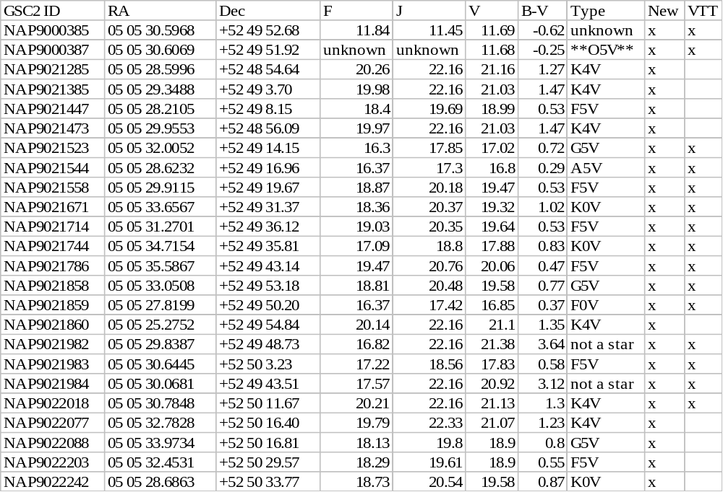
The field map, showing the objects found, is given below.

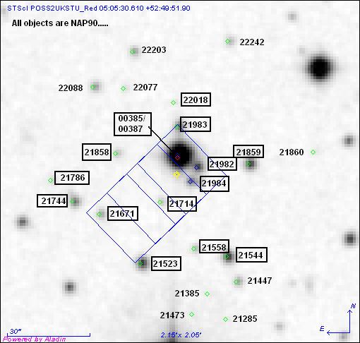

In the figure, the objects in boxes were found by the VTT/BOT. The new objects are all in the area that is expected.

Parallel

For this test, the standard exposure was modified making it be a coordinated parallel observation with a WPFC2 prime exposure. The test exposure was run through the new BOT/Aladin interface only; the old VTT/BOT did not take the position of the parallel aperture into account when performing its checking. The search radius used by BOT was 5.14’. The separation between the PC and STIS/FUV-MAMA is 4.84’, and after adding 0.65’ for the standard search radius, the approximate search radius BOT should have used is 5.49’, somewhat larger than what was actually used. However, manual measurement of the separation yields a search radius of 5.1’, in good agreement with the value used by BOT.

A total of 290stars were found in the new BOT, so the table below only lists the health-and-safety (30) and unknown objects (7). The objects detected were:

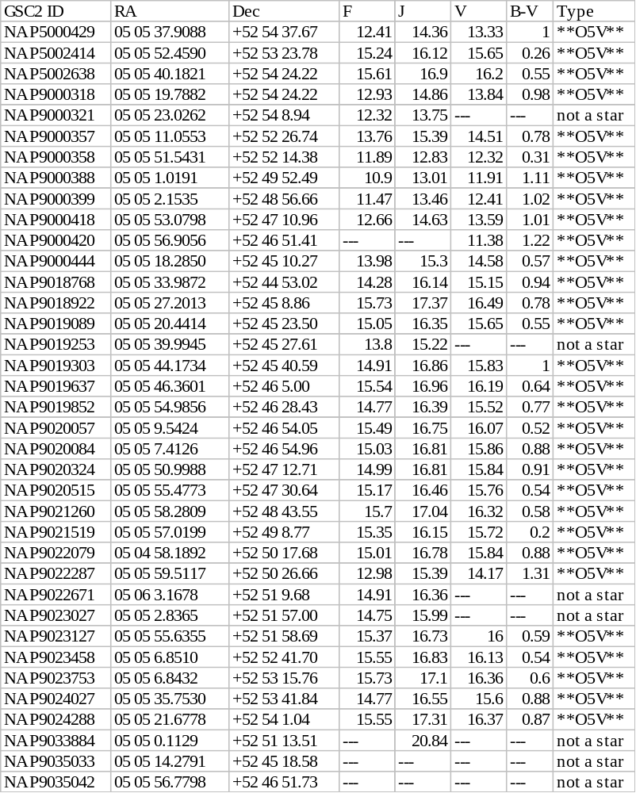
The field map, showing the objects found, is given below.

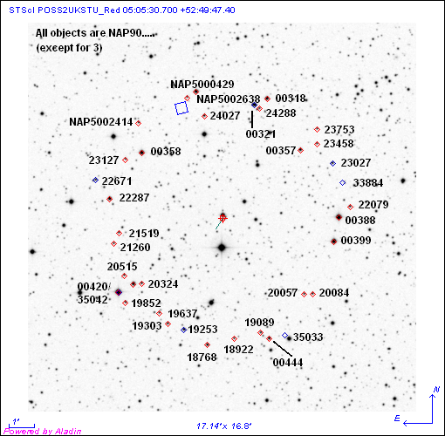

Actual Duration
There are two ways in which the STIS MAMAs can use actual durations – a pattern exposure and a number of iterations greater than 1 exposure. For this test, the second piece of the pattern will have the actual duration set to 500s, and the second of three exposures in a number of iterations=3 will have the actual duration set to 500s.

Pattern
An examination of the BOT details shows that the revised exposure time for the second piece of the pattern was indeed detected by the tool, as was evidenced by differing total counts for the targets.

Number of iterations
An examination of the BOT details shows that the revised exposure time for the second sub-exposure was indeed detected by the tool.

Issue
For actual duration and number of iterations, only the first sub-exposure is shown in Aladin. If there were different actual durations, both sub-exposures would need to be display, as they could have different answers. This is a problem is covered in APT-BOT OPR 56136, and should be corrected prior to the release of the tool for STIS/MAMA usage.

Visualization
There are many aspects to this test, all of which have already been verified by the previous ACS/SBC and ACS/HRC testing

Issue
Aladin spreadsheet name link to an external html page with more details fails for the GSC2; this is covered with APT-VTT PR 56234.

Existing Proposals
I ran BOT on eight cycle 12 (the last cycle with STIS) operational proposals – all but one were spectroscopic. All ran successfully, and in a reasonable amount of time. However, a couple issues were found in the testing.

Issue
The 0.2X0.2 aperture is fully supported for first order gratings, but BOT considers it unsupported; this is covered in OPR 51571, and should be corrected prior to the release of the tool for STIS/MAMA usage.

STIS ACQ exposures, although fully supported, should not be supported by BOT; this is covered in APT-BOT OPR 56643.

There should be a way for BOT to run on ONLY prime exposures, without having to explicitly select those exposures in the Tree Editor; this is covered in APT-BOT OPR 56644.

Exception Handling
There are four types of exception handling to be tested; Network Query Error and Cancel Ongoing Operations have been verified in the ACS/SBC testing, and Bad Exposures has been verified in the ACS/HRC testing.

Unsupported Exposures
Given the large number of unsupported STIS apertures, I ran all (at least a representative entry for each type (e.g. for the D1 apertures, I only ran one)) supported apertures to confirm that they processed. I also verified that the quad filter, as well as a sample of the most commonly used unsupported apertures, did not process.

Issue
The D1 (imaging and spectroscopic) and the F1 (spectroscopic) apertures, which are supported, did not process. This is due to the fact that these apertures were added for the last cycle of STIS, and STIS ceased operations prior to their usage. Consequently, they were never added into BOT; these are covered by BOT-OPR 56645, and should be added prior to the release of BOT for STIS/MAMA usage.

The NUV PRISM, which is supported, did not process (this spectral element also did not process in the VTT/BOT); this is covered by BOT-OPR 56645, and should be added prior to the release of BOT for STIS/MAMA usage.

