NICMOS Acceptance Testing
Ron Downes
September 28, 2006

Summary
A detailed acceptance test for the NICMOS has been performed. A regression test shows that BOT is giving the correct answers. The new features (exposure expansion, pointing adjustments, and visualization) are all functioning properly, and BOT can handle error conditions gracefully and provides meaningful feedback to the users.

There is one outstanding issue for NICMOS. The mode NIC2-ACQ should not be supported by BOT; this is covered with a previously filed PR.

Two issues with the Aladin display have been found – a slight misalignment of the BOT overlay with the DSS image, and a broken link in the Aladin spreadsheet; both of these are known issues with PRs previously filed.

BOT can be released to the community for NICMOS once the NIC2-ACQ mode is made unsupported.

Introduction
For this test, the following target and exposure was used:

Target: G191-B2B – 05h 05m 30.62s, +52º 49’ 51.95”

Exposure: NICMOS/NIC3, MULTI-ACCUM, F160W, NIC3, NSAMP=11,
SAMP-SEQ=SPARS128 (exposure time of 1152.005)

For comparison with the VTT/BOT, which does not support MULTI-ACCUM exposures, the equivalent ACCUM exposure was used; tests verified that ACCUM and MULTI-ACCUM yield the same results (when the ACCUM exposure time corresponds to the exposure time defined by NSAMP and SAMP-SEQ).

When appropriate, modifications to the exposure (e.g. POS TARG) are detailed below.
Also, use of the NIC-CORON aperture causes a position shift, so testing was also performed using this aperture (regression only).

This target/exposure was used to perform the following:

Test | Definition
Regression | Comparison with old VTT/BOT
New features | Exposure expansion, pointing adjustment, visualization (actual duration is not supported for NICMOS)
Exception Handling | Unsupported exposure (network query and cancel operations were performed with the ACS/SBC, Bad Exposure with the ACS/HRC)

For certain tests, both the tabular and graphic output products are included for ease of comparison with future test results.

Regression Test

The test exposure was run through both the VTT/BOT and the new BOT/Aladin interface. The VTT/BOT used a search radius of 92.4”, while the BOT/Aladin used 49.2”; the large search radius for the VTT/BOT was an error in the original tool. This resulted in 45 additional stars being found with the VTT/BOT, all of which were outside the new BOT search area. All objects found by the new BOT were found by the VTT/BOT, and the magnitudes and derived count rates were identical for the overlapping objects. The 21 objects detected (4 science, 1 safe, and 16 unknown) were:

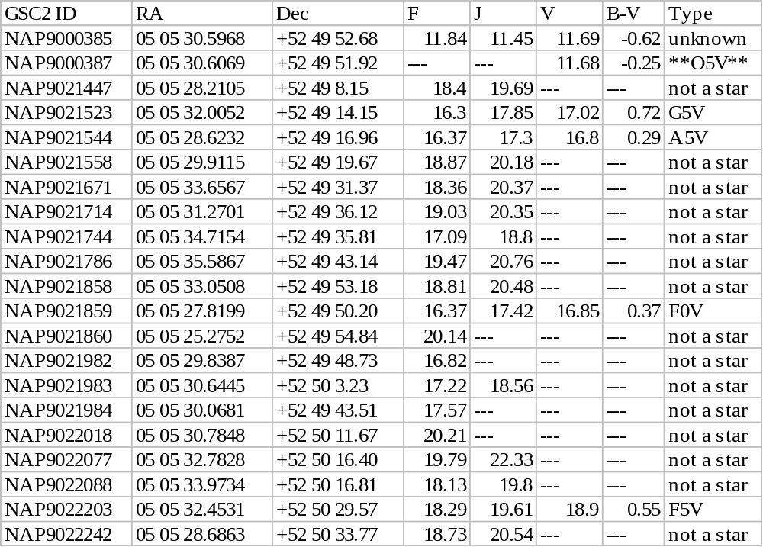

The field map, showing the objects found, is given below.

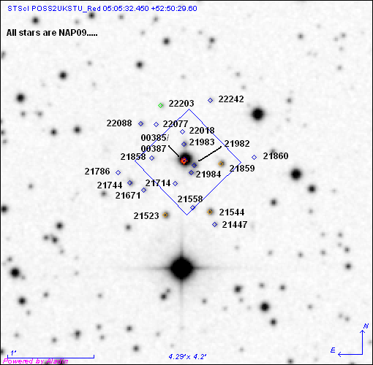

A test exposure, using NIC2 and the NIC2-CORON aperture, was run through the new BOT/Aladin interface; given the large search area of the VTT/BOT, all objects found by the new BOT were included in the VTT/BOT search. The search radius used was 31.20”, with the smaller size reflecting the small field-of-view of the NIC2 camera; the fiducial point of the aperture was also off-center due to the use of the coronographic aperture, and the Aladin search radius was appropriately determined.

The 9 objects detected (1 science, 1 safe, and 7 unknown) were:

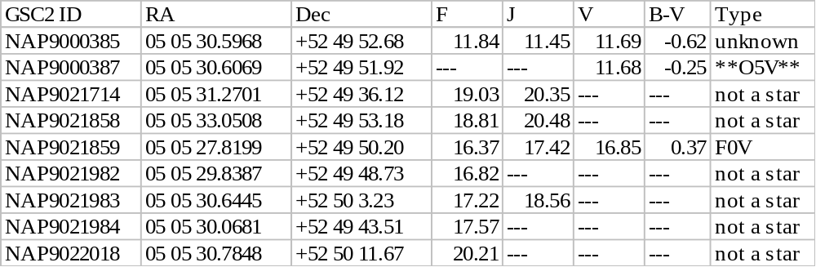

The field map, showing the objects found, is given below.
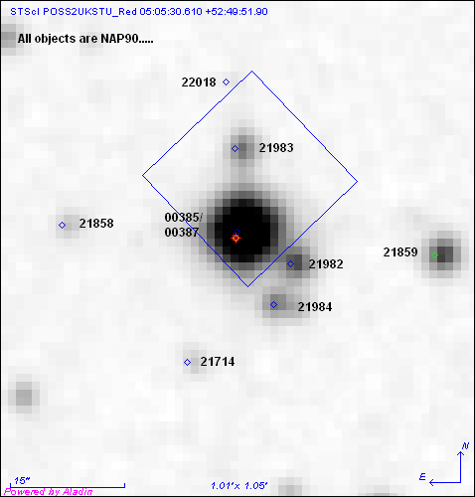

Issue
There appears to be a slight misalignment between the BOT overlay and the DSS image, which is 0.2” in both RA and Dec. The RA offset is consistent (the BOT overlay is always east of the star), while the Dec offset is sometimes north and sometimes south. This discrepancy is small enough (0.2 pixels) to be of no concern, but is covered under APT-VTT PR 56217.

New Features

Exposure Expansion
For NICMOS, there are two ways for exposures to be expanded – number of iterations greater than 1, and the use of a pattern; it is also possible to combine these methods. The following cases were tested:

Number of iterations | Pattern | Number of sub-exposures | Original Exposure Time | Predicted Exposure Time | BOT Exposure Time
1 | No | 1 | 1152.005 | 1152.005 | 1152.005
3 | No | 3 | 1152.005 | 1152.005 | 1152.005
1 | Yes | 4x1 | 1152.005 | 1152.005 | 1152.005
2 | Yes | 2x(4x1) | 1152.005 | 1152.005 | 1152.005

In each case, BOT created the correct number of sub-exposures, and maintained the given exposure time. As with the SBC, Aladin did display the BOT overlays, although there was only 1 image plane shown for the number of iterations case, unlike the Pattern case where each sub-exposure was its own plane. Since the number of iterations planes would all be, by definition, identical, showing only 1 plane is acceptable (as the actual duration capability is not supported, this is acceptable, unlike other instruments).

Pointing Adjustment
There are 3 different types of pointing adjustments valid for NICMOS – POS TARG, PATTERN, and use as a PARALLEL instrument.

POS TARG

For this test, the standard exposure was modified by adding a POS TARG of X=-20” and Y=-20”. The direction of the POS TARG is important in this test, and in order to be able to simply predict the size of the POS TARG motion, the motion must be in the same direction as the "Search Radius Vector" which is defined as the point from the fiducial to the outermost corner of the Aperture. A selection in a different direction makes the calculation of the motion vector more complicated.

The test exposure was run through both the new BOT/Aladin interface; given the large VTT/BOT search radius, a comparison with between the two tools is not useful. The new BOT increased the standard search radius of 49.2” by 23.08” to 72.28”, which resulted in a circle being analyzed to support any possible ORIENT value. Based on the size of the POS TARG, this increase in search radius was less than the predicted value (i.e. SQRT(20*20 + 20*20) = 28.28), which implies that the direction of the POS TARG was not properly aligned. A manual measurement of the search radius showed that the new BOT was indeed using the correct value.

The 42 objects detected (7 science, 1 safe, and 34 unknown) were:
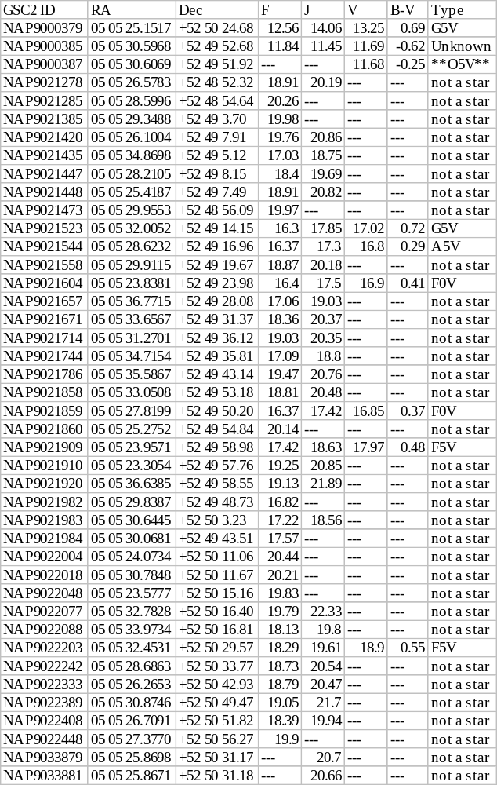
The field map, showing the objects found, is given below.

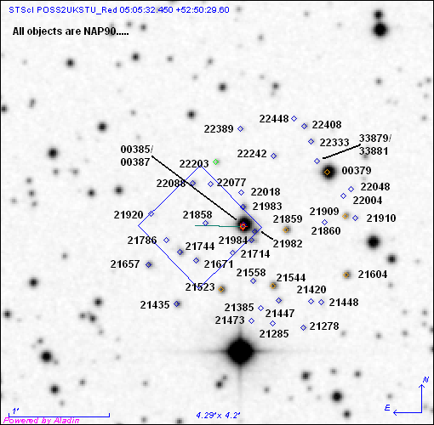

Pattern

For this test, the standard exposure was modified by putting it in a PATTERN (a NIC-SPIRAL-DITHER with 4 points with a 10” spacing at an orientation of 225º). The orientation of the pattern is important in this test, since in order to be able to simply predict the size of the PATTERN motion, the motion must be in the same direction as the "Search Radius Vector" which is defined as the point from the fiducial to the outermost corner of the Aperture. A selection in a different orientation makes the calculation of the motion vector more complicated.

The test exposure was run through both the new BOT/Aladin interface; given the large VTT/BOT search radius, a comparison with between the two tools is not useful. The new BOT did 4 searches – one for the initial pointing (with the standard 49.2” search radius) and one for each of the three pattern points (with the search radii of 54.0, 57.37, and 57.87). As the motion of the pattern was not aligned with the "Search Radius Vector", and manual check of the radii was performed. The results show:

Pattern point | BOT radius | Measured radius
1 | 49.17 | 49.4
2 | 54.00 | 54.3
3 | 57.87 | 57.4
4 | 57.37 | 56.9

The measured values were all within 0.5” of the BOT values, which is well within the measurement error.

The 25 objects detected (4 science, 1 safe, and 20 unknown) were:

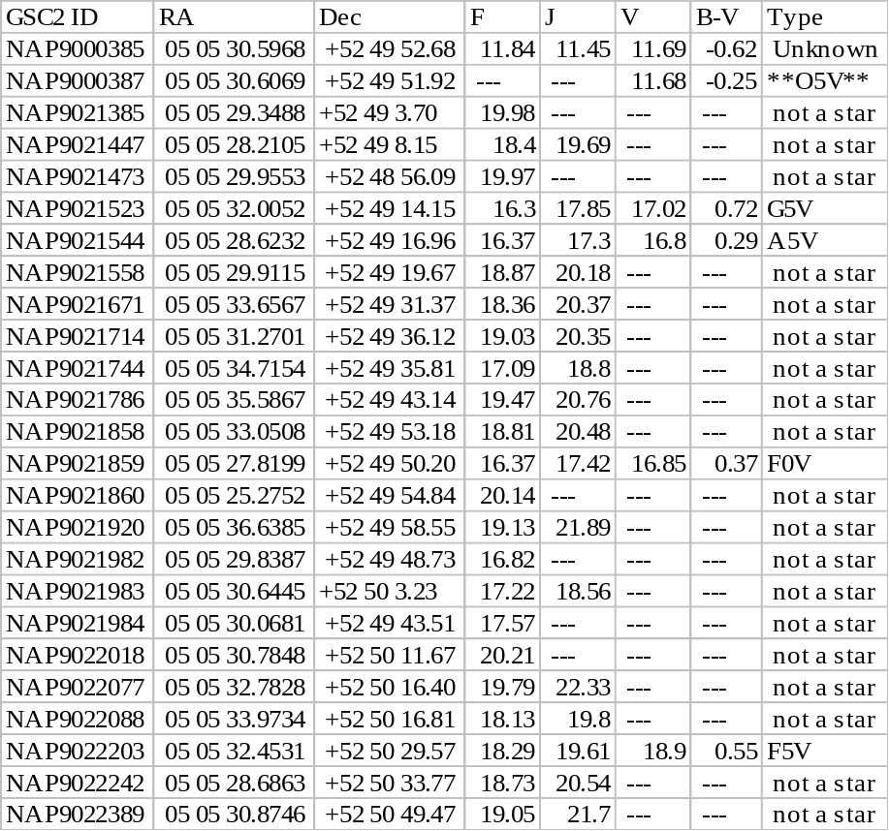
The field map, showing the objects found, is given below.
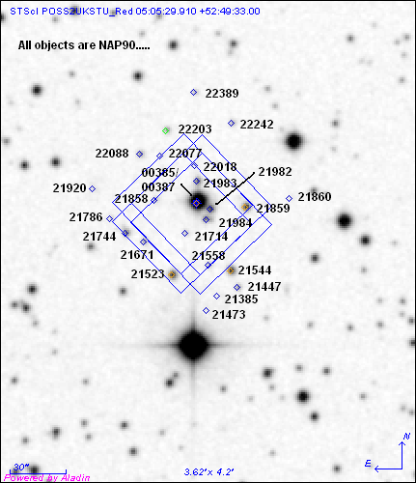

Parallel

For this test, the standard exposure was modified making it be a coordinated parallel observation with a WPFC2 prime exposure. The test exposure was run through the new BOT/Aladin interface only; the old VTT/BOT did not take the position of the parallel aperture into account when performing its checking. The search radius used by BOT was 6.70’. The separation between the PC and NIC3 is 6.08’, and after adding 0.82’ for the standard search radius, the approximate search radius BOT should have used is 6.96’, very close to what was actually used. Given that the apertures are not aligned along the Search Radius Vector (described above), this small difference (especially given that BOT uses a larger radius) is not important.

A total of 423 stars were found in the new BOT, so the table below only lists the science concerns (65). The objects detected were:

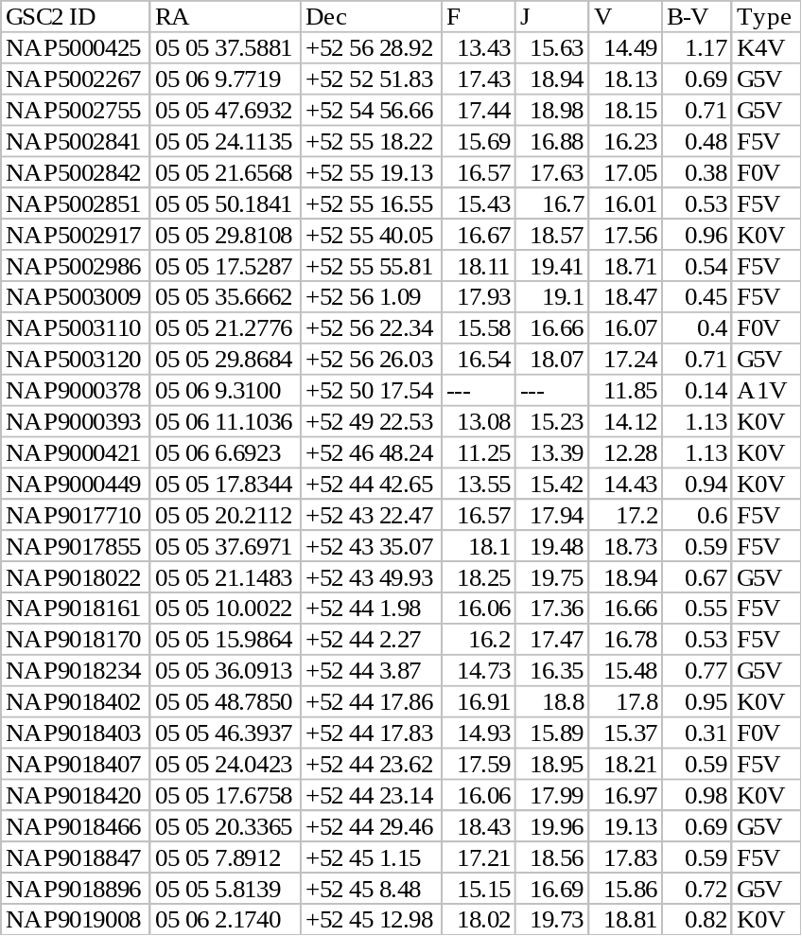
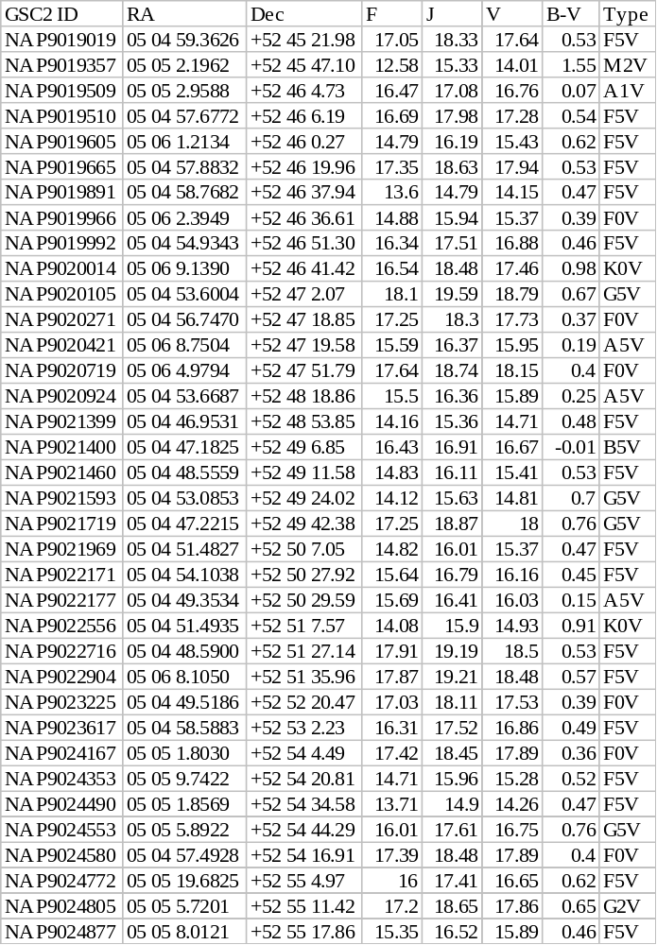
The field map, showing the objects found, is given below.

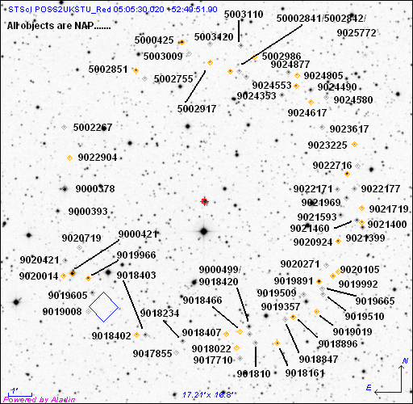

Actual Duration
This capability is not supported for NICMOS observations.

Visualization
- There are many aspects to this test, all of which have already been verified by the previous SBC and HRC testing.

Issue
Aladin spreadsheet name link to an external html page with more details fails for the GSC2; this is covered with APT-VTT PR 56234.

Existing Proposals
I ran BOT on eight cycle 15 operational proposals. All ran successfully, and in a reasonable amount of time. No issues were found in the testing.

Exception Handling
There are four types of exception handling to be tested; Network Query Error and Cancel Ongoing Operations have been verified in the SBC testing, and Bad Exposures has been verified in the HRC testing.

Unsupported Exposures
There are no unsupported apertures or optional parameters that could impact BOT processing. However, use of the grisms (NIC3) and the polarizers (NIC1 and NIC2) are (correctly) not supported by BOT.

Issue
NIC2-ACQ exposures should not be supported by BOT; this is covered under BOT-OPR 56661, and should be corrected prior to the release of the tool for NICMOS usage.

