

Astronomer’s Proposal Tool
Bright Object Tool Regression Test Document

Kate Henshaw

March 9, 2010
Table of Contents
1.0 Introduction 3
2.0 Search Field 4
2.1 Detector Sizes 4
2.2 Adjustments 5
2.2.1 POS-TARG 5
2.2.2 PATTERN 5
2.2.3 Modes 8
2.2.4 Parallel 12
2.2.5 COS Dual Aperture 13
3.0 Catalog Selection and Retrieval 14
3.1 Error Checking 14
3.1.1 No Stars in Field 14
3.1.2 WFC3 IR with no 2MASS uses GSC2 15
4.0 Convert to V and B – V 16
4.1 Bright Stars have V and B–V in GSC2 16
4.2 Detector Specific Adjustments 18
4.2.1 B–V ≤ +0.1 18
4.2.2 V_{crit} 19
4.2.3 Only F or Only J 23
4.2.4 Large Error on F and J 27
4.2.5 Ignore ‘Not a Star’ Flag 30
4.3 Error Checking 33
4.3.1 Illegal V 33
4.3.2 Illegal B–V 36
4.3.3 Incomplete Data 39
5.0 Trigger Values 40
1.0 Search Field 1
1.1 Detector Sizes 1
1.2 Adjustments 2
1.2.1 POS-TARG 2
1.2.2 PATTERN 3
1.2.3 Parallel 4
1.2.4 COS Dual Aperture 6

Table of Figures and Tables
Figure 2-1: Exposure 1 ACCUM (baseline) Aladin View 10
Figure 2-2: Exposure 2 ACQ/SEARCH Aladin View 11
Figure 2-4: Exposure 3 ACQ/PEAKD Aladin View 12
Figure 3-1: Warning Message for No Stars 14
Figure 3-2: No Stars Aladin View 15
Figure 4-1: Bright Target has V and B–V in GSC2 – BOT Details Dialogue Box 17
Figure 4-1: Faint Target Using F and J to Calculate V and B–V – BOT Details 18
Figure 4-2: UV Detector O5V Star – BOT Details Dialogue Box 19
Figure 4-3: Non-UV Detector Normal Classification Star – BOT Details 19
Figure 4-4: UV Detector Bright O5V Star – BOT Details Dialogue Box 20
Figure 4-5: UV Detector Faint Normal Classification – BOT Details Dialogue Box 21
Figure 4-6: Non-UV Detector Normal Classification – BOT Details Dialogue Box 22
Figure 4-7: Non-UV Detector Normal Classification – BOT Details Dialogue Box 22
Figure 4-8: Only F, Processed Normally 24
Figure 4-9: Only F, Object Unknown 25
Figure 4-10: Only J, Processed Normally 26
Figure 4-11: Only J, Object Unknown 27
Figure 4-12: No Error, Non-UV Detector; Spectral Type A5 28
Figure 4-13: Error, Non-UV Detector; Spectral Type O5 – BOT Details 29
Figure 4-14: No Error, UV Detector; Spectral Type A5 – BOT Details 30
Figure 4-15: Error, UV Detector; Spectral Type O5 – BOT Details Dialogue Box 30
Figure 4-16: STIS/NUV-MAMA; V > 16.5; Not a Star Flag Ignored 31
Figure 4-17: STIS/FUV-MAMA; V<15.8; Not a Star Flag Not Ignored 32
Figure 4-18: STIS/CCD; V>16.5; Not a Star Flag Set 33
Figure 4-19: V = -1.99 > -2.0 34
Figure 4-20: V = -2.01 < -2.0 and listed as unknown 34
Figure 4-21: V < 24.0 35
Figure 4-22: V > 24.0 and listed as unknown 36
Figure 4-23: B–V < 3.0 37
Figure 4-24: B–V > 3.0 and listed as no color info 38
Figure 4-25: B–V > -0.5 38
Figure 4-26: B–V < -0.5 and listed as no color info 39
Figure 4-27: Only F Defined and listed as unknown 40
Figure 1-1: Detector Specific Sizes Aladin View 1
Figure 1-2: POS TARG Adjustment Aladin View 2
Figure 1-3: Pattern Adjustment Aladin View 3
Figure 1-4: Prime and Parallel Exposures in Aladin View 4
Figure 1-5: Parallel Exposure in Aladin View 5
Figure 1-6: COS/NUV Exposure in Aladin View 6
Figure 1-7: COS/FUV Exposure in Aladin View 7

Table 1-1: Proposal Detector Coverage 4
Table 2-1: Detector Sizes BOT Objects 5
Table 2-2: POS-TARG BOT Objects 5
Table 2-3: Pattern Point 1 BOT Objects 6
Table 2-4: Pattern Point 2 BOT Objects 7
Table 2-5: Pattern Point 3 BOT Objects 7
Table 2-6: Pattern Point 4 BOT Objects 8
Table 2-7: Mode: Accum BOT Objects 9
Table 2-8: Mode: ACQ/SEARCH BOT Objects 9
Table 2-10: Mode: ACQ/PEAKD BOT Objects 9
Table 2-11: Parallel Exposure BOT Objects 13
Table 2-12: COS/NUV BOT Objects 13
Table 2-13: COS/FUV BOT Objects 14
Table 3-1: COS/FUV BOT Objects 16
Table 3-2: COS/FUV BOT Objects 16
Table 5-1: VOT File Object Information, Local Limit Exceeded 40
Table 5-2: VOT File Object Information, Global Limit Exceeded 41

Introduction
A set of proposals to test the functionality of the Bright Object Tool (BOT) are described in the following sections. In order to regression test the Bright Object Tool (BOT), a JUnit Test has been created for each proposal. JUnit is an open source framework designed for the purpose of writing and running tests the Java programming language. Each JUnit test will run a proposal through the BOT within the Astronomer’s Proposal Tool (APT). When the BOT runs, the proposal is expected to generate a set of VOT files, containing the results from the BOT. A baseline set of VOT files have all been verified by comparing the VOT files with the BOT Results Tables and Aladin Graphical view (see Appendix A) in the APT GUI, and those files will be used as a baseline to check for new or missing files. The JUnit test will check for differences between the newly created VOT files and the baselined VOT files. If there are no new, missing, or changed VOT files, then the JUnit test passes. If this is not the case, the test fails. The JUnit Test will email the console output from the run, and the new and different VOT files as attachments to bot-regression@stsci.edu. Details on how to fix the error(s) are included in the email and the requirements of the JUnit test are included as well. The JUnit tests will run nightly and are located in the Regression Tests folder of the APT code repository.
Throughout the following proposals, all detectors are used at least once in order ensure detector coverage (see Table 1-1: Proposal Detector Coverage).

Detector | Used In Proposal
ACS/SBC | PATTERN  Vcrit  Illegal
ACS/WFC | B–V ≤ +0.1  Large Error on F and J  Incomplete Data
COS/FUV | Modes  COS Dual Aperture  No Stars in Field  Only F or Only J
COS/NUV | Parallel  COS Dual Aperture  Only F or Only J
NIC1 | POS-TARG
NIC2 | Parallel  Vcrit
NIC3 | Illegal V
STIS/CCD | Ignore ‘Not a Star’ Flag
STIS/FUV-MAMA | Bright Stars have V and B–V in GSC2  B–V ≤ +0.1  Only F or Only J  Large Error on F and J  Ignore ‘Not a Star’ Flag  Trigger Values
STIS/NUV-MAMA | Detector Sizes  Only F or Only J  Ignore ‘Not a Star’ Flag
WFC3/IR | WFC3 IR with no 2MASS uses GSC2
WFC3/UVIS | Bright Stars have V and B–V in GSC2
Table 1-1: Proposal Detector Coverage

Note that the BOT results shown for the following proposals may not match what the current results are, but are included to give an idea of what the results might look like. For instance, the Exposure Time Calculators (ETCs) are updated every cycle, so any test that uses or displays the count rates will change.

Search Field
The following proposals are verified by comparing the objects listed in the VOT file for each proposal to see that the same object names and coordinates are found in the BOT Search Fields. Crowded fields are used for all targets such that objects lie just inside and just outside the search fields. If the search fields are changed, the same objects may not be found resulting in the test failing. For these tests, we are just concerned with which objects are found in the search (i.e. the details of the objects, such as spectral type and count rates, are not relevant).

Detector Sizes
This proposal is testing that BOT is properly reading the size of the detector from the instrument table; as the table are all of similar format, one detector will suffice for this test. The proposal is using G191-B2B as the target and the STIS/NUV-MAMA detector. The following table lists the objects that should be found.

Object ID | RA | Dec
NAP9000385 | 05 05 30.5969 | +52 49 52.68
NAP9000387 | 05 05 30.6061 | +52 49 51.92
NAP9021714 | 05 05 31.2708 | +52 49 36.11
NAP9021858 | 05 05 33.0505 | +52 49 53.17
NAP9021982 | 05 05 29.8389 | +52 49 48.72
NAP9021983 | 05 05 30.6445 | +52 50 3.22
NAP9021984 | 05 05 30.0677 | +52 49 43.52
NAP9022018 | 05 05 30.7855 | +52 50 11.67
Table 2-2: Detector Sizes BOT Objects

Adjustments
The following proposals are testing the search field where various adjustments are specified.

POS-TARG
This proposal is testing that BOT is properly reading the POS TARG value (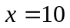, 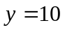) from the APT file; as the POS TARG values are not detector specific, one detector will suffice for this test. The proposal is using G191-B2B as the target and the NIC1 detector. The following table lists the objects that should be found.

Object ID | RA | Dec
NAP9000385 | 05 05 30.5969 | +52 49 52.68
NAP9000387 | 05 05 30.6061 | +52 49 51.92
NAP9021714 | 05 05 31.2708 | +52 49 36.11
NAP9021858 | 05 05 33.0505 | +52 49 53.17
NAP9021859 | 05 05 27.8192 | +52 49 50.20
NAP9021982 | 05 05 29.8389 | +52 49 48.72
NAP9021983 | 05 05 30.6445 | +52 50 3.22
NAP9021984 | 05 05 30.0677 | +52 49 43.52
NAP9022018 | 05 05 30.7855 | +52 50 11.67
NAP9022077 | 05 05 32.7832 | +52 50 16.41
Table 2-3: POS-TARG BOT Objects

PATTERN
This proposal is testing the BOT Search Field adjustment for a visit containing a pattern. The proposal uses a four-point mosaic box pattern. The target is G-191-B2B. There is one ACS/SBC exposure using the four-point mosaic box pattern. There are four overlapping BOT Search Fields due to the four-point box pattern. The following tables list the objects that should be found for each point in the pattern.

Pattern Point 1:
Instrument/Detector: ACS/SBC
Target: G-191-B2B

Object ID | RA | Dec
NAP9000385 | 05 05 30.5969 | +52 49 52.68
NAP9000387 | 05 05 30.6061 | +52 49 51.92
NAP9021385 | 05 05 29.3481 | +52 49 3.70
NAP9021447 | 05 05 28.2111 | +52 49 8.14
NAP9021473 | 05 05 29.9561 | +52 48 56.08
NAP9021523 | 05 05 32.0050 | +52 49 14.15
NAP9021544 | 05 05 28.6230 | +52 49 16.96
NAP9021558 | 05 05 29.9121 | +52 49 19.66
NAP9021671 | 05 05 33.6566 | +52 49 31.38
NAP9021714 | 05 05 31.2708 | +52 49 36.11
NAP9021744 | 05 05 34.7150 | +52 49 35.81
NAP9021786 | 05 05 35.5865 | +52 49 43.15
NAP9021858 | 05 05 33.0505 | +52 49 53.17
NAP9021859 | 05 05 27.8192 | +52 49 50.20
NAP9021860 | 05 05 25.2759 | +52 49 54.85
NAP9021920 | 05 05 36.6376 | +52 49 58.54
NAP9021982 | 05 05 29.8389 | +52 49 48.72
NAP9021983 | 05 05 30.6445 | +52 50 3.22
NAP9021984 | 05 05 30.0677 | +52 49 43.52
NAP9022018 | 05 05 30.7855 | +52 50 11.67
NAP9022077 | 05 05 32.7832 | +52 50 16.41
NAP9022088 | 05 05 33.9734 | +52 50 16.82
NAP9022203 | 05 05 32.4536 | +52 50 29.56
NAP9022242 | 05 05 28.6871 | +52 50 33.78
NAP9022389 | 05 05 30.8752 | +52 50 49.48
Table 2-4: Pattern Point 1 BOT Objects

Pattern Point 2:
Instrument/Detector: ACS/SBC
Target: G-191-B2B

Object ID | RA | Dec
NAP9000385 | 05 05 30.5969 | +52 49 52.68
NAP9000387 | 05 05 30.6061 | +52 49 51.92
NAP9021523 | 05 05 32.0050 | +52 49 14.15
NAP9021544 | 05 05 28.6230 | +52 49 16.96
NAP9021558 | 05 05 29.9121 | +52 49 19.66
NAP9021671 | 05 05 33.6566 | +52 49 31.38
NAP9021714 | 05 05 31.2708 | +52 49 36.11
NAP9021744 | 05 05 34.7150 | +52 49 35.81
NAP9021786 | 05 05 35.5865 | +52 49 43.15
NAP9021858 | 05 05 33.0505 | +52 49 53.17
NAP9021859 | 05 05 27.8192 | +52 49 50.20
NAP9021860 | 05 05 25.2759 | +52 49 54.85
NAP9021982 | 05 05 29.8389 | +52 49 48.72
NAP9021983 | 05 05 30.6445 | +52 50 3.22
NAP9021984 | 05 05 30.0677 | +52 49 43.52
NAP9022018 | 05 05 30.7855 | +52 50 11.67
NAP9022077 | 05 05 32.7832 | +52 50 16.41
NAP9022088 | 05 05 33.9734 | +52 50 16.82
NAP9022203 | 05 05 32.4536 | +52 50 29.56
NAP9022242 | 05 05 28.6871 | +52 50 33.78
Table 2-5: Pattern Point 2 BOT Objects

Pattern Point 3:
Instrument/Detector: ACS/SBC
Target: G-191-B2B

Object ID | RA | Dec
NAP9000385 | 05 05 30.5969 | +52 49 52.68
NAP9000387 | 05 05 30.6061 | +52 49 51.92
NAP9021385 | 05 05 29.3481 | +52 49 3.70
NAP9021447 | 05 05 28.2111 | +52 49 8.14
NAP9021523 | 05 05 32.0050 | +52 49 14.15
NAP9021544 | 05 05 28.6230 | +52 49 16.96
NAP9021558 | 05 05 29.9121 | +52 49 19.66
NAP9021671 | 05 05 33.6566 | +52 49 31.38
NAP9021714 | 05 05 31.2708 | +52 49 36.11
NAP9021744 | 05 05 34.7150 | +52 49 35.81
NAP9021786 | 05 05 35.5865 | +52 49 43.15
NAP9021858 | 05 05 33.0505 | +52 49 53.17
NAP9021859 | 05 05 27.8192 | +52 49 50.20
NAP9021860 | 05 05 25.2759 | +52 49 54.85
NAP9021982 | 05 05 29.8389 | +52 49 48.72
NAP9021983 | 05 05 30.6445 | +52 50 3.22
NAP9021984 | 05 05 30.0677 | +52 49 43.52
NAP9022018 | 05 05 30.7855 | +52 50 11.67
NAP9022077 | 05 05 32.7832 | +52 50 16.41
NAP9022088 | 05 05 33.9734 | +52 50 16.82
NAP9022203 | 05 05 32.4536 | +52 50 29.56
NAP9022242 | 05 05 28.6871 | +52 50 33.78
Table 2-6: Pattern Point 3 BOT Objects

Pattern Point 4:
Instrument/Detector: ACS/SBC
Target: G-191-B2B

Object ID | RA | Dec
NAP9000385 | 05 05 30.5969 | +52 49 52.68
NAP9000387 | 05 05 30.6061 | +52 49 51.92
NAP9021385 | 05 05 29.3481 | +52 49 3.70
NAP9021447 | 05 05 28.2111 | +52 49 8.14
NAP9021523 | 05 05 32.0050 | +52 49 14.15
NAP9021544 | 05 05 28.6230 | +52 49 16.96
NAP9021558 | 05 05 29.9121 | +52 49 19.66
NAP9021671 | 05 05 33.6566 | +52 49 31.38
NAP9021714 | 05 05 31.2708 | +52 49 36.11
NAP9021744 | 05 05 34.7150 | +52 49 35.81
NAP9021786 | 05 05 35.5865 | +52 49 43.15
NAP9021858 | 05 05 33.0505 | +52 49 53.17
NAP9021859 | 05 05 27.8192 | +52 49 50.20
NAP9021860 | 05 05 25.2759 | +52 49 54.85
NAP9021982 | 05 05 29.8389 | +52 49 48.72
NAP9021983 | 05 05 30.6445 | +52 50 3.22
NAP9021984 | 05 05 30.0677 | +52 49 43.52
NAP9022018 | 05 05 30.7855 | +52 50 11.67
NAP9022077 | 05 05 32.7832 | +52 50 16.41
NAP9022088 | 05 05 33.9734 | +52 50 16.82
NAP9022242 | 05 05 28.6871 | +52 50 33.78
NAP9022389 | 05 05 30.8752 | +52 50 49.48
Table 2-7: Pattern Point 4 BOT Objects

Modes
This proposal is checking the BOT Search Field adjustment for the COS modes ACQ/SEARCH and ACQ/PEAKD; an ACCUM mode exposure is included as the baseline.
The proposal uses the COS/FUV detector and has three exposures, one for each mode. The following tables list the objects that are found by the BOT.

Exposure 1:
Instrument/Detector: COS/FUV
Mode : ACCUM (baseline)
Target: G-191-B2B

Object ID | RA | Dec
NAP9000385 | 05 05 30.5969 | +52 49 52.68
NAP9000387 | 05 05 30.6061 | +52 49 51.92
NAP9021714 | 05 05 31.2708 | +52 49 36.11
NAP9021982 | 05 05 29.8389 | +52 49 48.72
NAP9021983 | 05 05 30.6445 | +52 50 3.22
NAP9021984 | 05 05 30.0677 | +52 49 43.52
NAP9022018 | 05 05 30.7855 | +52 50 11.67
Table 2-8: Mode: Accum BOT Objects

Exposure 2:
Instrument/Detector: COS/FUV
Mode : ACQ/SEARCH
Target: G-191-B2B

Object ID | RA | Dec
NAP9000385 | 05 05 30.5969 | +52 49 52.68
NAP9000387 | 05 05 30.6061 | +52 49 51.92
NAP9021714 | 05 05 31.2708 | +52 49 36.11
NAP9021858 | 05 05 33.0505 | +52 49 53.17
NAP9021982 | 05 05 29.8389 | +52 49 48.72
NAP9021983 | 05 05 30.6445 | +52 50 3.22
NAP9021984 | 05 05 30.0677 | +52 49 43.52
NAP9022018 | 05 05 30.7855 | +52 50 11.67
Table 2-9: Mode: ACQ/SEARCH BOT Objects

Exposure 3:
Instrument/Detector: COS/FUV
Mode : ACQ/PEAKD
Target: G-191-B2B

Object ID | RA | Dec
NAP9000385 | 05 05 30.5969 | +52 49 52.68
NAP9000387 | 05 05 30.6061 | +52 49 51.92
NAP9021714 | 05 05 31.2708 | +52 49 36.11
NAP9021858 | 05 05 33.0505 | +52 49 53.17
NAP9021859 | 05 05 27.8192 | +52 49 50.20
NAP9021982 | 05 05 29.8389 | +52 49 48.72
NAP9021983 | 05 05 30.6445 | +52 50 3.22
NAP9021984 | 05 05 30.0677 | +52 49 43.52
NAP9022018 | 05 05 30.7855 | +52 50 11.67
Table 2-10: Mode: ACQ/PEAKD BOT Objects

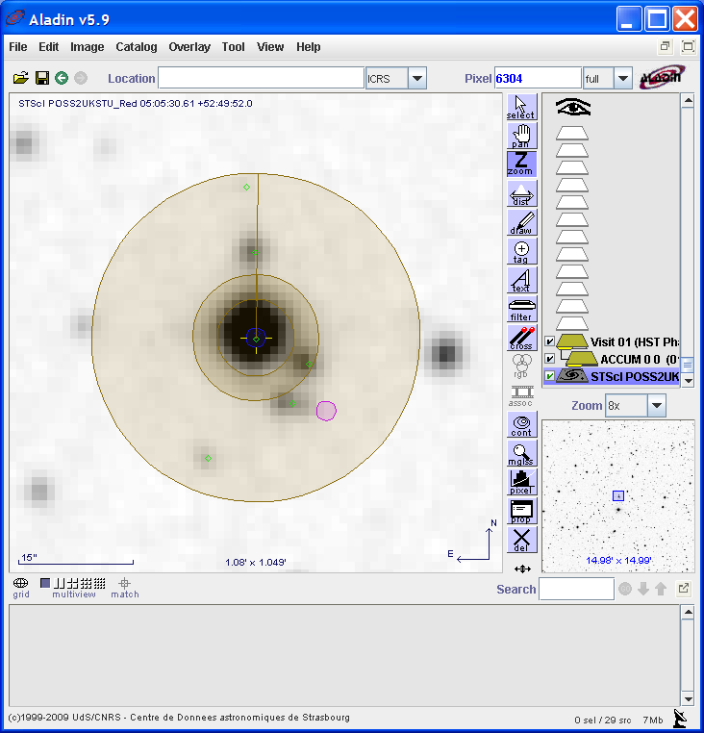
Figure 2-1: Exposure 1 ACCUM (baseline) Aladin View

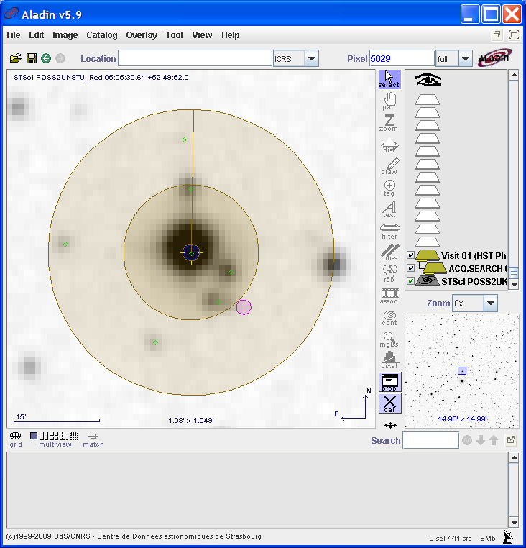
Figure 2-2: Exposure 2 ACQ/SEARCH Aladin View

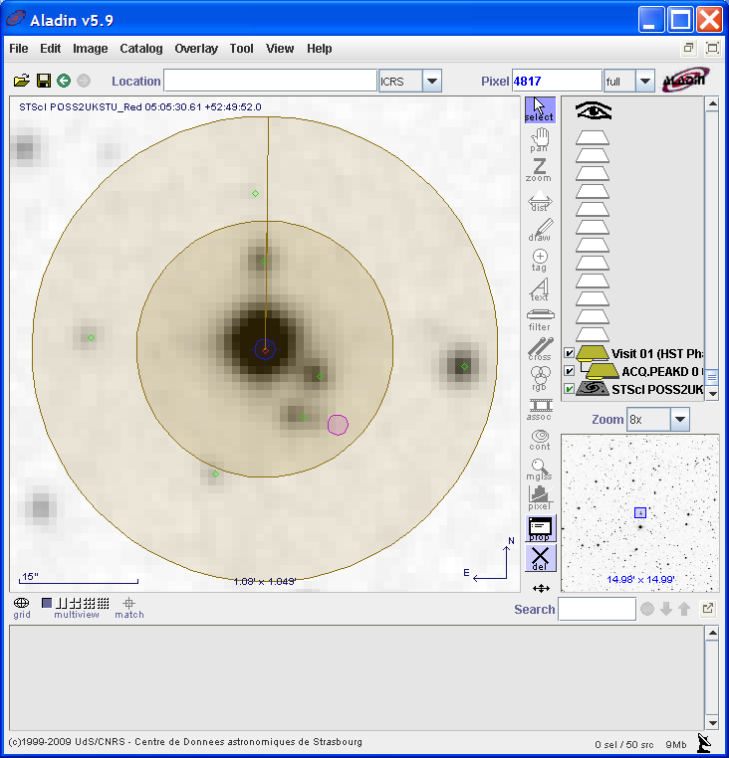
Figure 2-3: Exposure 3 ACQ/PEAKD Aladin View

Parallel
This proposal will check the BOT Search Field for a parallel exposure. The prime exposure uses COS/NUV, and the parallel exposure uses NIC2. The target is G-191-B2. For this test, we are just concerned with which objects are found in the search for the parallel exposure (i.e. the details of the objects, such as spectral type and count rates, are not relevant). The following tables list the objects that should be found.

Exposure 2 (Parallel):
Instrument/Detector: NIC2
Target: G-191-B2B

Object ID | RA | Dec
NAP9014965 | 05 06 21.5369 | +52 39 22.42
NAP9014996 | 05 06 18.3893 | +52 39 25.51
NAP9015489 | 05 06 24.6790 | +52 40 3.01
NAP9015752 | 05 06 29.5807 | +52 40 26.04
NAP9015763 | 05 06 28.0829 | +52 40 18.91
NAP9015764 | 05 06 28.7054 | +52 40 24.63
NAP9015828 | 05 06 31.9135 | +52 40 29.89
NAP9015935 | 05 06 28.0664 | +52 40 41.29
NAP9016063 | 05 06 29.9835 | +52 40 51.76
NAP9016326 | 05 06 22.3553 | +52 39 58.38
NAP9016328 | 05 06 24.6552 | +52 40 2.93
NAP9032793 | 05 06 23.6829 | +52 39 52.22
NAP9032797 | 05 06 25.0598 | +52 39 54.54
NAP9032798 | 05 06 23.2819 | +52 39 59.54
NAP9033730 | 05 06 21.4618 | +52 39 40.90
Table 2-11: Parallel Exposure BOT Objects

COS Dual Aperture
This proposal will test the BOT Search Field using the COS Dual Aperture Adjustment. The proposal contains two exposures, one using COS/NUV, and one using COS/FUV. For this test, we are just concerned with which objects are found in the search (i.e. the details of the objects, such as spectral type and count rates, are not relevant). The following tables list the objects that should be found.

Exposure 1:
Instrument/Detector: COS/NUV
Target: G-191-B2B

Object ID | RA | Dec
NAP9000385 | 05 05 30.5969 | +52 49 52.68
NAP9000387 | 05 05 30.6061 | +52 49 51.92
NAP9021714 | 05 05 31.2708 | +52 49 36.11
NAP9021982 | 05 05 29.8389 | +52 49 48.72
NAP9021983 | 05 05 30.6445 | +52 50 3.22
NAP9021984 | 05 05 30.0677 | +52 49 43.52
NAP9022018 | 05 05 30.7855 | +52 50 11.67
Table 2-12: COS/NUV BOT Objects

Exposure 2:
Instrument/Detector: COS/FUV
Target: G-191-B2B

Object ID | RA | Dec
NAP9000385 | 05 05 30.5969 | +52 49 52.68
NAP9000387 | 05 05 30.6061 | +52 49 51.92
NAP9021714 | 05 05 31.2708 | +52 49 36.11
NAP9021982 | 05 05 29.8389 | +52 49 48.72
NAP9021983 | 05 05 30.6445 | +52 50 3.22
NAP9021984 | 05 05 30.0677 | +52 49 43.52
NAP9022018 | 05 05 30.7855 | +52 50 11.67
Table 2-13: COS/FUV BOT Objects

Catalog Selection and Retrieval
The following section will describe the proposals to test that BOT uses the catalogs correctly in order to retrieve the BOT results.

Error Checking
This section will test that the tool alerts the user to errors while running the BOT.

No Stars in Field
This proposal will test that the BOT alerts the user when it finds no stars in the BOT search field. The proposal uses the target Messier-031 and contains one exposure using the COS/FUV detector. When the BOT runs, a pop-up appears with a warning that no stars were found (see Figure 3-4). In this example, BOT found no stars because the region is so crowded that the GSC2 could not differentiate objects (see Figure 3-5). This message will also appear when the region is blank.

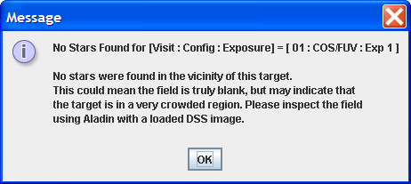
Figure 3-4: Warning Message for No Stars

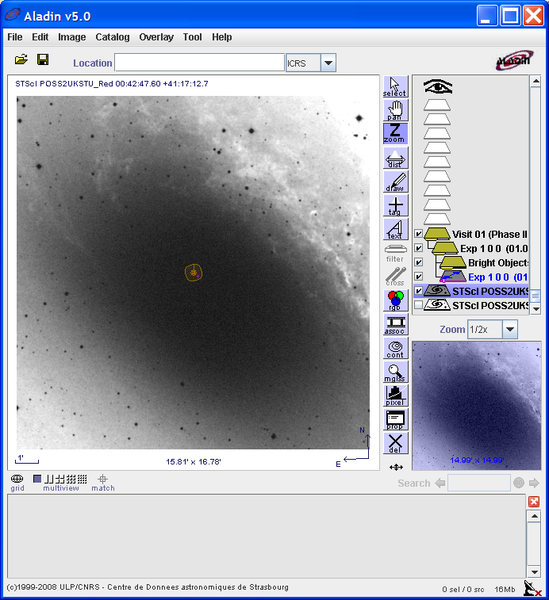
Figure 3-5: No Stars Aladin View

WFC3 IR with no 2MASS uses GSC2
This proposal will test that both 2MASS and GSC2 catalogs are used to retrieve information for the BOT. The proposal contains two fixed targets and one exposure for each target. Both exposures use the WFC3/IR detector.

Exposure 1 (GSC2):
Instrument/Detector: WFC3/IR
Target: Target 1 (RA: 23 59 52.0400 Dec: -00 00 45.30)

Target 1 has no 2MASS data. The table below lists the objects found by the BOT, all of which are retrieved from the GSC2 catalog.

Object ID | RA | Dec | Catalog
N000000193 | 23 59 54.5947 | +00 00 6.96 | GSC2
N000000205 | 23 59 52.8516 | +00 00 16.43 | GSC2
N000000225 | 23 59 55.2026 | +00 00 28.68 | GSC2
N000000251 | 23 59 53.2764 | +00 00 42.91 | GSC2
SB28004832 | 23 59 49.5410 | -00 01 53.15 | GSC2
SB28005007 | 23 59 55.6348 | -00 00 15.40 | GSC2
SB28006685 | 23 59 56.3892 | -00 00 19.92 | GSC2
SB28007593 | 23 59 56.3232 | -00 01 5.76 | GSC2
Table 3-14: COS/FUV BOT Objects

Exposure 2 (2MASS):
Instrument/Detector: WFC3/IR
Target: Target 2 (RA: 12 34 56.7000 Dec: +12 34 56.70)

Target 2 has 2MASS data. The table below lists the objects found by the BOT, all of which are retrieved from the 2MASS catalog.

Object ID | RA | Dec | Catalog
12345220+1236082 | 12 34 52.2031 | +12 36 8.20 | 2MASS
12345455+1236261 | 12 34 54.5527 | +12 36 26.14 | 2MASS
12345520+1235091 | 12 34 55.2024 | +12 35 9.20 | 2MASS
12345569+1234405 | 12 34 55.6944 | +12 34 40.53 | 2MASS
12345617+1234297 | 12 34 56.1778 | +12 34 29.79 | 2MASS
12345810+1233325 | 12 34 58.1023 | +12 33 32.53 | 2MASS
12345972+1234392 | 12 34 59.7259 | +12 34 39.27 | 2MASS
12350124+1234016 | 12 35 1.2497 | +12 34 1.68 | 2MASS
12350175+1234042 | 12 35 1.7518 | +12 34 4.22 | 2MASS
12350202+1234231 | 12 35 2.0220 | +12 34 23.19 | 2MASS
Table 3-15: COS/FUV BOT Objects

Convert to V and B – V
The following proposals will test the BOT’s use of V and B–V.

Bright Stars have V and B–V in GSC2
This proposal will test that BOT correctly retrieves V and B–V values from the GSC2 catalog, and that it correctly computes V and B–V when the values are not specified in the catalog. This proposal contains two targets.

Exposure 1 (Bright Target):
Instrument/Detector: STIS/FUV-MAMA
Target: MIRA

The figure below shows the BOT Details Dialogue where the object SOF2000125 has V and B–V specified in the GSC2 catalog for the bright target, MIRA.

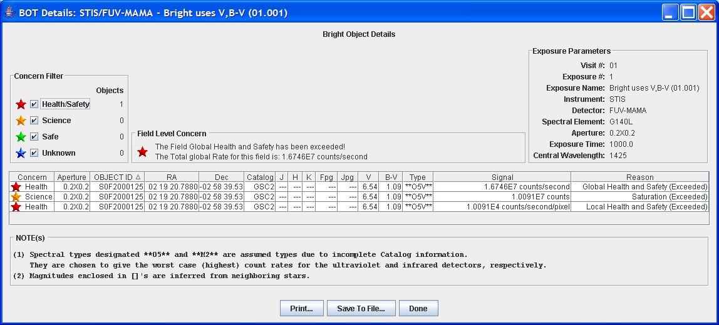
Figure 4-6: Bright Target has V and B–V in GSC2 – BOT Details Dialogue Box

Exposure 2 (Faint Target):
Instrument/Detector: WFC3/UVIS
Target: BOT-TARGET (F=13.8, J=15, V=12.01, B–V=0)

This exposure uses a BOT target where the F, J, V, & B–V values are manually specified. Since V=12.01, the target is too faint to have V and B–V specified in the GSC2 catalog. BOT will calculate the values (see Figure 4-7). The calculated values are confirmed below.

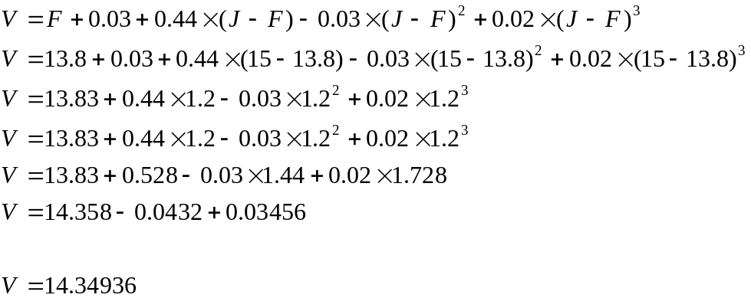

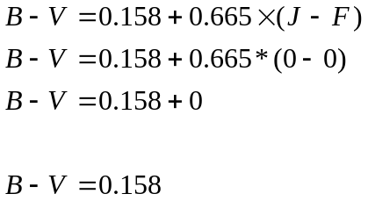
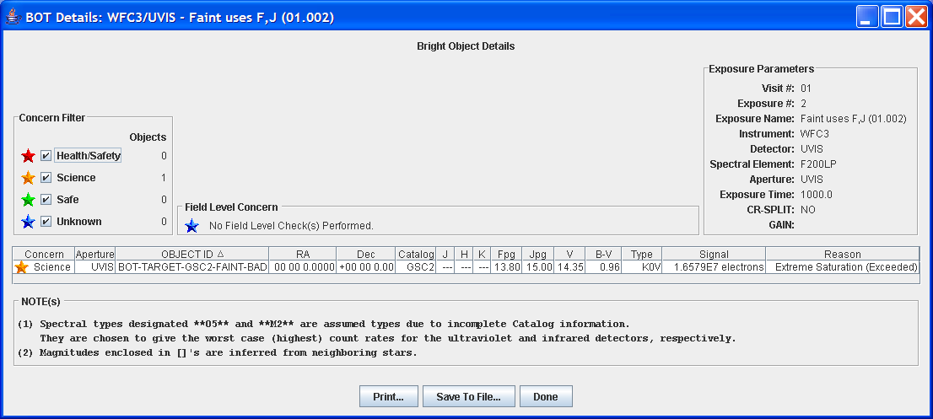
Figure 4-7: Faint Target Using F and J to Calculate V and B–V – BOT Details Dialogue Box

Detector Specific Adjustments

B–V ≤ +0.1
For UV detectors, there are two checks done for each star, a local and a global. The local looks at the brightest pixel, where the global looks at the total counts from the object.
This proposal will test that for UV detectors, objects with a B–V value less than (bluer than) +0.1 are classified as 05V stars. For non-UV detectors, the objects will remain in their normal classification. This proposal contains two exposures, one using a UV Detector and one using a non-UV detector. Each exposure is using a BOT target where B–V is less than +0.1.

Exposure 1 (UV Detector):
Instrument/Detector: STIS/FUV-MAMA
Target: BOT-TARGET (F=18, J=17.9)

F and J are used to specify the B–V < +0.1 by the following calculation:

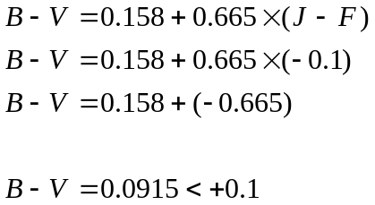

For UV detectors, when B–V < +0.1, the object is classified as an O5V star (see Figure 4-8).

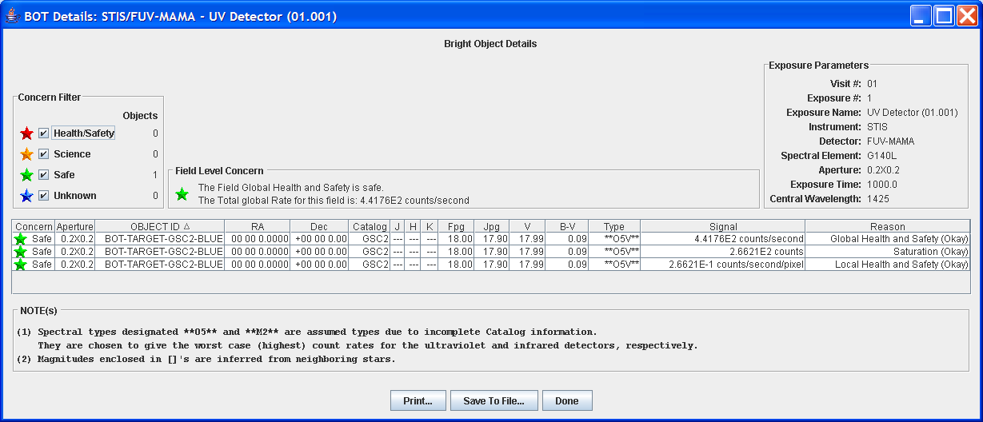
Figure 4-8: UV Detector O5V Star – BOT Details Dialogue Box

Exposure 2 (Non-UV Detector):
Instrument/Detector: ACS/WFC
Target: BOT-TARGET (F=18, J=17.9)

See calculation in Exposure 1 for B–V.

For non-UV detectors, when B–V < +0.1, the object is classified normally. In Figure 4-9, the object is classified as an A1V star.

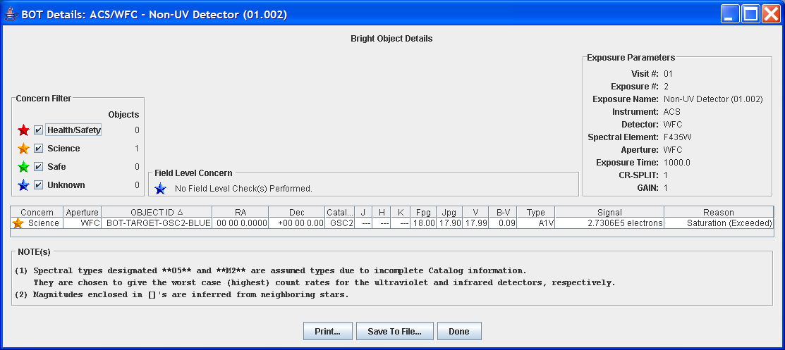
Figure 4-9: Non-UV Detector Normal Classification Star – BOT Details Dialogue Box

V_{crit}
This proposal will test the V_{crit} for a specific UV detector. The proposal will confirm that an object brighter than the V_{crit} ( < V_{crit} ) is classified as O5V, and an object fainter than V_{crit} ( > V_{crit}) is classified normally. It will also confirm for a non-UV detector, both objects are classified normally. Two BOT targets are used where V is above and below V_{crit}. There are a total of four exposures, one for each target for each detector.

Exposure 1 (V < V_{crit}):
Instrument/Detector: ACS/SBC
Target: BOT-TARGET (F=16, J=17.29)
ACS/SBC V_{crit}: 16.6

F and J are specified in the BOT-TARGET since V and B–V are ignored for stars fainter than V=12. The following calculation confirms the F and J values where V < V_{crit}.

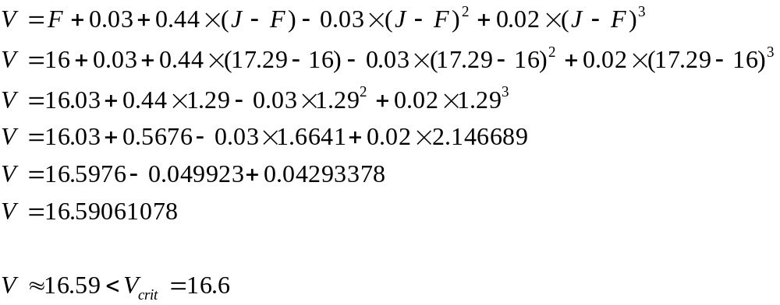

Figure 4-10 confirms that for UV detectors, the BOT classifies objects brighter than V_{crit} as O5V.

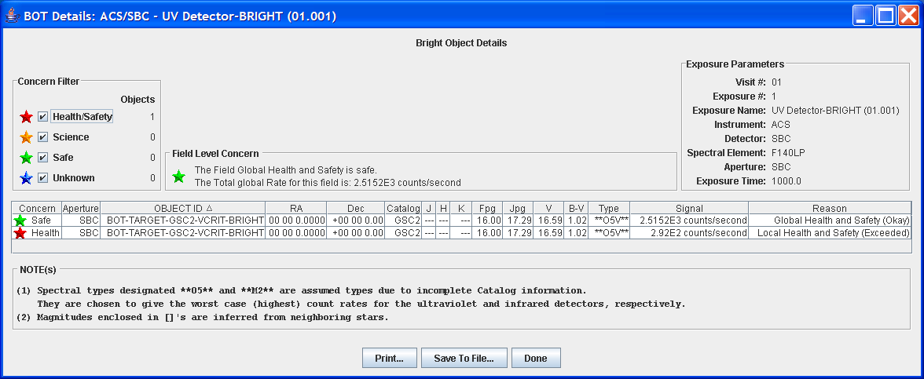
Figure 4-10: UV Detector Bright O5V Star – BOT Details Dialogue Box

Exposure 2 (V > V_{crit}):
Instrument/Detector: ACS/SBC
Target: BOT-TARGET (F=16, J=17.33)
ACS/SBC V_{crit}: 16.6

F and J are specified in the BOT-TARGET since V and B–V are ignored for stars fainter than V=12. The following calculation confirms the F and J values where V < V_{crit}.

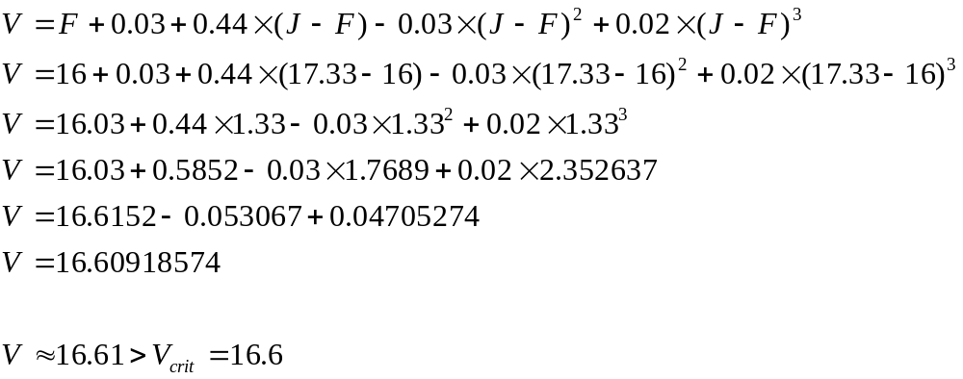

Figure 4-11 confirms that for UV detectors, the BOT classifies objects fainter than V_{crit} normally.

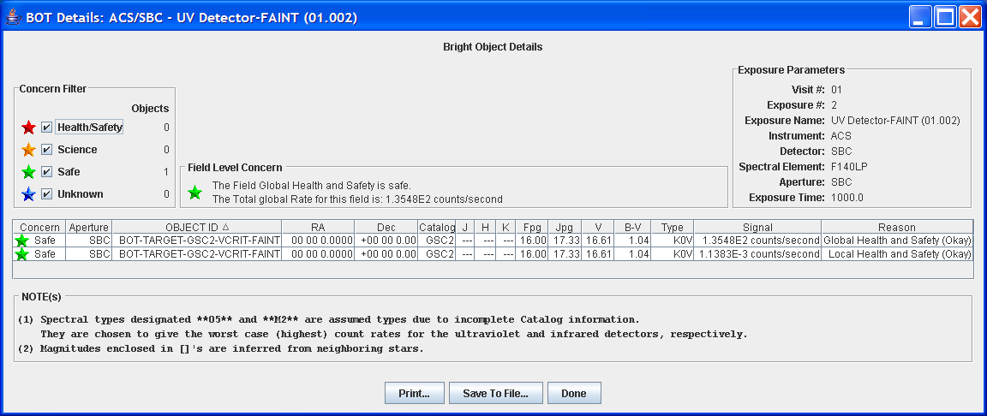
Figure 4-11: UV Detector Faint Normal Classification – BOT Details Dialogue Box

Exposure 3 (Non-UV Detector):
Instrument/Detector: NIC2
Target: BOT-TARGET (F=16, J=17.29)

See calculation for V in Exposure 1.

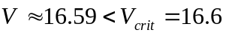

Figure 4-12 confirms that for non-UV detectors, the BOT classifies the object normally.

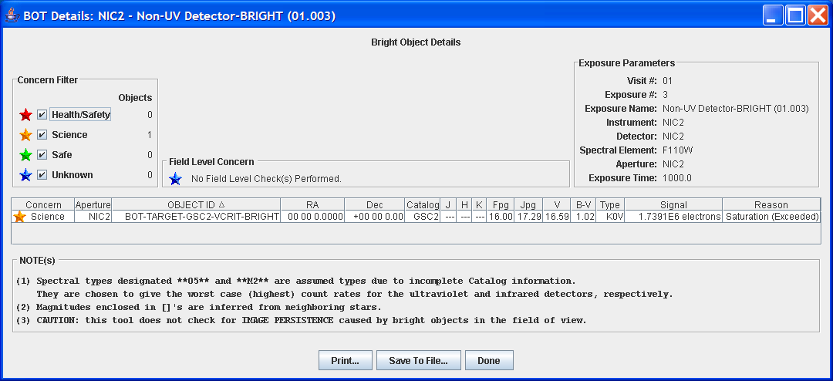
Figure 4-12: Non-UV Detector Normal Classification – BOT Details Dialogue Box

Exposure 4 (Non-UV Detector):
Instrument/Detector: NIC2
Target: BOT-TARGET (F=16, J=17.33)

See calculation for V in Exposure 3.

Figure 4-13 confirms that for non-UV detectors, the BOT classifies the object normally.

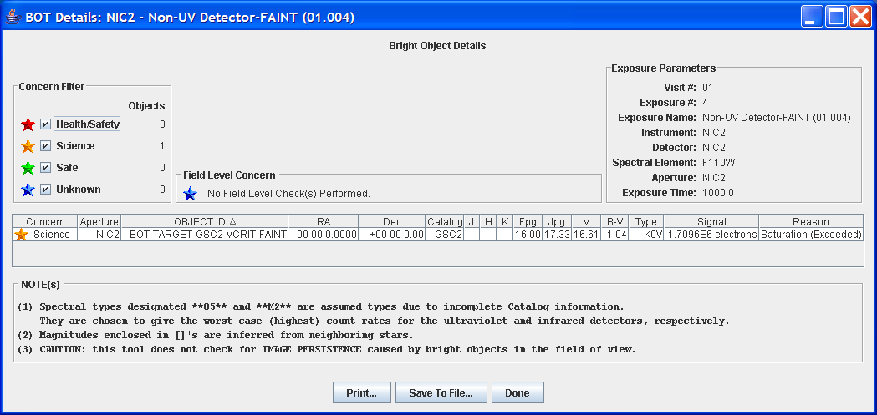
Figure 4-13: Non-UV Detector Normal Classification – BOT Details Dialogue Box

Only F or Only J
This proposal will test the BOT’s conversion to V and B–V when only F or only J is specified. Four BOT targets are used, two where only F is specified and two where only J is specified. There are four exposures, one for each target.

For both STIS-MAMA and COS detectors, for objects where no J is specified or no F is specified, the BOT assumes the object is an O5V star where J – F = -0.42, and processes normally. If the object does not trigger an alert, BOT will list the F or J, V, spectral type (O5V), count rates, and status. If the object does trigger an alert, BOT will list the F or J, spectral type as “no color info,” and reason as “unknown.”

Exposure 1 (Only F):
Instrument/Detector: STIS/FUV-MAMA
Target: BOT-TARGET (F=10)

The following calculations are used to determine V and B–V:

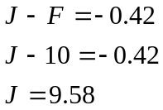

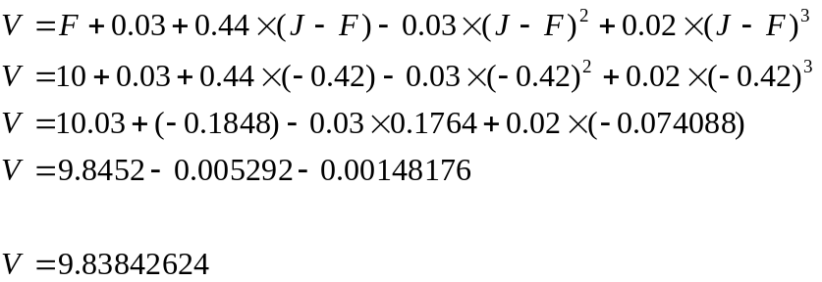

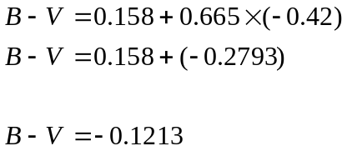

See Figure 4-14 below where no alert has been triggered so BOT lists F, spectral type, count rates, and status.

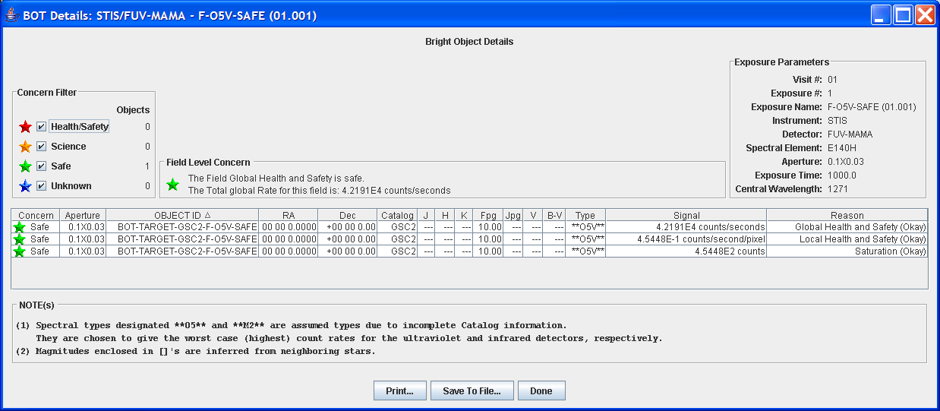
Figure 4-14: Only F, Processed Normally

Exposure 2 (Only F):
Instrument/Detector: STIS/NUV-MAMA
Target: BOT-TARGET (F=2)

The following calculations are used to determine V and B–V:

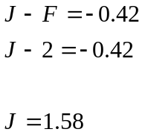

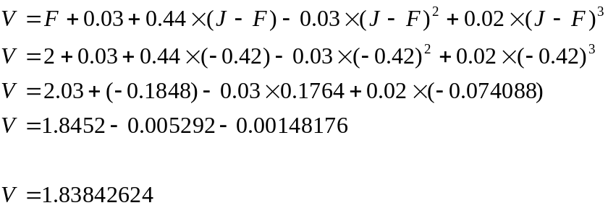

See Figure 4-15 below where an alert has been triggered so BOT lists F, “no color info,” and reason as “unknown.”

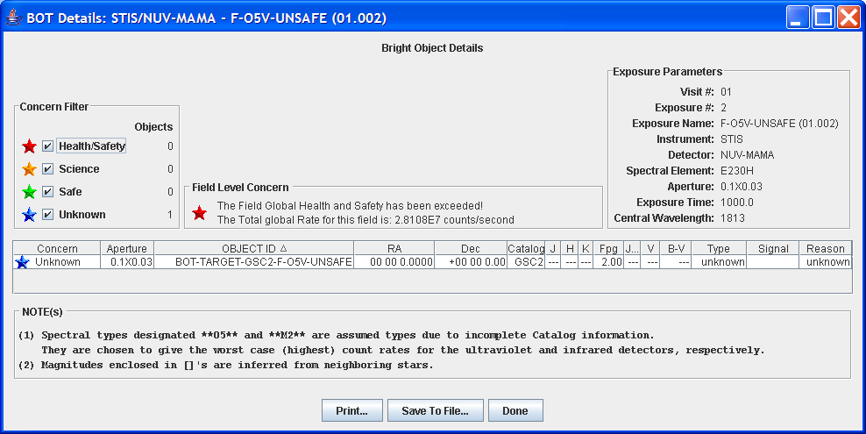
Figure 4-15: Only F, Object Unknown

Exposure 3 (Only J):
Instrument/Detector: COS/FUV
Target: BOT-TARGET (J=10)

The following calculations are used to determine V and B–V:

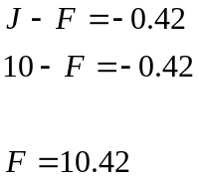

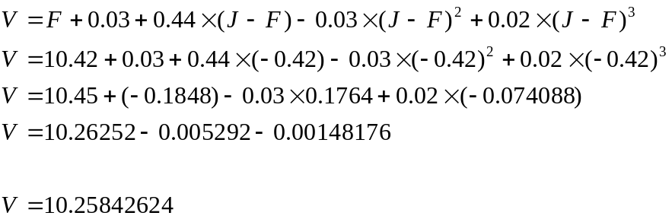

See Figure 4-16 below where no alert has been triggered so BOT lists J, spectral type, count rates, and status.

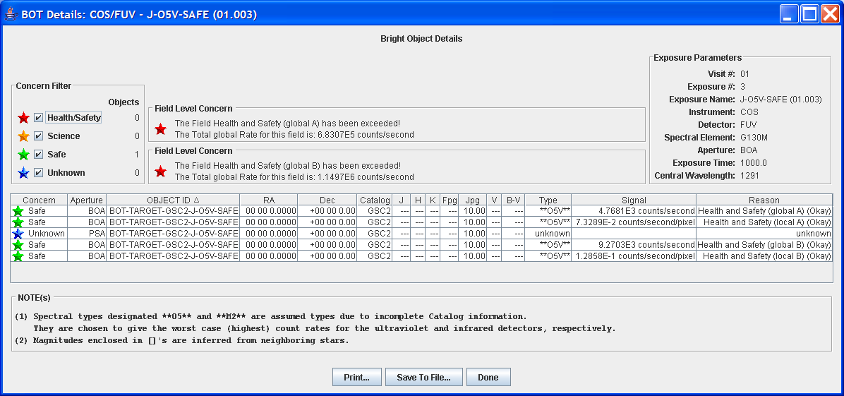
Figure 4-16: Only J, Processed Normally

Exposure 4 (Only J):
Instrument/Detector: COS/NUV
Target: BOT-TARGET (J=2)

The following calculations are used to determine V and B–V:

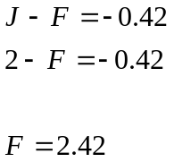

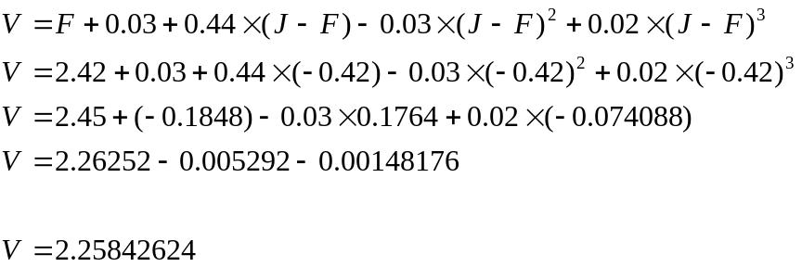

See Figure 4-17 below where an alert has been triggered so BOT lists J, “unknown,” and reason as “unknown.”

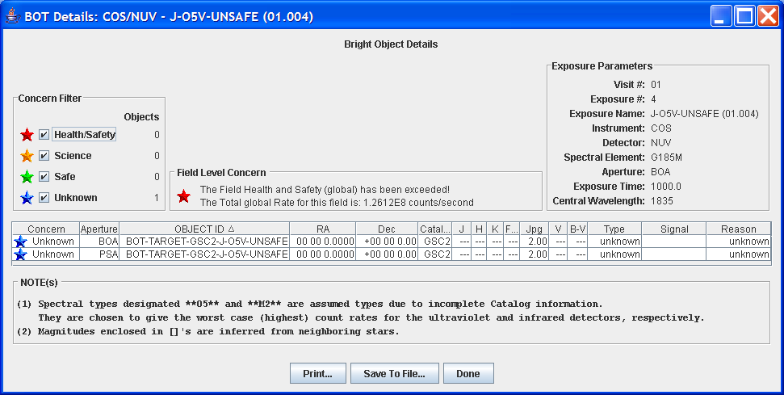
Figure 4-17: Only J, Object Unknown

Large Error on F and J
This proposal will test how V and B–V are calculated when there exists a large (>0.28) error on F and J. The proposal contains two BOT targets. The first target specifies F and J. The second specifies F and J, and a large error for both parameters.

Exposure 1 (No Error, Non-UV):
Instrument/Detector: ACS/WFC
Target: BOT-TARGET (F=15, J=15)

The following calculations confirm B–V:

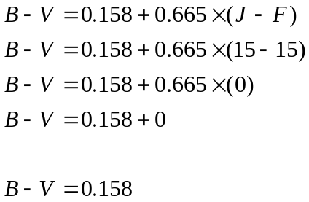

Spectral Type: A5

BOT displays A5 as the spectral type in Figure 4-18.

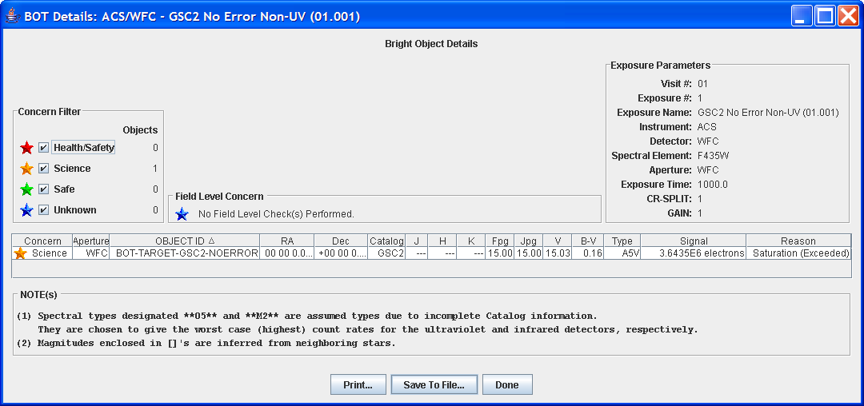
Figure 4-18: No Error, Non-UV Detector; Spectral Type A5

Exposure 2 (Error, Non-UV):
Instrument/Detector: ACS/WFC
Target: BOT-TARGET (F=15, J=15, F_{ERROR}=0.5, J_{ERROR}=0.5)

The tool will adjust the color by the difference between the nominal error and the actual error by making the color bluer by (Error – 0.28m). The Error is calculated by taking the square root of the sum of the squares of the F and J errors.

The following calculations confirm B–V with the errors on F and J:

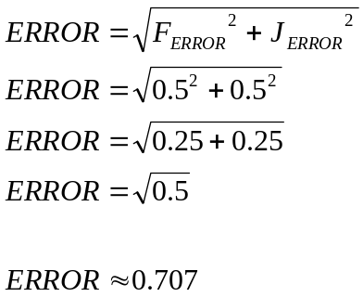

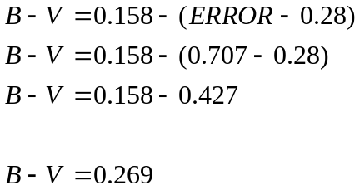

Spectral Type: O5

BOT displays O5 as the spectral type in Figure 4-19.

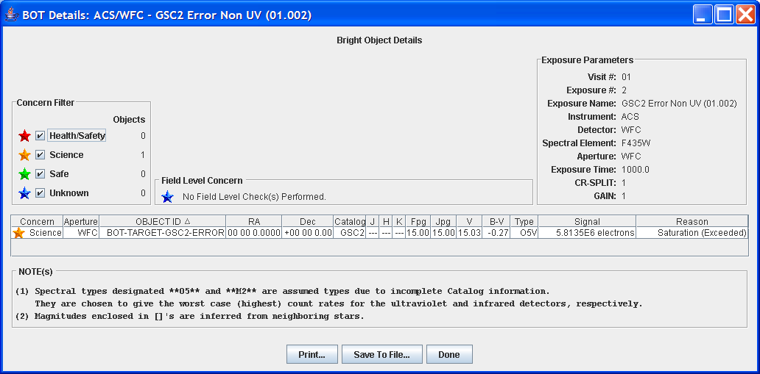
Figure 4-19: Error, Non-UV Detector; Spectral Type O5 – BOT Details Dialogue Box

Exposure 3 (No Error, UV):
Instrument/Detector: STIS/FUV-MAMA
Target: BOT-TARGET (F=15, J=15)

See Exposure 1 for B-V calculation.

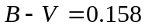

Spectral Type: A5

BOT displays A5 as the spectral type in Figure 4-20.

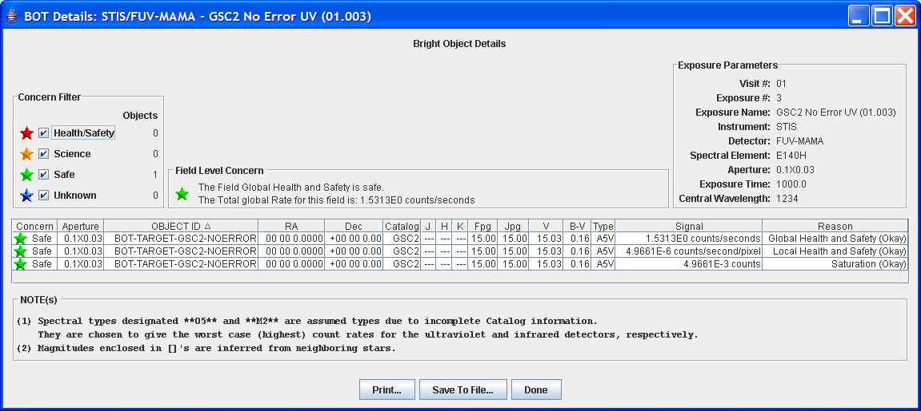
Figure 4-20: No Error, UV Detector; Spectral Type A5 – BOT Details Dialogue Box

Exposure 4 (Error, UV):
Instrument/Detector: STIS/FUV-MAMA
Target: BOT-TARGET (F=15, J=15, F_{ERROR}=0.5, J_{ERROR}=0.5)

See Exposure 2 for B-V calculation.

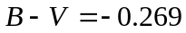

Spectral Type: O5

BOT displays O5 as the spectral type in Figure 4-21.

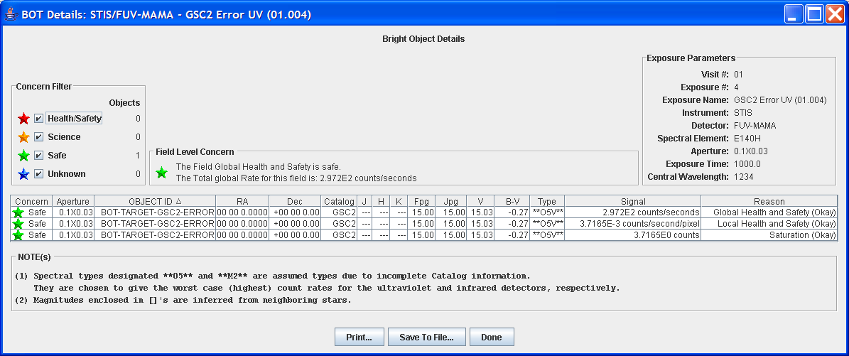
Figure 4-21: Error, UV Detector; Spectral Type O5 – BOT Details Dialogue Box

Ignore ‘Not a Star’ Flag
This proposal will test that the GSC2 ‘Not a Star’ Flag is ignored for all faint objects when using a UV detector, which is implemented in order to account for objects that have poor S/N in the PSF. These objects are relevant for bright object checking, so they are included in the BOT results appearing as “unknown” objects when the flag is ignored. The proposal contains three exposures, one UV detector exposure with a target whose V value is fainter than the limit for accepting the ‘Not a Star’ flag, one UV detector exposure with a target whose V value is brighter than the limit for accepting the ‘Not a Star’ flag, and one non-UV detector exposure with a target whose V value is brighter than the limit for accepting the ‘Not a Star’ flag. In order to enable the ‘Not a Star’ flag, the parameter Type=”?” is used when defining the BOT targets.

Exposure 1 (UV Detector):
Instrument/Detector: STIS/NUV-MAMA
Target: BOT-TARGET (F=16, J=17.12)
Not a Star Flag Set: V>16.5

The following calculations confirm V>16.5 where the ‘Not a Star’ flag is set but ignored:

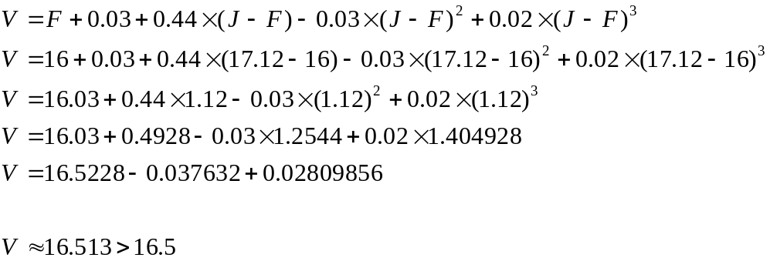

The BOT displays the objects where the ‘Not a Star’ flag is set but ignored in Figure 4-22.

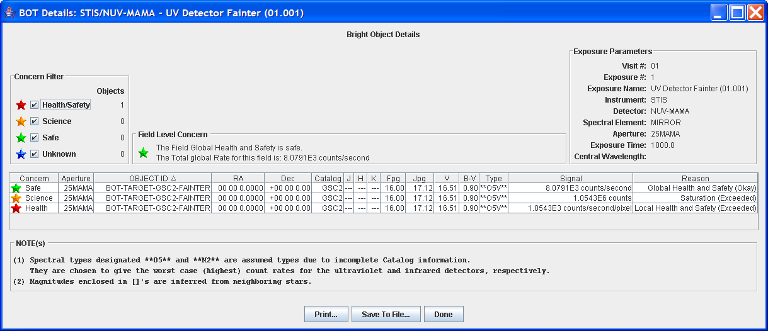
Figure 4-22: STIS/NUV-MAMA; V > 16.5; Not a Star Flag Ignored

Exposure 2 (UV Detector):
Instrument/Detector: STIS/FUV-MAMA
Target: BOT-TARGET (F=15, J=16.7)
Not a Star Flag Set: V>15.8

The following calculations confirm V<15.8 where the ‘Not a Star’ flag is not ignored:

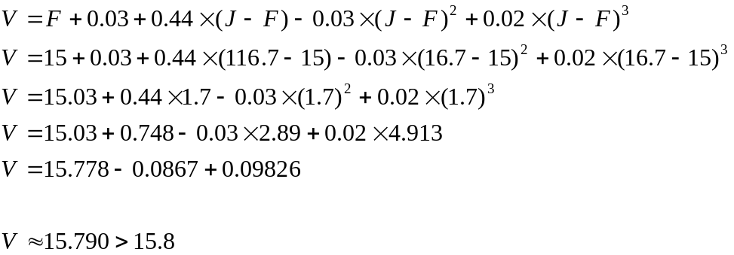

The BOT displays the object type as ‘not a star’ because the ‘Not a Star’ flag is not ignored in Figure 4-23.

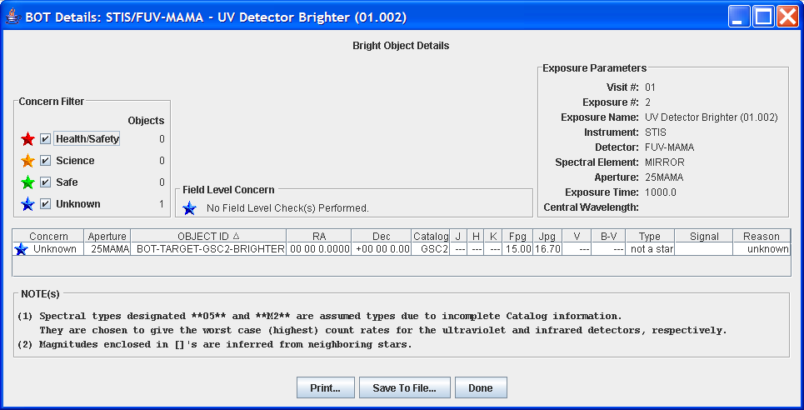
Figure 4-23: STIS/FUV-MAMA; V<15.8; Not a Star Flag Not Ignored

Exposure 3 (Non-UV Detector):
Instrument/Detector: STIS/CCD
Target: BOT-TARGET (F=16, J=17.12)
Not a Star Flag Set: V>16.5

For STIS, when both F & J are listed as parameters, the object is flagged as ‘Not a Star.’ The BOT details dialog lists V, B–V, spectral type = ‘not a star,’ and Reason = ‘unknown.’

See Calculation for V in Exposure 1.

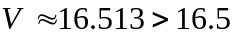

The BOT displays the object type as ‘not a star’ because the ‘Not a Star’ flag is not ignored in Figure 4-24.

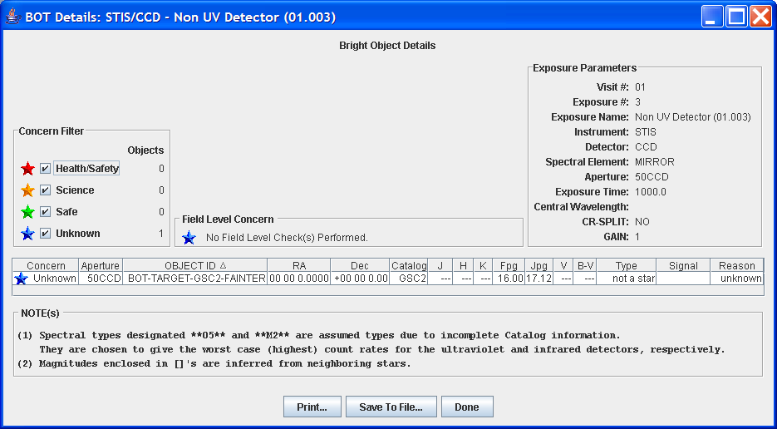
Figure 4-24: STIS/CCD; V>16.5; Not a Star Flag Set

Error Checking
This section will test that BOT correctly handles illegal V & B–V values, as well as incomplete data.

Illegal V
This proposal will test that for any V value brighter (less) than -2.0 or fainter (greater) than 24.0, the photometry is faulty and should not be used. These objects types will be listed as ‘unknown’ or ‘no color info’ and spectral elements will be listed as ‘unknown’ in the BOT details dialogue. This proposal will use four exposures with targets to test four cases of V values, one slightly inside and outside each bound.

Exposure 1:
Instrument: NIC3
Target: BOT-TARGET (V=-1.99, B–V =0)

The V value can be defined directly within the BOT-TARGET definition.

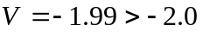

The BOT does not consider the object as faulty since 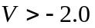 (see Figure 4-25).
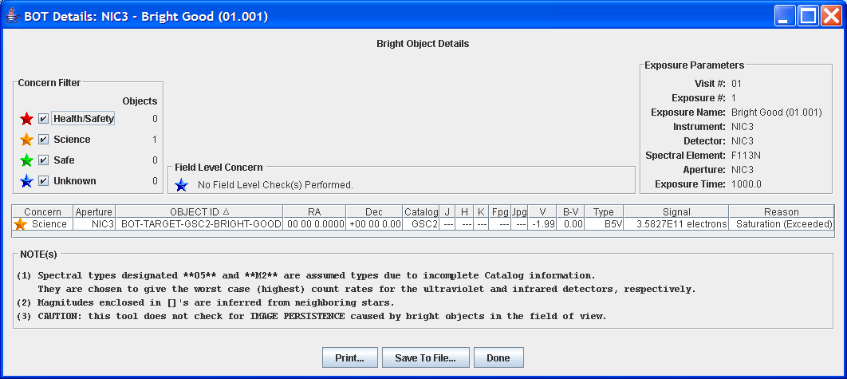
Figure 4-25: V = -1.99 > -2.0

Exposure 2:
Instrument: NIC3
Target: BOT-TARGET (V=-2.01, B–V =0)

The V value can be defined directly within the BOT-TARGET definition.

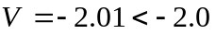

The BOT considers the object as faulty since 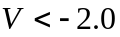 (see Figure 4-26).

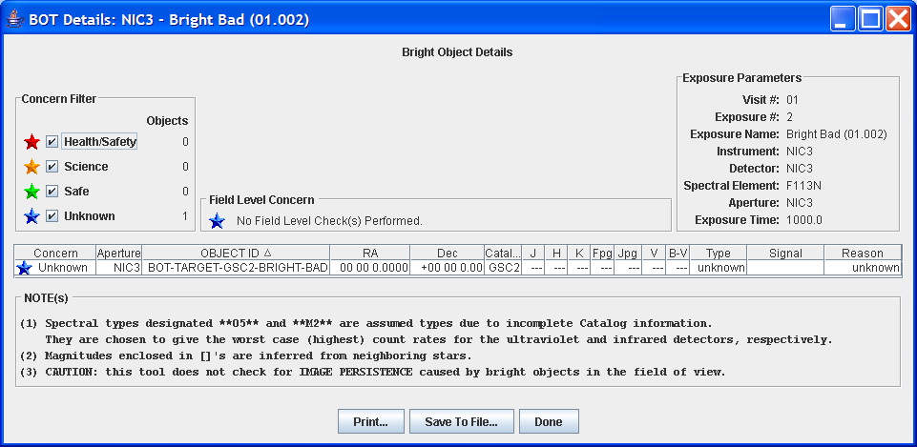
Figure 4-26: V = -2.01 < -2.0 and listed as unknown

Exposure 3:
Instrument: NIC3
Target: BOT-TARGET (F=23.96, J=23.97)

F and J values are used to define V since V and B–V values are not in GSC2 for objects fainter than V=12.0 (See Bright Stars have V and B–V in GSC2).

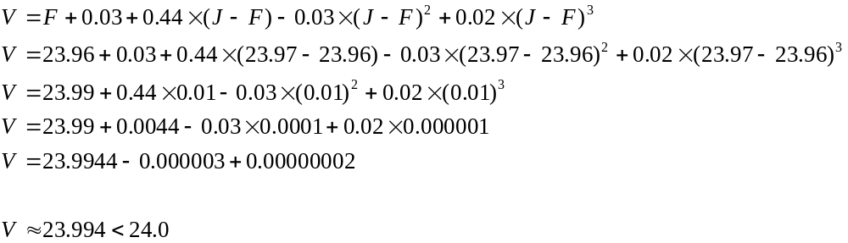
The BOT does not consider the object as faulty since 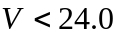 (see Figure 4-27).

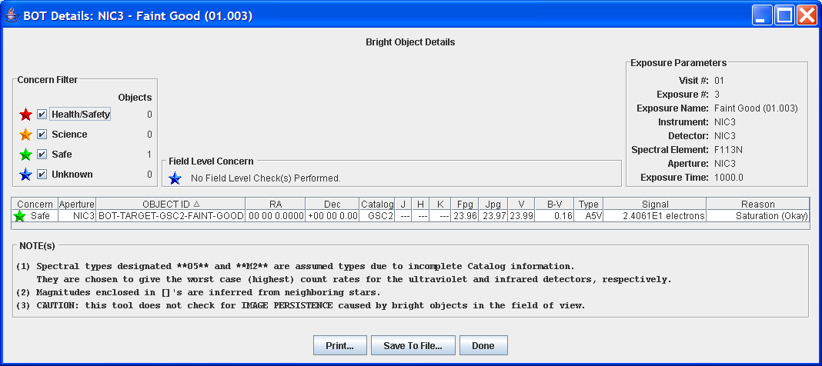
Figure 4-27: V < 24.0

Exposure 4:
Instrument: NIC3
Target: BOT-TARGET (F=23.98, J=23.97)

F and J values are used to define V since V and B–V values are not in GSC2 for objects fainter than V=12.0 (See Bright Stars have V and B–V in GSC2).

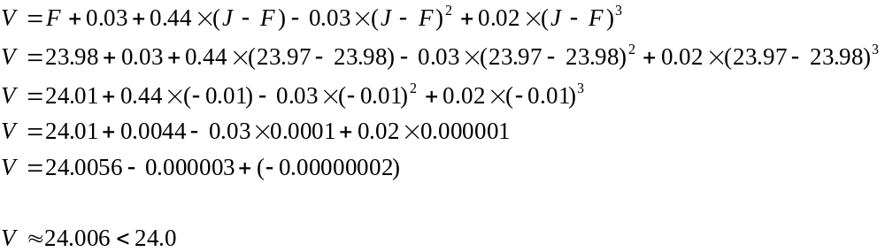
The BOT considers the object as faulty since 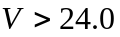 (see Figure 4-28).

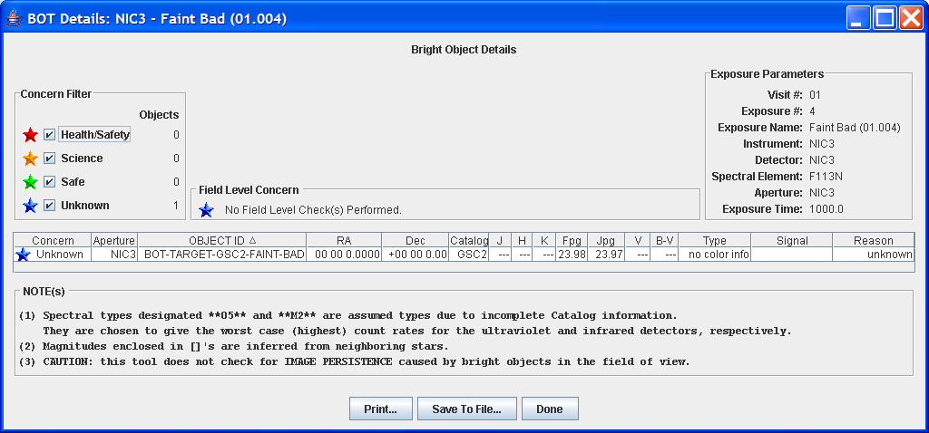
Figure 4-28: V > 24.0 and listed as unknown

Illegal B–V
This proposal will test that for any B–V value bluer (less) than -0.5 or redder (greater) than 3.0, the photometry is faulty and should not be used. These object types will be listed as ‘no color info’ and spectral elements will be listed as ‘unknown’ in the BOT details dialog. This proposal will use four exposures with targets to test four cases of B–V values, one slightly inside and outside each bound.

Exposure 1:
Instrument: ACS/SBC
Target: BOT-TARGET (F=15.0, J=19.27)

F and J values are used to define B–V since V and B–V values are not in GSC2 for objects fainter than V=12.0 (See Bright Stars have V and B–V in GSC2).

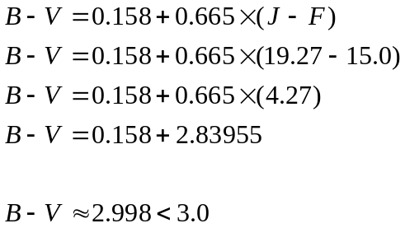

The BOT does not consider the object as faulty since 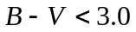 (see Figure 4-29).

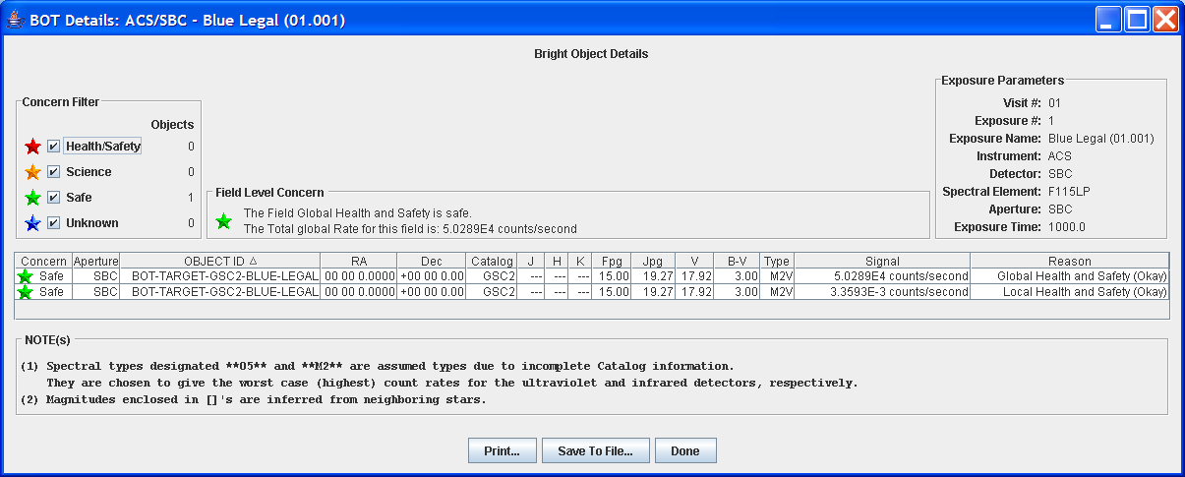
Figure 4-29: B–V < 3.0

Exposure 2:
Instrument: ACS/SBC
Target: BOT-TARGET (F=15.0, J=19.29)

F and J values are used to define B-V since V and B–V values are not in GSC2 for objects fainter than V=12.0 (See Bright Stars have V and B–V in GSC2).

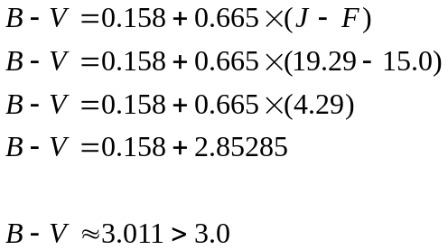

The BOT considers the object as faulty since B–V >3.0 (see Figure 4-30).

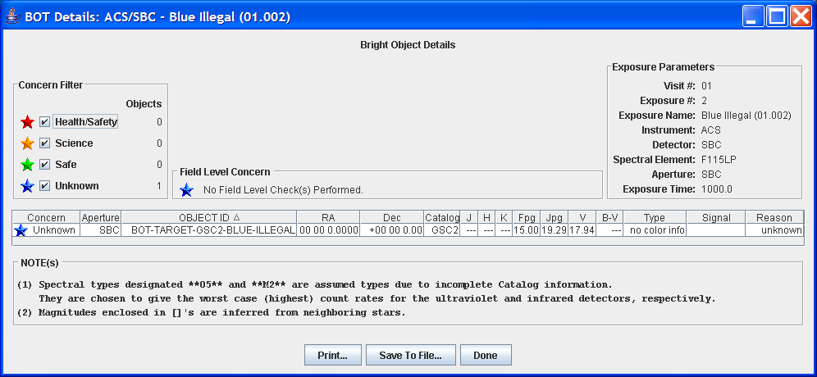
Figure 4-30: B–V > 3.0 and listed as no color info

Exposure 3:
Instrument: ACS/SBC
Target: BOT-TARGET (F=15.0, J=14.02)

F and J values are used to define B–V since V and B–V values are not in GSC2 for objects fainter than V=12.0 (See Bright Stars have V and B–V in GSC2).

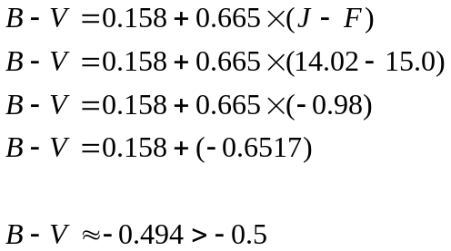

The BOT does not consider the object as faulty since B–V >-0.5 (see Figure 4-31).

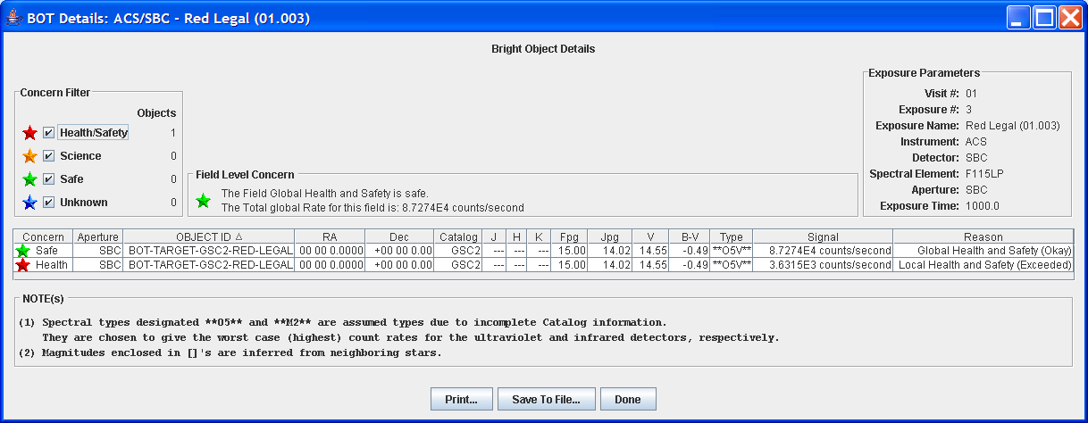
Figure 4-31: B–V > -0.5

Exposure 4:
Instrument: ACS/SBC
Target: BOT-TARGET (F=15.0, J=14.0)

F and J values are used to define B–V since V and B–V values are not in GSC2 for objects fainter than V=12.0 (See Bright Stars have V and B–V in GSC2).

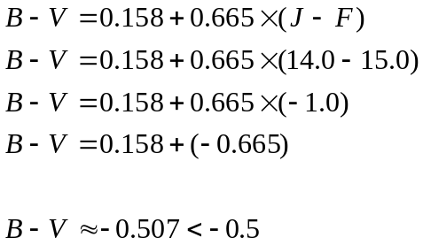

The BOT considers the object as faulty since B–V <-0.5 (see Figure 4-32).

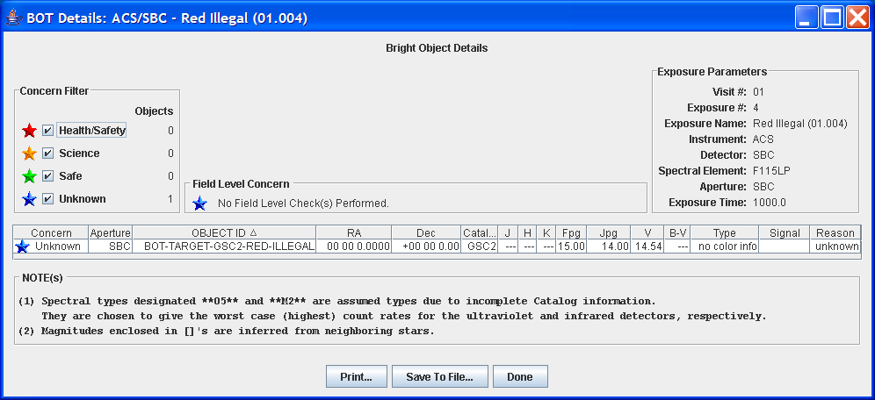
Figure 4-32: B–V < -0.5 and listed as no color info

Incomplete Data
This proposal will test that BOT correctly handles incomplete data, i.e. if only F is specified in the target. Since one case will suffice, the proposal contains one exposure with one target where only F is specified. The BOT details dialog will display F, V, B–V (V and B–V are shown only if present in the GSC2), the reason as "unknown," F as GSC2 value, and spectral type as "unknown" (See Figure 4-33).

Exposure 1:
Instrument: ACS/WFC
Target: BOT-TARGET (F=15.0)

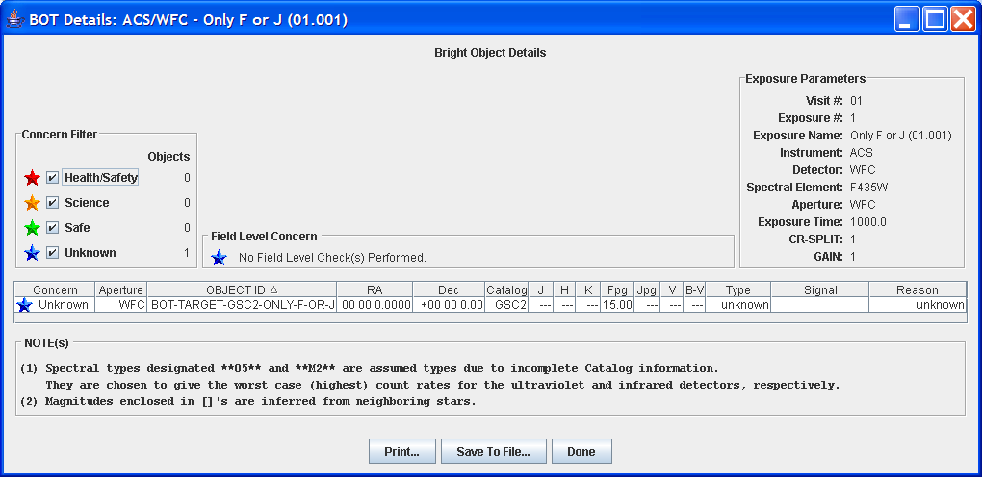
Figure 4-33: Only F Defined and listed as unknown

Trigger Values
This proposal will test the trigger values for the local limit and the global limit. Two real targets are used for two exposures.

The global count rate limit for STIS/FUV-MAMA is 200,000 and the local count rate limit is 100. The saturation for the global count rate is 65,536 electrons.

Exposure 1:
Instrument/Detector: STIS/FUV-MAMA
Target: G-191-B2B (RA: 05 05 28.0305 Dec: +52 49 8.52)

The object NAP9021544 in the BOT results exceeds the local limit:

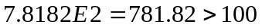counts/second
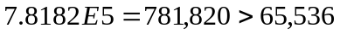electrons

The table below displays the object data taken from the VOT file.

Object ID | RA | Dec | Signal | Reason
NAP9021544 | 05 05 28.6230 | +52 49 16.96 | 7.8182E2 counts/second/pixel | Local Health and Safety (Exceeded)
NAP9021544 | 05 05 28.6230 | +52 49 16.96 | 7.8182E5 counts | Saturation (Exceeded)
Table 5-16: VOT File Object Information, Local Limit Exceeded

Exposure 2:
Instrument/Detector: STIS/FUV-MAMA
Target: Messier 15

Object N2QO000908 exceeds the global limit:

counts/second
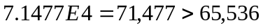electrons

The table below displays the object data taken from the VOT file.

Object ID | RA | Dec | Signal | Reason
N2QO000908 | 21 30 8.4448 | +12 16 14.47 | 2.227E5 counts/second | Global Health and Safety (Exceeded)
Table 5-17: VOT File Object Information, Global Limit Exceeded

Appendix A. Aladin Displays

Search Field

Detector Sizes
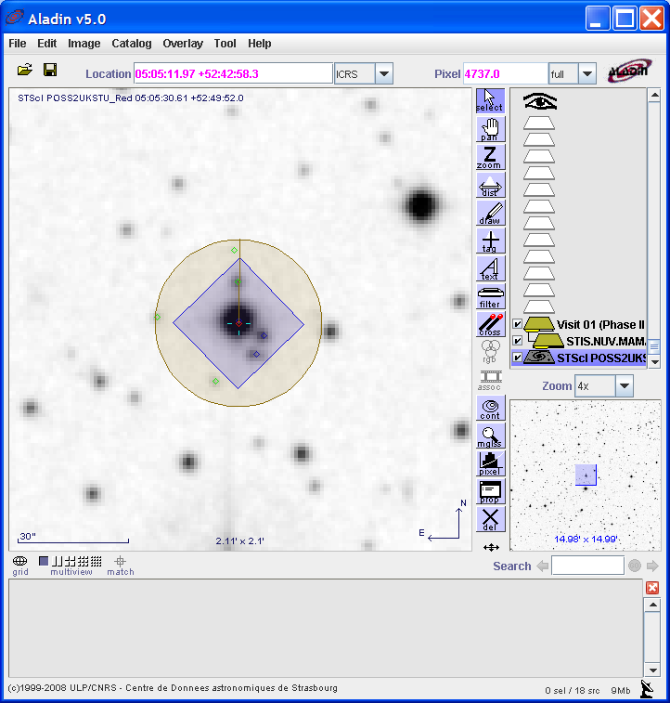
Figure 1-34: Detector Specific Sizes Aladin View

Adjustments

POS-TARG
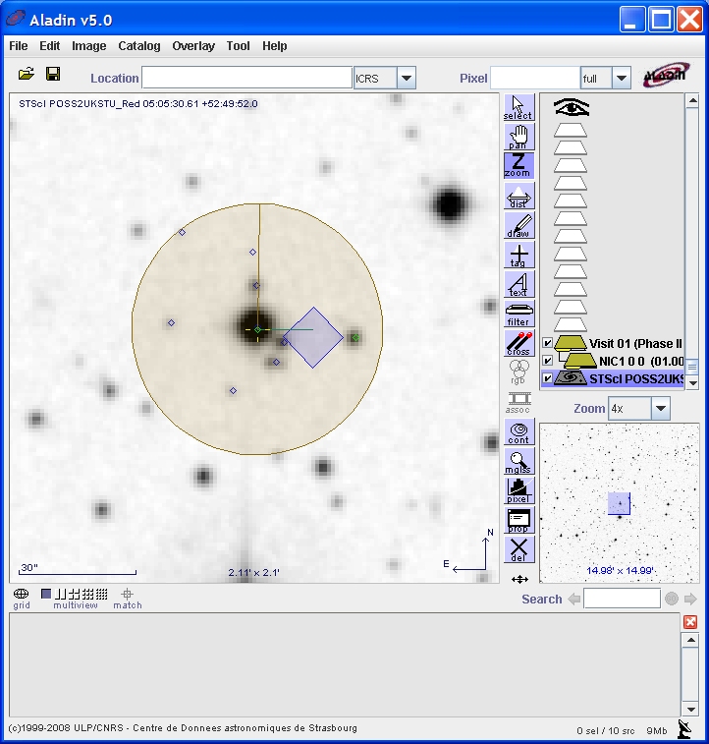
Figure 1-35: POS TARG Adjustment Aladin View

PATTERN
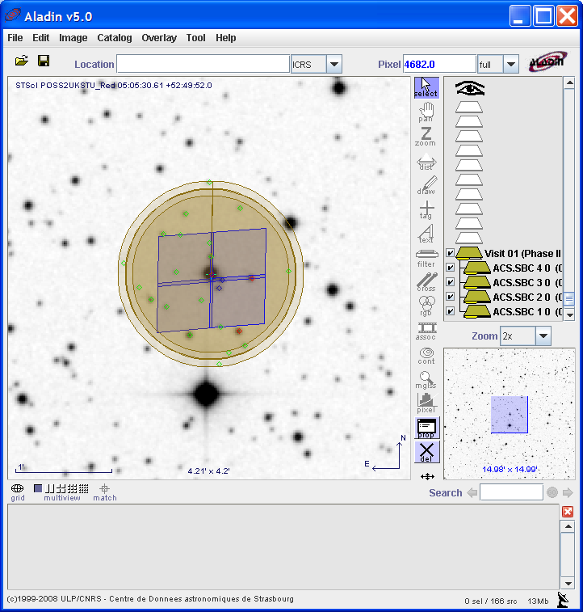
Figure 1-36: Pattern Adjustment Aladin View

Parallel
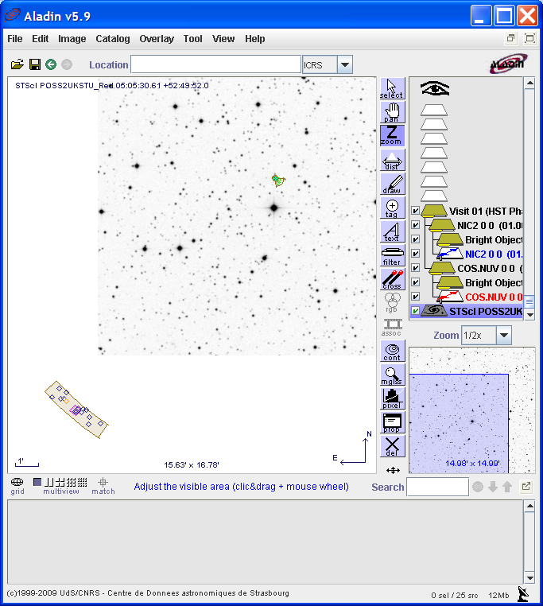
Parallel Exposure
Prime Exposure
Figure 1-37: Prime and Parallel Exposures in Aladin View

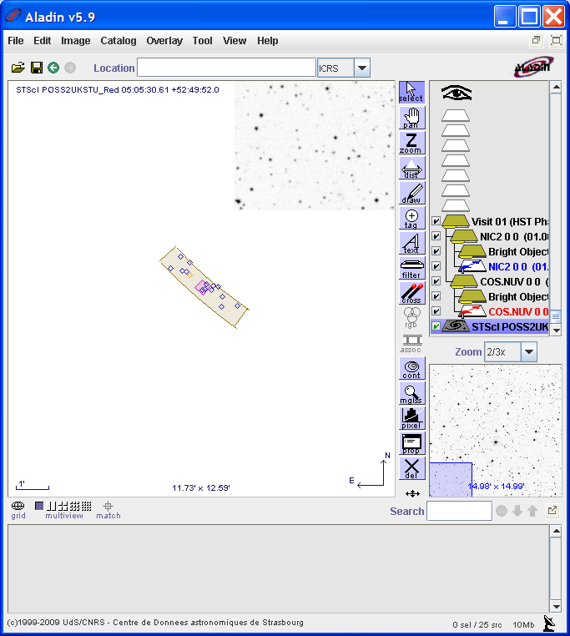
Figure 1-38: Parallel Exposure in Aladin View

COS Dual Aperture
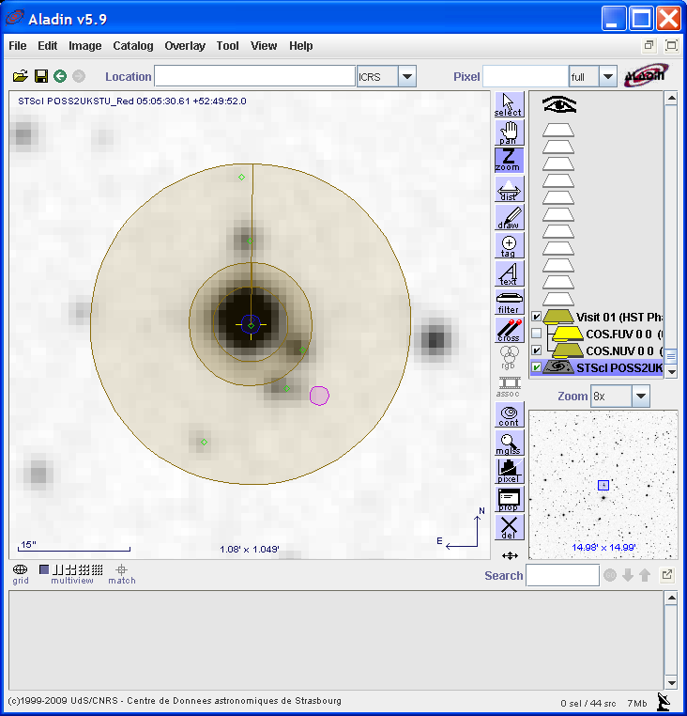
Figure 1-39: COS/NUV Exposure in Aladin View
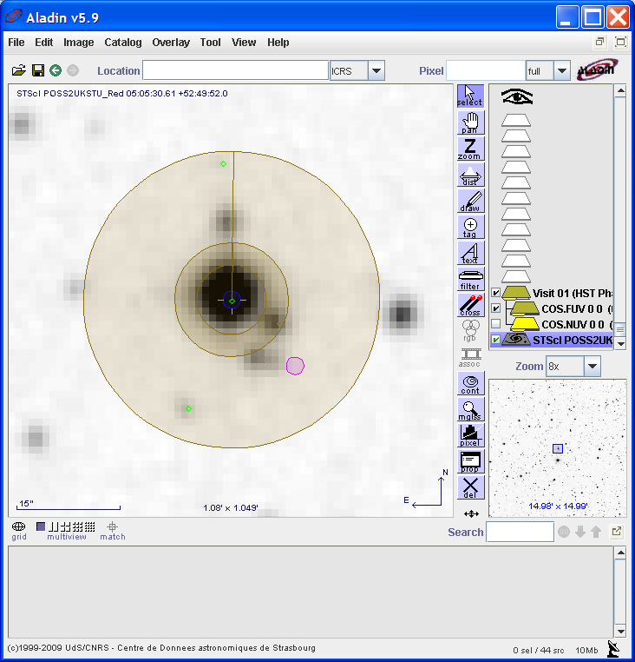
Figure 1-40: COS/FUV Exposure in Aladin View

