WFC Acceptance Testing
Ron Downes
Aug 21, 2006

Summary
A detailed acceptance test for the WFC has been performed. A regression test shows that BOT is giving the correct answers. The new features (exposure expansion, pointing adjustments, actual duration usage, and visualization) are all functioning properly, and BOT can handle error conditions gracefully and provides meaningful feedback to the users.

There is one outstanding issue for the WFC. The optional parameters GAIN and CR-SPLIT, which appear in the details page for an exposure, are not included when you save that page to a file.

Three issues with the Aladin display have been found – a slight misalignment of the BOT overlay with the DSS image, a failure to display all sub-exposures, and a broken link in the Aladin spreadsheet; all of these are known issues with PRs or DRs previously filed.

BOT can be released to the community for the WFC once all sub-exposures are displayed in Aladin, and the optional parameters are included when the details page is saved to a file.

Introduction
For this test, the following target and exposure was used:

Target: FY Com – 12h 49m 16.0s, +27º 25’ 22.00”

Exposure: ACS/WFC, ACCUM, F555W, WFC, 500s, CR-SPLIT=NO, GAIN=2

When appropriate, modifications to the exposure (e.g. POS TARG) are detailed below.

This target/exposure was used to perform the following:

Test | Definition
Regression | Comparison with old VTT/BOT
New features | Exposure expansion, pointing adjustment, actual duration, visualization
Exception Handling | Unsupported exposure (network query and cancel operations were performed with the ACS/SBC, Bad Exposure with the ACS/HRC)

For certain tests, both the tabular and graphic output products are included for ease of comparison with future test results.

Regression Test

The test exposure was run through both the VTT/BOT and the new BOT/Aladin interface. The VTT/BOT used a search radius of 156”, while the BOT/Aladin used 169.66”. This resulted in 17 additional stars being found with the new BOT interface; the magnitudes and derived count rates were identical for the overlapping objects. The 43 objects detected (5 science, 5 safe, and 33 unknown) were:

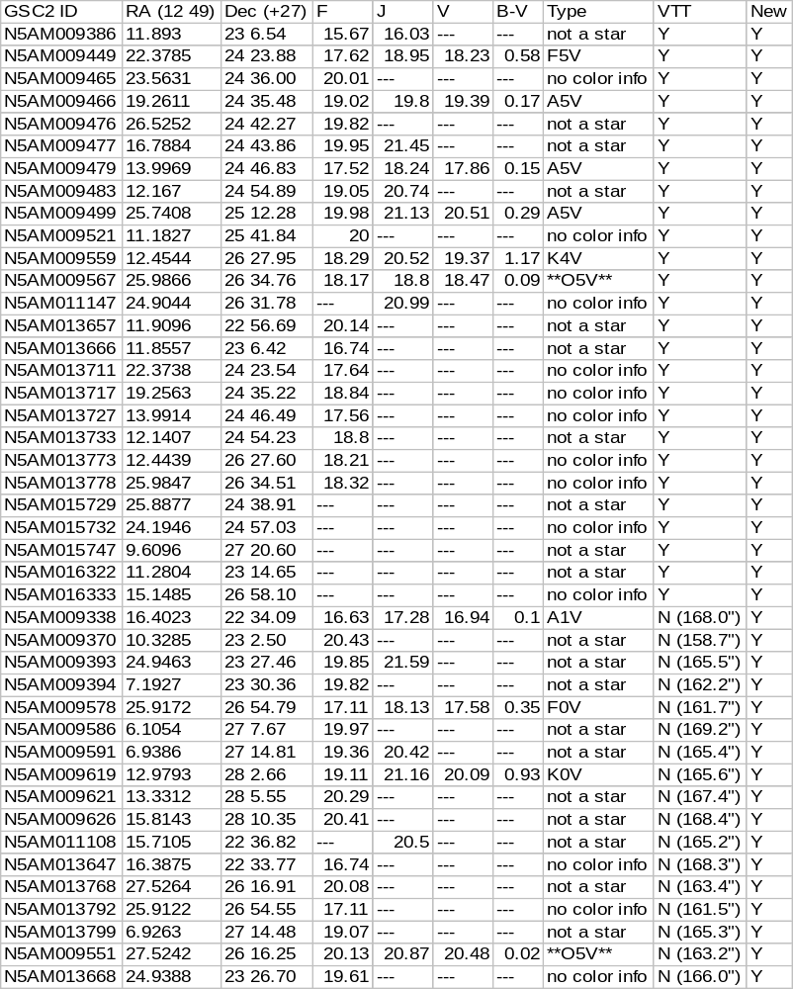

The 17 stars that were only found by the new BOT were all located between 158.7” and 169.2” from the center of the aperture, and are therefore due to the increase in the search radius.

The field map, showing the objects found, is given below.

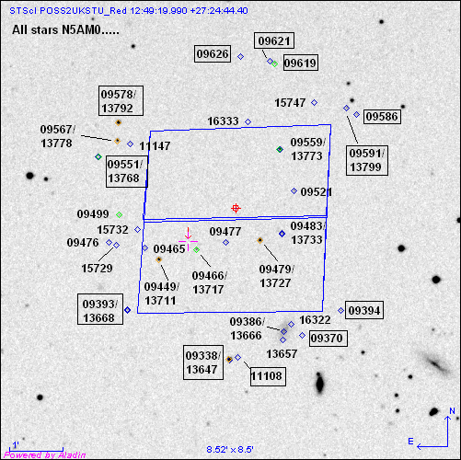

In the figure, all objects were found by the VTT/BOT except the ones in the boxes (described above).

Issue
There appears to be a slight misalignment between the BOT overlay and the DSS image, which is 0.2” in both RA and Dec. The RA offset is consistent (the BOT overlay is always east of the star), while the Dec offset is sometimes north and sometimes south. This discrepancy is small enough (0.2 pixels) to be of no concern, but is covered under APT-VTT DR 1170.

There are two optional parameters – GAIN and CR-SPLIT – that impact the BOT results, and these are displayed in the details page for an exposure. However, they should also be included when you save the results to a file; this is covered in APT-BOT PR 56382.

New Features

Exposure Expansion
For the HRC, there are three ways for exposures to be expanded – use of the CR-SPLIT optional parameter, number of iterations greater than 1, and the use of a pattern; it is also possible to combine these methods (i.e. CR-SPLIT and pattern). The following cases were tested:

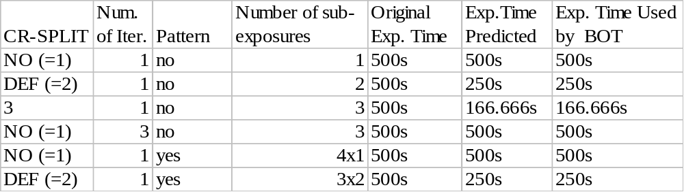
In each case, BOT created the correct number of sub-exposures, and modified the given exposure time correctly. As with the SBC, Aladin did display the BOT overlays, although there was only 1 image plane shown for the CR-SPLIT and number of iterations cases, unlike the Pattern case where each sub-exposure was its own plane. Since the CR-SPLIT and number of iterations planes would all be, by definition, identical, showing only 1 plane is acceptable (however, if the actual duration field was used, a problem could result).

Pointing Adjustment
There are 3 different types of pointing adjustments valid for the HRC – POS TARG, PATTERN, and use as a PARALLEL instrument.

POS TARG

For this test, the standard exposure was modified by adding a POS TARG of X=-40” and Y=-40”. The direction of the POS TARG is important in this test, and in order to be able to simply predict the size of the POS TARG motion, the motion must be in the same direction as the "Search Radius Vector" which is defined as the point from the fiducial to the outermost corner of the Aperture; for the WFC this is the lower left corner. A selection in a different direction makes the calculation of the motion vector more complicated.

The test exposure was run through both the VTT/BOT and the new BOT/Aladin interface. The VTT/BOT used a search radius of 156”, and only did analysis at the exact pointing (i.e. it assumed ORIENT=0). The new BOT increased the search radius by 50” (40” for the POS TARG, 10” for the larger search radius) to 206”, which resulted in a circle being analyzed to support any possible ORIENT value. Based on the size of the POS TARG, this increase in search radius was less than the predicted value (i.e. SQRT(40*40 + 40*40) = 56.5), which implies that the direction of the POS TARG was not properly aligned. I then ran a series of POS TARGs from 10”-50” in steps of 10”, and the increase in search radius was 13.8” each time, very close to the predicted value of SQRT(10*10 + 10*10) = 14.1”, so it appears the search radius is being properly incremented for POS TARGs.

With the increased search radius, the new BOT analyzed more objects than the VTT/BOT, but all objects in the VTT/BOT were detected, and for those objects, the magnitudes and derived count rates were identical.

The 67 objects detected (7 science, 7 safe, and 53 unknown) were:

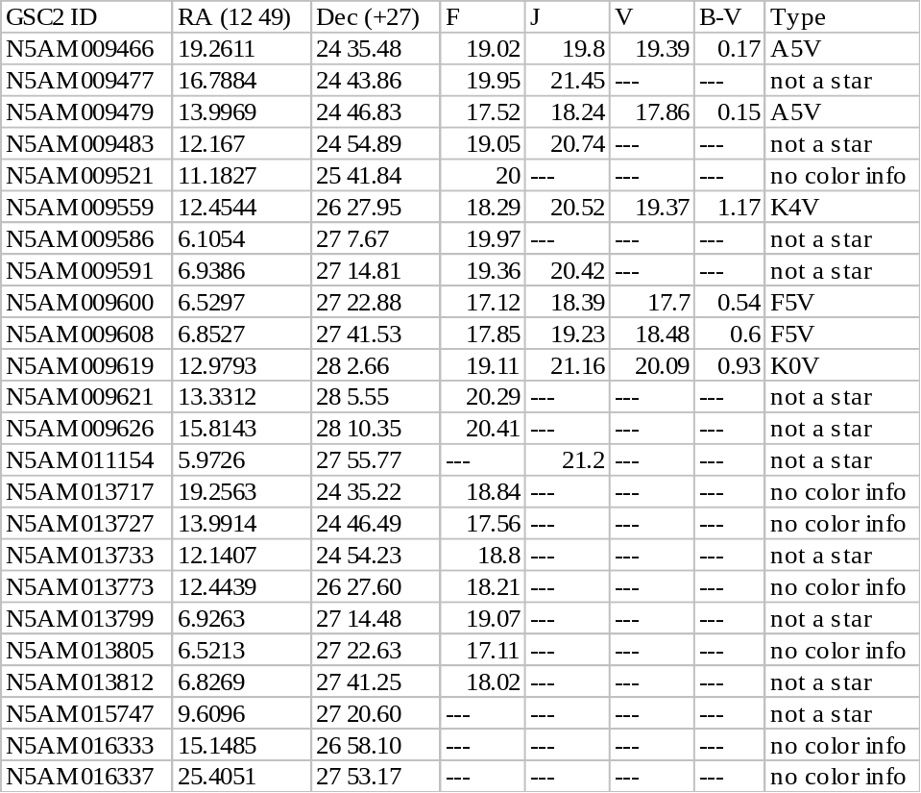

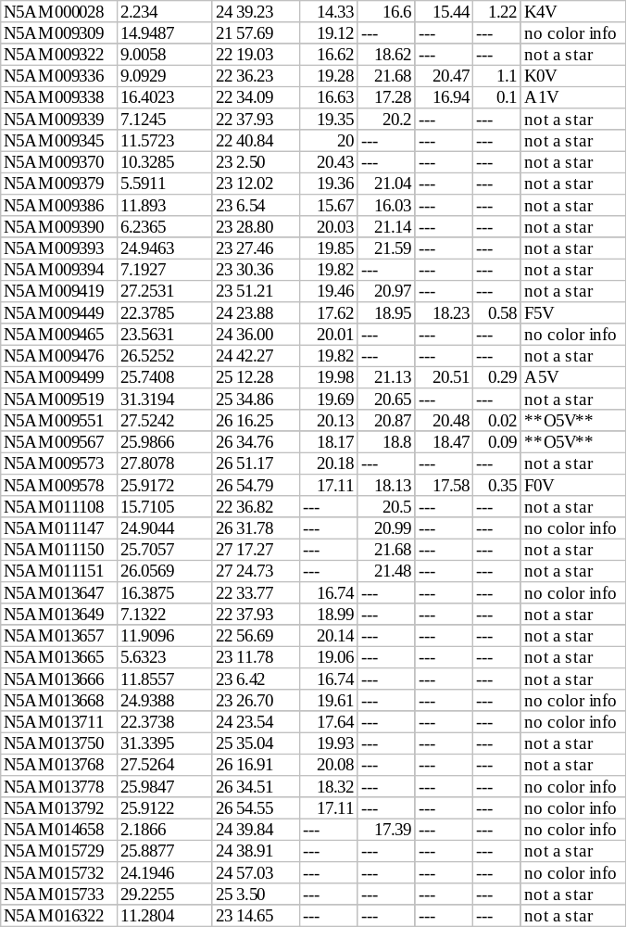
The field map, showing the objects found, is given below.
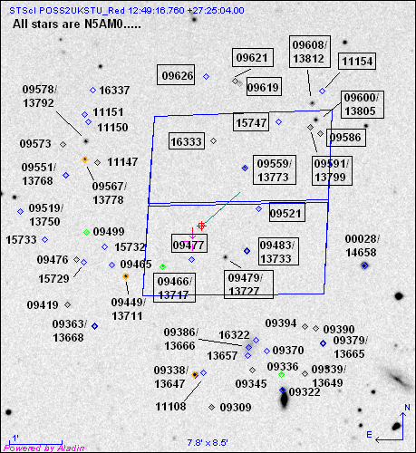
In the figure, the objects in boxes were found by the VTT/BOT. The new objects are all in the area that is expected.

Pattern

For this test, the standard exposure was modified by putting it in a PATTERN (a WFC-DITHER-LINE with 3 points with a 5” spacing at an orientation of 225º). The orientation of the pattern is important in this test, since in order to be able to simply predict the size of the PATTERN motion, the motion must be in the same direction as the "Search Radius Vector" which is defined as the point from the fiducial to the outermost corner of the Aperture; for the WFC this is the lower left corner. A selection in a different orientation makes the calculation of the motion vector more complicated.

The test exposure was run through both the VTT/BOT and the new BOT/Aladin interface. The VTT/BOT used a search radius of 156”, and only did analysis as if there were no pattern. The new BOT did 3 searches – one for the initial pointing (with the standard 169.8” search radius) and one for each of the two pattern points (with the search radius decreased to 164.4” and 159.6”); all objects in the initial pointing were included in the larger pattern pointing report, as expected. The expanded (in this case decreased) search radius was calculated to be 162.7” and 155.7” for the non-central pattern points; this was in error by 1.7” for each point (5.4” separation instead of 7.1”), which is an acceptable level of accuracy. With the increased search radius, the new BOT analyzed more objects than the VTT/BOT, but all objects in the VTT/BOT were detected, and for those objects, the magnitudes and derived count rates were identical.

The 43 objects detected (5 science, 5 safe, and 33 unknown) were:

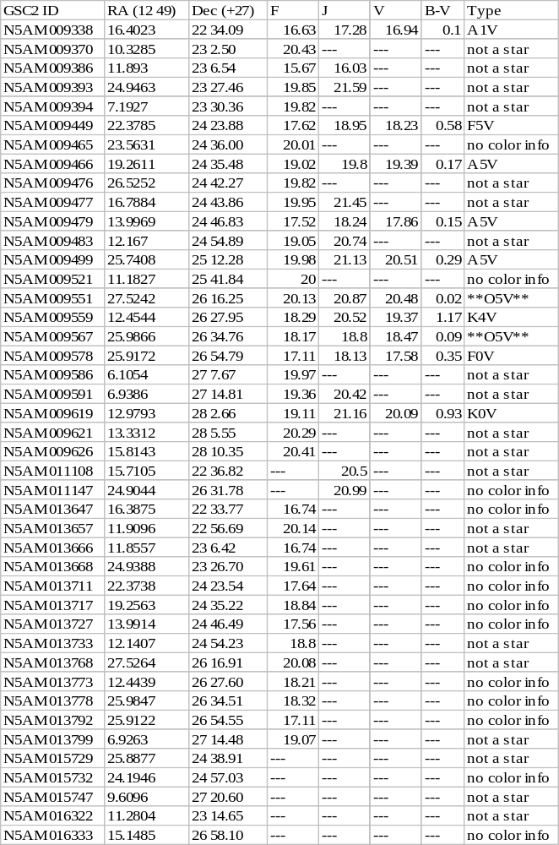
The field map, showing the objects found, is given below.
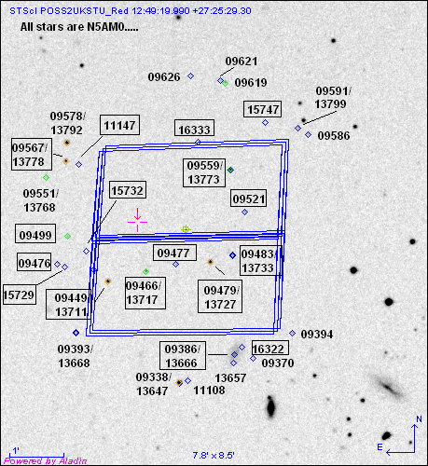

In the figure, the objects in boxes were found by the VTT/BOT. The new objects are all in the area that is expected.

Parallel

For this test, the standard exposure was modified making it be a coordinated parallel observation with a WPFC2 prime exposure. The test exposure was run through the new BOT/Aladin interface only; the old VTT/BOT did not take the position of the parallel aperture into account when performing its checking. The search radius used by BOT was 8.88’. The separation between the PC and WFC is 6.21’, and after adding 2.83’ for the standard search radius, the approximate search radius BOT should have used is 9.04’, very close to what was actually used. Given that the apertures are not aligned along the Search Radius Vector (described above), this small difference (especially given that BOT uses a larger radius) is not important.

A total of 923 stars were found in the new BOT, so the table below only lists the science concerns (35). The objects detected were:

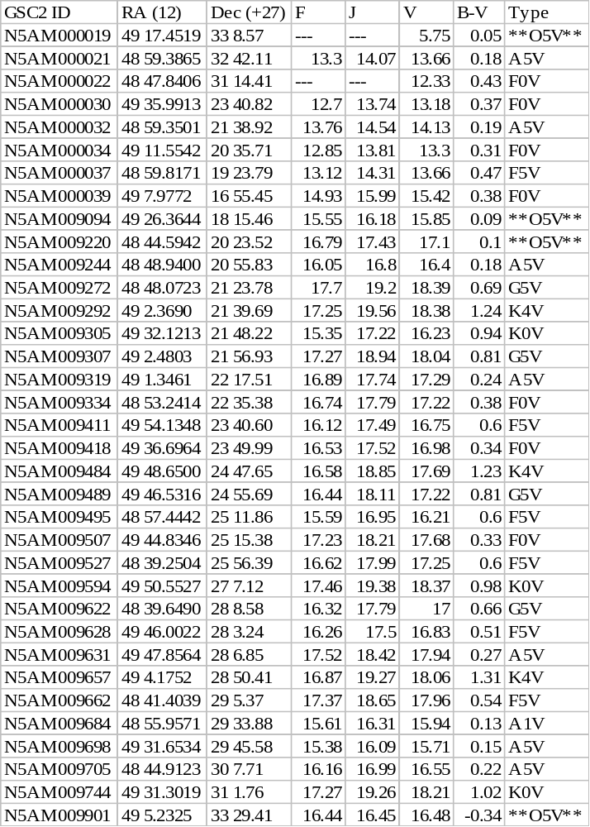
The field map, showing the objects found, is given below.

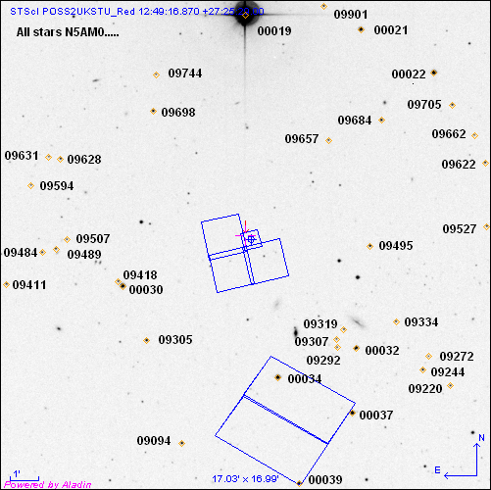

Actual Duration
There are three ways in which the WFC can use actual durations – a CR-SPLIT exposure, a pattern exposure, and a number of iterations greater than 1 exposure. For this test, the second piece of a CR-SPLIT, the third piece of the pattern, and the third piece of a number of iterations=3 exposure will have the actual duration set to 100s, 200s, and 200s, respectively.

CR-SPLIT
An examination of the BOT details shows that the revised exposure time for the second piece of the CR-SPLIT was detected by the tool, and that value was used in the determination of the total counts from the stars; for the other pieces of the CR-SPLIT, the exposure time of 166.6s was used.

Pattern
An examination of the BOT details shows that the revised exposure time for the third piece of the pattern was detected by the tool, and that value was used in the determination of the total counts for the stars; for the other pieces of the pattern, the exposure time of 500s was used.

Number of iterations
An examination of the BOT details shows that the revised exposure time for the third piece of the pattern was detected by the tool, and that value was used in the determination of the total counts for the stars; for the other pieces of the number of iterations, the exposure time of 500s was used.

Issue
For CR-SPLIT and number of iterations, only the first sub-exposure is shown in Aladin. If there were different actual durations, both sub-exposures would need to be display, as they could have different answers. This is a problem is covered in APT-BOT OPR 56136, and should be corrected prior to the release of the tool for WFC usage.

Visualization - done
- There are many aspects to this test, all of which have already been verified by the previous SBC and HRC testing.

Issue
Aladin spreadsheet name link to an external html page with more details fails for the GSC2; this is covered with APT-VTT DR 1197.

Exception Handling
There are four types of exception handling to be tested; Network Query Error and Cancel Ongoing Operations have been verified in the SBC testing, and Bad Exposures has been verified in the HRC testing.

Unsupported Exposures
There are is 1 unsupported aperture (WFC2-2K) for the WFC, and 1 unsupported spectral element (CLEAR); when these are used, an appropriate error message is given.
There are 2 unsupported GAIN values (4 and 8).

