The Integrated Bright Object Tool (BOT) – WFC3/IR
R. Downes, K. Henshaw, C. Moriaryy, T. Rogers, K. Peterson
May 20, 2013

A integrated Bright Object Tool (BOT) has replaced the old VTT-based RObust Bright Object Tool. The main engine for the tool, as well as the basic processing steps, has remained unchanged, but the source of the input data, as well as the display of the results, have been changed to provide more complete tool. The tool will check each exposure in a program for field (and prime) objects that are either health-and-safety concerns, or may impact the scientific value of the data. The tool will utilize the 2MASS catalog to determine the brightness of all objects in the macro-aperture, determine the count rate and total counts for each object via a lookup table, and compare these values to limits set by the WFC3 Group. In those cases where there is no 2MASS data available, the tool will fall back and use the GSC2 catalog to determine the brightness and (rough) spectral type of all objects. The output products will be a table listing those objects that are possible problems, and an Aladin image with the offending objects indicated.

The new tool utilizes information in the proposal file, and also uses the APT and Aladin interfaces for its tabular and graphical display, respectively. For Instrument Scientists,
the use of the proposal file, instead of the ASSIST database, allows for the support of position changes (e.g. POS TARGs) for exposures. For GOs, the use of the proposal file allows for more than one exposure to be processed at one time, making it much easier to run the tool on the entire proposal.

Introduction
The VTT-based Robust Bright Object Tool (ROBOT) has be utilized by both GOs and Instrument Scientists since Cycle 10. One of the main deficiencies of the tool for Instrument Scientists has been the inability to handle exposures with positional changes (e.g. POS TARGs), which is due to the need to access the ASSIST database. For GOs, the need to run each exposure individually makes proposal checking extremely tedious. The new tool will utilize information in the proposal, which eliminates both problems. The tool will use information in the Phase II proposal to identify all the stars in the macro-aperture that are in the 2MASS catalog, and if no objects are found, the GSC2 catalog will be searched. The brightness of the objects will used to determine count rates (and total counts) for each star via a lookup table (based on Exposure Time Calculator results); if the GSC2 is used, color information will be converted to spectral types in order to derive the count rates and total counts. The final products will be a tabular view of analysis of each star in the field (available through the APT interface) and a graphical view (available through the Aladin interface), in which all stars with health-and-safety concerns are labelled in red, all stars with science concerns (e.g. bright targets that could bleed) are labelled in orange, all stars for which an analysis could not be performed (e.g. incomplete color information) are labelled in blue,and all stars that are safe are labelled in green. There will also be a printable and downloadable listing of the results for all targets.

It is important to note that BOT will only be useful for field stars that are in the 2MASS/GSC2 catalogs, and for the target if it is a normal star. Since most science targets are not normal main- sequence stars, use of the ETCs to fully verify the prime targets will still be required. Extended targets will not appear in the 2MASS/GSC2 catalogs, and will therefore need to be checked by hand. Variable targets, although in the catalogs, will only have the magnitude at the time of the survey observations, and may therefore not have the “correct” magnitude for the time of the HST observation. While most variables have small amplitudes, some objects (e.g. cataclysmic variables and symbiotics) have large amplitudes, which could pose problems (either as field objects, or as the prime target).

In this document, we describe how the tool works. This tool will enhance (compared with the VTT-based ROBOT) the bright object checking performed by the Instrument Groups, and can allow PIs to more easily do their own checks to assure their observations are valid from both a health-and-safety as well as scientific integrity perspective.

Assumptions
The following assumptions were made in implementing BOT processing:

- For 2MASS data, no spectral type determination will be made. Analysis by the WFC3 Group has shown that there is little dependence on type, and whatever dependence exists is accounted for in the lookup tables (which are for a filter-dependent, worst case spectral type).

- The size of the macro-aperture (search radius) is padded over the nominal size to account for possible mispointings (but still close enough for the Guide Star acquisition to be considered successful) of HST. The size of the pad – 10.4" - was determined by the Instrument Group.

- When processing exposures that use the subarray apertures, the BOT search is performed using the full-field aperture size.

- All field objects are Main Sequence stars. This is a reasonable assumption, although it will not be always correct (e.g. most prime targets are not normal stars). This is the only assumption possible due to only 1 color being available for the GSC2, and was also used for 2MASS data.

- All objects have no reddening. This is clearly incorrect in the plane, but is not unreasonable at high galactic latitude (where most HST observation are obtained). This is the only assumption possible due to only 1 color being available for the GSC2, while for 2MASS, having the data in the bandpass of the detector minimizes the impact of reddening on the results.

- The GSC2 flag indicating the object is not a star is ignored for all faint (V > 17) objects. This is due to the fact that the reason most of these objects have the flag set due to the poor S/N in the PSF. While is issue is important in determining the object can be used as a guide star, it is not relevant for bright object checking. Failure to do this resulted in a large number of "unknown" objects appearing in many fields, which then needed to be "manually" cleared.

Processing Steps
- The user loads their Phase II APT file, and selects their desired exposure(s) to process.
- The user clicks on the BOT button to bring up the tool, and clicks on the Update Display button to begin processing.
- The 2MASS All Sky Point Source Catalog (PSC) is searched for all objects within the macro-aperture. The tool should also check the data quality flags cc_flg, gal_contam, and mp_flg, and only accept the magnitude as valid if the flag is set to 0. The macro-aperture is a circle centered on the fiducial point of the aperture (i.e. where the prime target will be placed) that encompasses the entire aperture with a pad to account for pointing errors.
Detector | Shape | Radius | Radius in ROBOT | Radius in BOT
WFC3/IR | quad | 94.6 | N/A | 105.0

Note that this definition of the macro-aperture is not always consistent with the values in the SIAF files. All area targets are ignored. The information returned is the object name, coordinates, and magnitudes (J, H, and K).
- The exposure information is derived from the proposal file, and the relevant parameters are given below.
Exposure Parameters
Detector | Parameters
WFC3/IR | spectral element, NSAMP, SAMP-SEQ

- Based on the magnitudes, apertures, and exposure information, determine the count rate and total counts for each star via a lookup table (see Appendix 1 – 2MASS Count Rate Lookup Table). The table will contain the count rate for most (see Appendix 2 – Number of Instrument Configurations) instrument configurations for a J = J_{o} or H = H_{o} object. To scale for the true magnitude of a star, multiply the table value by 10^{(0.4*[Jo-Jobj])} (or 10^{(0.4*[Ho-Hobj])}). To determine the total counts, multiply the corrected count rate by the derived exposure time.
- Based on the count rates and total counts, perform the health-and-safety and science checks as described below. Note that only the worst case message should be displayed (e.g. if the counts are 1,000,000, the single message for the target should be moderate saturation).

Checks Performed by BOT
Saturation  (electrons) | Warning message¹
60,001 – 225,000 | Moderate Saturation (>0.8X); level = value
> 225,001 | Severe Saturation (>3.0X); level = value

¹ Value = observed total counts/60,000.
Also note that the following precautionary messages will be displayed regarding persistence:

Moderate Saturation: Objects with total accumulations of charge at this level or above will produce noticeable persistence in exposures within a single orbit, and may produce some persistence in the subsequent orbit, particularly for objects a factor of 2
brighter than the cut-off value.

Severe Saturation: Objects with total accumulations of charge at this level or above will not only produce noticeable persistence within this orbit but in long exposures in subsequent orbits. The persistence image will include not only the core but also the
wings of the psf of the object causing the persistence.

- For all objects, produce a table giving the following:
Catalog | Table Items
2MASS | 2MASS name, coordinates, J¹, H¹, and K¹ magnitudes, signal (count rate and total counts), and an indication of the status of the object
GSC2 | guide star name, coordinates, F¹ and J¹ magnitudes, converted V and B-V magnitudes, spectral type², signal (count rate and total counts), and an indication of the status of the object

¹ if any magnitude is undefined, convert the default value of “-99.9” to “unknown”.
² For assumed spectral types (i.e. M2), indicate type is assumed and not derived from the B-V color.
A summary table is also be produced, and these tables are printable and downloadable to be a file.

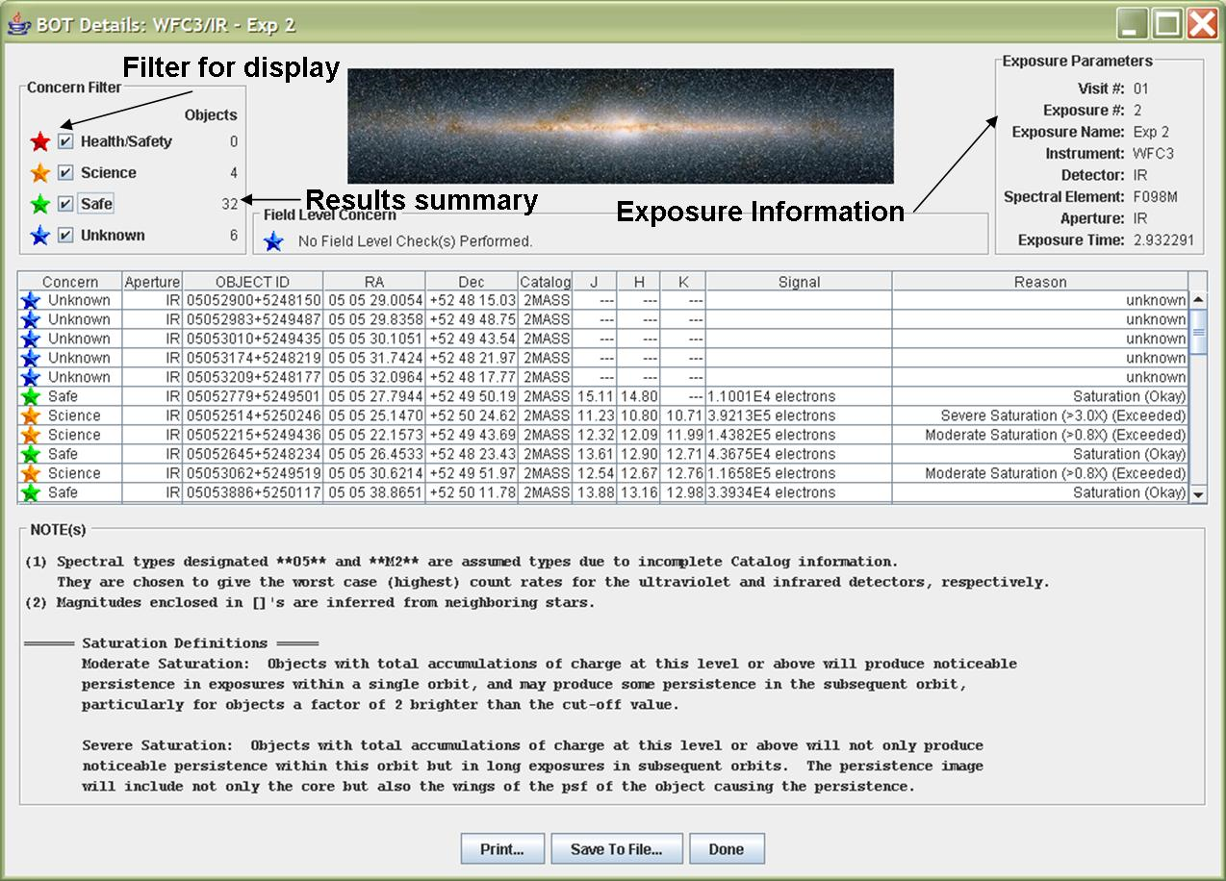
For all objects, produce an overlay for Aladin which marks objects that are health-and-safety concerns in red, science concerns in orange, unknown concerns in blue, and safe objects in green.
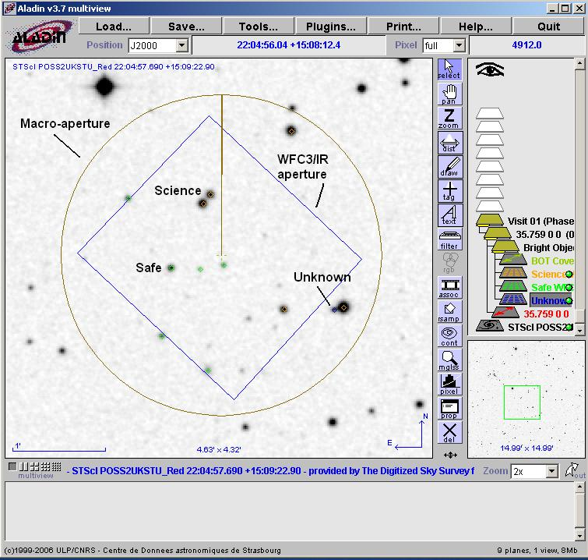

Appendix 1 – 2MASS Count Rate Lookup Table

The following item was used in creating the lookup table:
- 2MASS mag = 15

WFC3 Filter | 2MASS band | Count Rate (electrons/sec)
F098W | J | 2834.8
F105W | J | 4321.9
F110W | J | 6116.3
F125W | J | 2856.0
F126N | J | 140.7
F127M | J | 711.5
F128N | J | 160.9
F130N | J | 164.3
F132N | J | 142.1
F139M | J | 425.9
F140W | J | 3061.9
F153M | H | 372.8
F160W | H | 1493.5
F164N | H | 101.2
F167N | H | 91.7

Appendix 2 – Number of Instrument Configurations

To keep the lookup table manageable, we will make several simplifying assumptions. For WFC3/IR, the grisms are excluded.

The following table estimates the number of entries in the lookup table for WFC3/IR.

Instrument Configurations
Instrument | Parameters | Configur ations | Spectral Types | Total
WFC3 | IR 15 filters | 15 | 13 | 195

Appendix 3 – GSC2 Processing Steps

The following steps should be performed when no 2MASS data is available, These replace steps 3-5 above.

- The GSC2 is searched for all objects (even those flagged as not usable as guide stars) within the macro-aperture. The information returned is the object name, coordinates, and magnitudes (F and J). Note that Tycho entries (objects with V < 12) in the GSC2 will have V and B-V, and these must be corrected to get them on the standard system via:
V(corrected) = V(Tycho) - 0.09*B-V(Tycho)
B-V(corrected) = 0.85*B-V(Tycho)
- The F and J magnitudes are converted to V and B-V via the following conversions:
- for the northern hemisphere (determined by the coordinates of the stars)
V = F + 0.03 + 0.44*(J-F) - 0.03*(J-F)² + 0.02*(J-F)³
B-V = 0.158 + 0.665*(J-F)
- for the southern hemisphere
V = F + 0.03 + 0.43*(J-F) - 0.02*(J-F)² + 0.02*(J-F)³
B-V = 0.158 + 0.665*(J-F)
- Some objects in the GSC2 do not have both and F and J magnitudes, while other objects are not considered stars. The treatment of these objects depends on the detector selected, and is described in the table below.
Detector | no F and no J | F and no J
WFC3/IR | list F, J, V, B-V, and reason as "unknown", spectral type as "no color info" | Assume the object is an M2 star, with F-J=2.08 (south) or 2.22 (north), and use this to determine V. Do not determine J or B-V. List F and V as GSC2 value, J and B-V as blank, spectral type as M2V (assumed)

Detector | no F and J | F and J, not a star
WFC3/IR | Do a second query of the GSC2 using a 10 arcminute radius centered on the target coordinates. From the targets detected in this query, select the F magnitude of the faintest object, and add (make brighter) 0.2 magnitudes.  Use this value as the F magnitude of the target and process as if a star. List F, J, V, B-V, and spectral type as values | list F, J as values, V and B-V as “unknown”, spectral type as "not a star" if V<17; if V>17, treat as though the object is a star

- After the V and B-V is derived, a sanity check should be performed. If the V magnitude is fainter than 24 or brighter than -2.0, or if the B-V color is redder than 3.0 or bluer than -0.5, the photometry is faulty and should not be used. The V, B-V, and spectral type should be listed as “unknown”.
- The B-V color is converted to a spectral type (assumed main sequence) via the table below . The tool will adjust the color by the difference between the nominal error and the actual error (i.e. make the color bluer by [error - 0.28^{m}. To determine the error, use the square root of the sum of the squares of the F and J errors. To interpolate, always take the bluest color (e.g. if the star has V- R=0.85, select K0).
Color to Spectral Type conversion
B-V | Spectral Type | B-V | Spectral Type
-0.32 | O5 | -0.30 | B0
-0.24 | B1 | -0.14 | B5
0.00 | A0 | +0.03 | A1
+0.14 | A5 | +0.31 | F0
+0.43 | F5 | +0.59 | G0
+0.63 | G2 | +0.66 | G5
+0.82 | K0 | +1.15 | K4
+1.41 | M0 | +1.49 | M2

- The exposure information is derived from the proposal file, and the relevant parameters are given below.
Exposure Parameters
Detector | Parameters
WFC3/IR | spectral element, NSAMP, SAMP-SEQ

- Based on the magnitudes, apertures, and exposure information, determine the count rate and total counts for each star via a lookup table (see Appendix 4 – WFC3 Sample GSC2 Lookup table). The table will contain the count rate for most (see Appendix 2 – Number of Instrument Configurations) instrument configurations for a V = V_{o} object. To scale for the true V magnitude of a star, multiply the table value by 10^{(0.4*[Vo-Vobj])}. To determine the total counts, multiply the corrected count rate by the exposure time.

Appendix 4 – WFC3 Sample GSC2 Lookup table

The following items are used in creating the lookup table:
- Exposure time = 1
- V=10 (point source) for IR, E(B-V) = 0.0
- Zodiacal light/Bright Earth = average
- binning = 1x1
- IR dark current = 0.1 e⁻/pix/s, read noise = 15 e⁻

Spectral Type | Detector | Filter | Countrate
B5 | IR | F098M | TBD
B5 | IR | F105W | TBD
B5 | IR | F110W | TBD
B5 | IR | F125W | TBD
B5 | IR | F126N | TBD
B5 | IR | F127M | TBD
B5 | IR | F128N | TBD
B5 | IR | F130N | TBD
B5 | IR | F132N | TBD
B5 | IR | F139M | TBD
B5 | IR | F140W | TBD
B5 | IR | F153M | TBD
B5 | IR | F160W | TBD
B5 | IR | F164N | TBD
B5 | IR | F167N | TBD

