The Integrated Bright Object Tool (BOT) – ACS/SBC
R. Downes, K. Henshaw, C. Moriarty, A. Spina, T. Rogers, K. Peterson
Updated June 12, 2014

A integrated Bright Object Tool (BOT) has replaced the old VTT-based RObust Bright Object Tool. The main engine for the tool, as well as the basic processing steps, has remained unchanged, but the source of the input data, as well as the display of the results, have been changed to provide a more complete tool. The tool will check each exposure in a program for field (and prime) objects that are either health-and-safety concerns, or may impact the scientific value of the data. The tool will utilize the GSC2 and GALEX AIS catalogs to determine the brightness (and for GSC2, rough spectral types) of all objects in the macro-aperture, determine the count rate and total counts for each object via a lookup table, and compare these values to limits set by the ACS Group. The output products will be a table listing the results for all objects, with the status of each object (health-and-safety concern, science concern, safe, or unknown status), and an Aladin image with the object’s status indicated.

The new tool utilizes information in the proposal file, and also uses the APT and Aladin interfaces for its tabular and graphical display, respectively. For Instrument Scientists,
the use of the proposal file, instead of the ASSIST database, allows for the support of position changes (e.g. POS TARGs) for exposures. For GOs, the use of the proposal file allows for more than one exposure to be processed at one time, making it much easier to run the tool on the entire proposal.

Introduction
The VTT-based Robust Bright Object Tool (ROBOT) has be utilized by both GOs and Instrument Scientists since Cycle 10. One of the main deficiencies of the tool for Instrument Scientists has been the inability to handle exposures with positional changes (e.g. POS TARGs), which is due to the need to access the ASSIST database. For GOs, the need to run each exposure individually makes proposal checking extremely tedious. The new tool will utilize information in the proposal, which eliminates both problems. The tool will use information in the Phase II proposal to identify all the stars in the macro-aperture that are in the GSC2 and/or GALEX catalogs. The color information of those stars will be converted to spectral types, and count rates (and total counts) for each star will be determined via a lookup table (based on Exposure Time Calculator results). The final products will be a tabular view of analysis of each star in the field (available through the APT interface) and a graphical view (available through the Aladin interface), in which
all stars with health-and-safety concerns are labelled in red, all stars with science concerns (e.g. bright targets that could bleed) are labelled in orange, all stars for which an analysis could not be performed (e.g. incomplete color information) are labelled in blue,and all stars that are safe are labelled in green. There will also be a printable and downloadable listing of the results for all targets.

It is important to note that BOT will only be useful for field stars that are in the GSC2 and/or GALEX, and for the target if it is a normal star. Since most science targets are not normal main- sequence stars, use of the ETCs to fully verify the prime targets will still be required. Extended targets will not appear in the GSC2 or GALEX, and will therefore need to be checked by hand. Variable targets, although in the catalogs, will only have the magnitude at the time of the catalog, and may therefore not have the “correct” magnitude for the time of observation. While most variables have small amplitudes, some objects (e.g. cataclysmic variables and symbiotics) have large amplitudes, which could pose problems (either as field objects, or as the prime target).

In this document, we describe how the tool works for the ACS/SBC. This tool will enhance (compared with the VTT-based ROBOT) the bright object checking performed by the Instrument Group, and can allow PIs to more easily do their own checks to assure their observations are valid from both a health-and-safety as well as scientific integrity perspective.

Assumptions
The following assumptions were made in implementing BOT processing:

- The size of the macro-aperture (search radius) is padded over the nominal size to account for possible mispointings (but still close enough for the Guide Star acquisition to be considered successful) of HST. The size of the pad - 8.2" - was determined by the Instrument Group.

- All field objects are Main Sequence stars. This is a reasonable assumption, although it will not be always correct (e.g. most prime targets are not normal stars). This is the only assumption possible due to only 1 color being available. For GALEX, all objects are assumed to be the worst-case O5V star.

- All objects have no reddening. This is clearly incorrect in the plane, but is not unreasonable at high galactic latitude (where most HST observation are obtained). This is the only assumption possible due to only 1 color being available. Since reddening would decrease the ultraviolet flux, this is also the conservative assumption when doing health-and-safety checks.

For objects with only 1 GSC2 magnitude, the tool assumes the object is a worst case O5V star (with J-F=-0.42) to derive the missing magnitude and processes normally. If the object does not trigger any alerts, then the object is listed as safe. If the object does trigger an alert, then the object is listed as unknown. This process is also used if the derived B-V magnitude is outside the acceptable limit (B-V>-0.50).

- All GSC2 objects with only an N magnitude are ignored. These objects are either not real objects or extremely IR objects and are of no concern.

- All objects with B-V<+0.1 are assumed to be O5V stars. This assumption is necessary due to the near degeneracy in the spectral type-color relation at the blue end.

- All objects above a Vcrit value (spectral element dependent) are assumed to be O5V stars. This assumption is necessary due to the lack of reddening information.

- The GSC2 flag indicating the object is not a star is ignored for all objects. However, objects with this flag set are indicated in the output table (blue text).

- The tool does not treat the background properly (i.e. remove the background prior to scaling for the object brightness, and then add it back in). For spectroscopic observations; it does treat the background properly for imaging. For cases where the source dominates the sky, the derived count rates will be a good match to the ETC. However, in cases where the sky is comparable or greater than the source, the tool will underestimate the count rate (since it is scaling the background to the faint magnitude of the source). Since this situation only occurs for very faint sources, the status of the star (i.e. safe) is still correct.

Processing Steps
- The user loads their Phase II APT file, and selects their desired exposure(s) to process.
- The user clicks on the BOT button to bring up the tool, selects the tab of the desired catalog (GSC2 is selected as default), and clicks on the Update Display button to begin processing.
- The GSC2 or GALEX catalog is searched for all objects (even those flagged as not usable as guide stars for the GSC2) within the macro-aperture. The macro-aperture is a circle centered on the fiducial point of the aperture (i.e. where the prime target will be placed) that encompasses the entire aperture with a pad to account for pointing errors.
Detector | Shape | Radius | Radius in  ROBOT | Radius in  BOT
ACS/SBC | circular | 26.8” | 35.0” | 35.0”

Note that this definition of the macro-aperture is not always consistent with the values in the SIAF files. All area targets are ignored. The information returned is the object name, coordinates, and magnitudes (F and J for GSC2, NUV and FUV for GALEX).
If either the F or J magnitude is undefined, convert the default value of “-99.9” to “unknown”. Note that Tycho entries (objects with V < 12) in the GSC2 will have V and B-V, and these must be corrected to get them on the standard system via:
V(corrected) = V(Tycho) - 0.09*B-V(Tycho)
B-V(corrected) = 0.85*B-V(Tycho)
The following procedures through step 7 apply to the GSC2 catalog only. To continue with GALEX catalog processing, proceed to step 8.
- The F and J magnitudes are converted to V and B-V via the following conversions:
- for the northern hemisphere (determined by the coordinates of the stars)
V = F + 0.03 + 0.44*(J-F) - 0.03*(J-F)² + 0.02*(J-F)³
B-V = 0.158 + 0.665*(J-F)
- for the southern hemisphere
V = F + 0.03 + 0.43*(J-F) - 0.02*(J-F)² + 0.02*(J-F)³
B-V = 0.158 + 0.665*(J-F)
- Some objects in the GSC2 do not have both and F and J magnitudes, while other objects are not considered stars (objects listed as NOT A STAR consist of galaxies, blends, defects, etc). The treatment of these objects depends on the detector selected, and is described below.
Detector | no F and no J | F and no J
ACS/SBC | list F, J, V, B-V, and rea son as "unknown", spec tral type as "no color info" | For objects with no J, assume the object is an O5V star (J-F=-0.42) and process normally. If the object does not trigger any alerts, list the F, V, spectral type (assumed O5V), countrates, and status. If the object does trigger an alert, list the F, spectral type as “no color info”, and reason as “unknown”.

Detector | no F and J | F and J, not a star
ACS/SBC | For objects with no F, assume the object is an O5V star (J-F=-0.42) and process normally. If the object does not trigger any alerts, list the J, V, spectral type (assumed O5V), countrates, and status. If the object does trigger an alert, list the J, spectral type as “no color info”, and reason as “unknown”. | Compute the V magnitude as though the object were a star. Indicate that the flag was set by putting the text in the output table in blue.

- After the V and B-V is derived, a sanity check should be performed. If the V magnitude is fainter than 24 or brighter than -2.0, or if the B-V color is redder than 3.0 or bluer than -0.5, the photometry is faulty and should not be used. The V, B-V, and spectral type should be listed as “unknown”.
- The B-V color is converted to a spectral type (assumed main sequence) via the table below . The tool will adjust the color by the difference between the nominal error and the actual error (i.e. make the color bluer by [error - 0.28^{m}]); for objects with inferred J magnitudes (see Step 5), do not correct for errors. To determine the error, use the square root of the sum of the squares of the F and J errors. Note that for the health-and-safety checks, we will treat all stars with B-V colors less than or equal to +0.1, and all stars brighter than or equal to a critical V (V_{crit}) magnitude (filter/ grating dependent), as O5 stars; the V_{crit} values are listed in Appendix 1 – Vcrit values. While this may result in false positives, analysis has shown that the rate is acceptably low. To interpolate, always take the bluest color (e.g. if the star has B-V=0.85, select K0).
Color to Spectral Type conversion
B-V | Spectral Type | B-V | Spectral Type
-0.32 | O5 | -0.30 | B0
-0.24 | B1 | -0.14 | B5
0.00 | A0 | +0.03 | A1
+0.14 | A5 | +0.31 | F0
+0.43 | F5 | +0.59 | G0
+0.63 | G2 | +0.66 | G5
+0.82 | K0 | +1.15 | K4
+1.41 | M0 | +1.49 | M2

- The exposure information is derived from the proposal file, and the relevant parameters are given below.
Exposure Parameters
Detector | Parameters
ACS/SBC | spectral element, exposure time

- Based on the magnitudes, apertures, and exposure information, determine the count rate and total counts for each star via a lookup table (see Appendix 2 - ACS Sample Lookup table). The table containS the count rate for all (see Appendix 3 – Number of Instrument Configurations) instrument configurations for a Mag = Mag_{o} object.
For GSC2, scale for the true V magnitude of a star by multiplying the table value by 10^{(0.4*[Vo-Vobj])}. To determine the total counts, multiply the corrected count rate by the exposure time. For the ACS/SBC imaging observations (spectral element not starting with G or P), a slightly more complicated procedure is needed. The lookup table values have had the sky background contribution removed. After scaling the counts for the V magnitude, the sky contribution needs to be added back in. Also, a "field check" should be performed by summing the count rates for all the objects in the field and forming a "pseudo-object"; note that the count rates should be summed before adding in the (single) sky value. The “pseudo-object” should only appear if there is at least one valid star in the proposal i.e. if all the objects in the field are either unknowns, only have one GSC2 magnitude, or are assumed type of O5V, then the “pseudo-object” should not appear.
For GALEX, before scaling for the true FUV or NUV magnitude of the star, use the following criteria to set the table value in BOT. For the ACS/SBC detector, use the GALEX FUV magnitude if present, and the GALEX NUV magnitude if the FUV is not available.
Magnitude | Lim1 | Lim2
FUV | 14.332d0 | 12.6
NUV | 14.875 | 10.2
- If the GALEX magnitude of the object is fainter than the value given by Lim1, (i.e. FUV_{obj} or NUV_{obj} > Lim1), then use the GALEX magnitude as the object’s magnitude.
- If the GALEX magnitude of the object is between Lim1 and Lim2, then use the new linearity corrected value as the object’s new magnitude, calculated by the following formula:
FUVx = FUV_{obj} – FUV_Lim1
NewFUV_{obj} = FUV_{obj} + 0.55034d0*FUVx + 0.648884d0*FUVx² + 0.386545d0*FUVx³

NUVx = NUV_{obj} – NUV_Lim1
NewNUV_{obj} = NUV_{obj} + 0.02211d0*NUVx – 0.09026d0*NUVx²

Scale for the FUV or NUV magnitude of the object by muliplying the table value by 10^{(0.4*[FUVo-FUVobj])}. To determine the total counts, multiply the corrected count rate by the exposure time. Also, a "field check" should be performed by summing the count rates for all the objects in the field and forming a "pseudo-object".
- If the GALEX magnitude is brighter than Lim2 (i.e. FUV_{obj} or NUV_{obj} < Lim2), then flag the object as ‘unknown.’ In the reason column, of the BOT Details, a warning that “Target is too bright to be measured by GALEX” will appear.
- Based on the count rates and total counts, perform the health-and-safety and science checks as described in the table below. For the “pseudo-objects”, compare the count rate with the appropriate value in the table for the GLOBAL check only.
Checks Performed by BOT
Detector | Health-and-Safety  (counts/second)
ACS/SBC | Global: 200,000  Local: 50

- For all objects, produce a table giving the guide star name, coordinates, signal (count rate and total counts), and an indication of the status of the object. When using the GSC2 catalog, display the F and J magnitudes, converted V and B-V magnitudes, and spectral type. For assumed spectral types (i.e. O5), make clear that the type is assumed and not derived from the B-V color. When using the GALEX catalog, display the FUV & NUV magnitudes where the magnitude used is highlighted, and F-lambda. A summary table should also be produced. Note that this table is printable and downloaded to be a file.
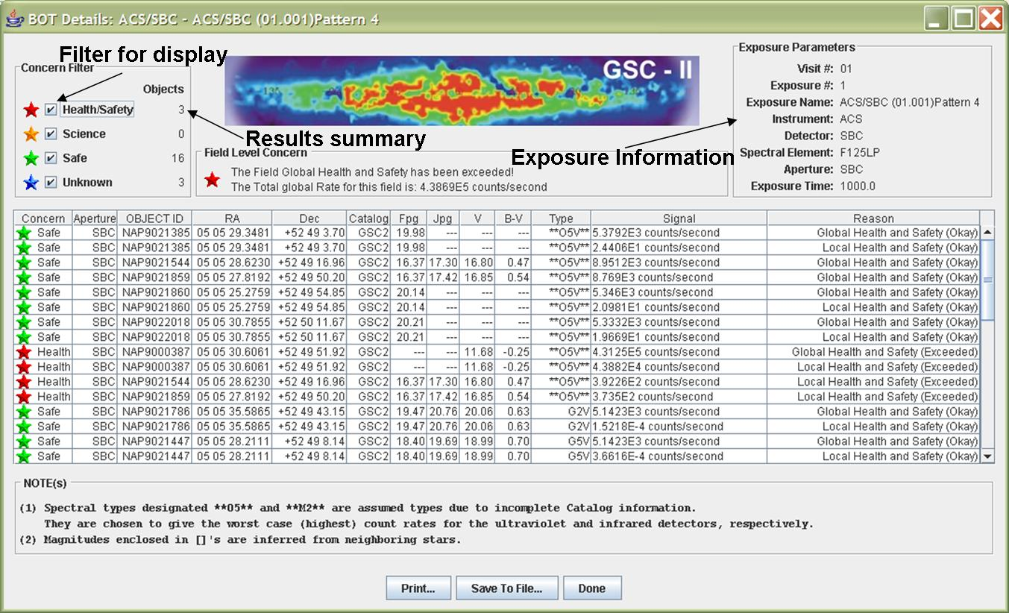

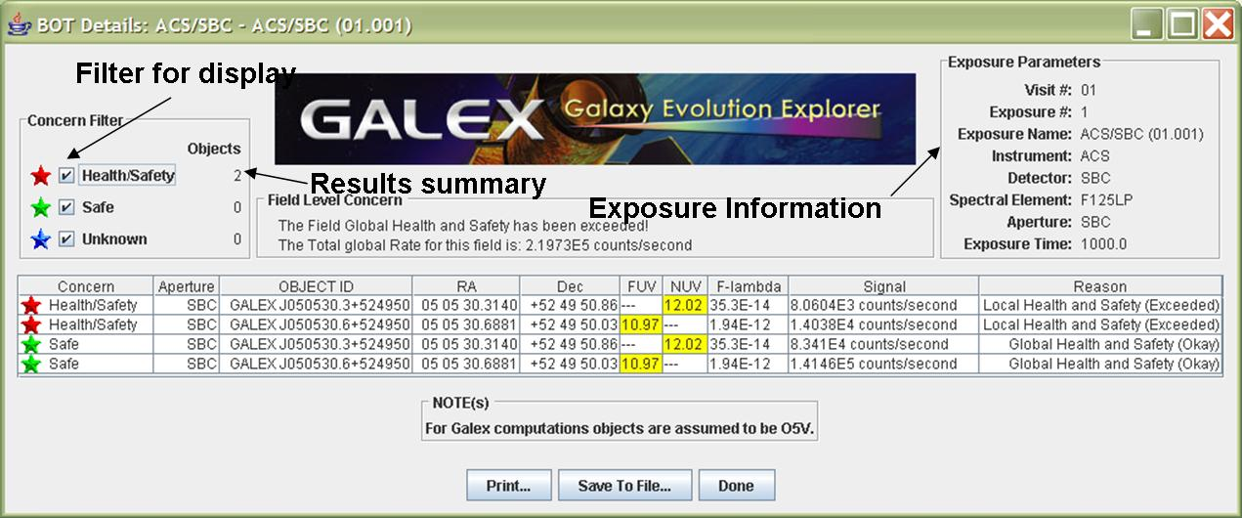
- For all objects, produce an overlay for Aladin which marks objects that are health-and-safety concerns in red, science concerns in orange, unknown concerns in blue, and safe objects in green. The overlay should be able to show both the GSC2 and GALEX results individually and together.

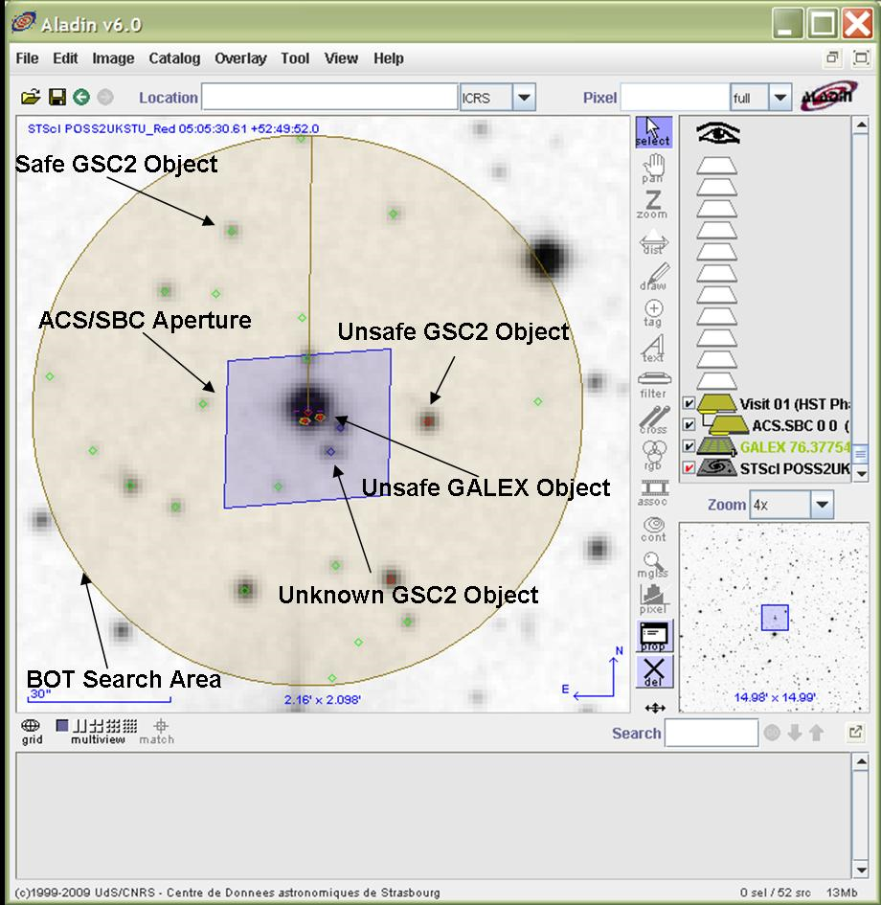

Appendix 1 – V_{crit} values

Given the degeneracy of B-V (and V-R) for the bluest stars, we want to be conservative and say that all stars with B-V less than some value should be considered O stars. Also, since we only have 1 color in the GSC, we have to worry about reddened O stars looking like later-type objects. To determine the appropriate color cutoff, I selected a cutoff (B- V=+0.1), and determined what V magnitude (V_{crit}) would make an O5 star (B-V=-0.3, so E(B-V)=0.4) safe. The checking rule would then be that all stars brighter than V_{crit} and all stars with B-V<+0.1 are assumed to be O5, while the remaining objects have the spectral types set by their observed color. See the ROBOT document for more detailed analysis on the number of false positives.

Instrument | Detector | Spectral Element | Central Wavelength | V_{crit}
ACS | SBC | F122M |  | 13.5
 |  | F115LP |  | 17.0
 |  | F125LP |  | 16.9
 |  | F140LP |  | 16.5
 |  | F150LP |  | 16.1
 |  | F165LP |  | 14.8
 |  | PR110L |  | 13.7
 |  | PR130L |  | 13.5

Appendix 2 - ACS Sample Lookup table

The following items are used in creating the lookup table;
- Exposure time = 1
- V=10 (point source), E(B-V) = 0.0
- Zodiacal light/Bright Earth = average
- default aperture size
- only one filter is supported (i.e. the other wheel is assumed to have a clear filter)

Spectral  Type | Detector | Filter | Gain | Countrate  Local/Global
B5 | SBC | F115LP |  | TBD/TBD
B5 | SBC | F125LP |  | TBD/TBD
B5 | SBC | F140LP |  | TBD/TBD
B5 | SBC | F150LP |  | TBD/TBD
B5 | SBC | F165LP |  | TBD/TBD
B5 | SBC | F122M |  | TBD/TBD

Appendix 3 – Number of Instrument Configurations

To keep the lookup table manageable, we will make several simplifying assumptions. For ACS/SBC, no such assumptions were necessary.

Based on the above assumptions, the following table estimates the number of entries in the lookup table for each instrument..

Instrument Configurations
Instrument | Parameters | Configur ations | Spectral Types | Total
ACS | SBC 6 filters, 2 PRISMs | 8 | 13 | 104

